# Race: AQU | 2025-03-28 | Race #2 | Post: 13:42 | Track: AQUEDUCT

Track: AQUEDUCT

|  |  |  |  |  |  |
| --- | --- | --- | --- | --- | --- |
| Program # | Horse Name | Morn Odds | GCSF | Model Score | Win Prob (%) |
| 1 | Poseidon's Mist | 1-1 | 111.6 | 1.18 | 5.15 |
| 1A | Trade Secret | 1-1 | 101.3 | 1.28 | 7.75 |
| 2 | Irish Jackson | 4-1 | 112.8 | 1.27 | 7.33 |
| 3 | Lady Arwen | 3-1 | 83.8 | 1.13 | 4.01 |
| 4 | La Grotte | 6-1 | 97.8 | 1.98 | 72.80 |
| 5 | Last Glory | 15-1 | 95.0 | 0.86 | 0.97 |
| 6 | Dashing Della | 8-1 | 116.7 | 0.98 | 1.99 |

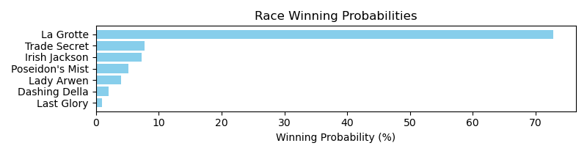

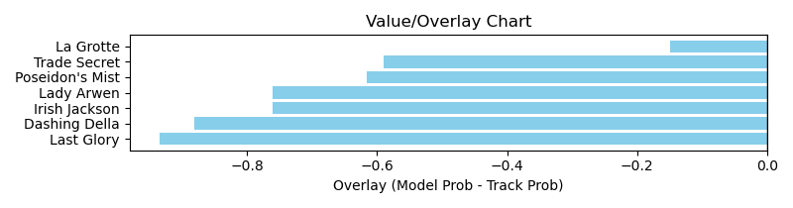

NOTE: GCSF - Global Combined Speed Figure

# Race: AQU | 2025-03-28 | Race #3 | Post: 14:13 | Track: AQUEDUCT

Track: AQUEDUCT

|  |  |  |  |  |  |
| --- | --- | --- | --- | --- | --- |
| Program # | Horse Name | Morn Odds | GCSF | Model Score | Win Prob (%) |
| 1 | Echo Seven | 2-1 | 121.6 | 1.21 | 3.37 |
| 1A | Shezanarcticqueen | 2-1 | 107.8 | 2.24 | 79.87 |
| 2 | Balenciaga Betty | 12-1 | 96.2 | 0.95 | 1.00 |
| 3 | Jolly Miss Jill | 12-1 | 89.2 | 1.11 | 2.20 |
| 4 | Ghostly Girl | 12-1 | 105.4 | 1.15 | 2.59 |
| 5 | Goldcrest | 1-1 | 105.2 | 1.18 | 2.93 |
| 6 | Everlys Girl | 12-1 | 82.0 | 1.39 | 7.01 |
| 7 | Jackie the Joker | 6-1 | 101.4 | 0.96 | 1.03 |

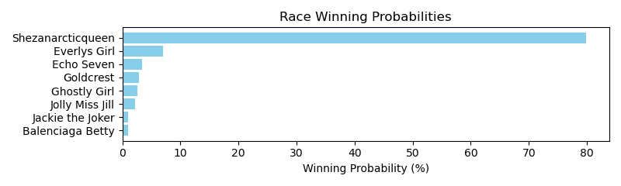

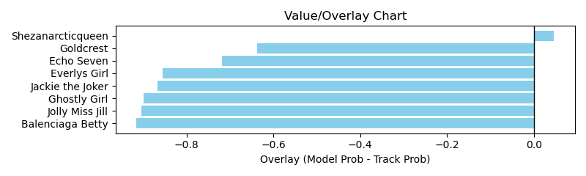

NOTE: GCSF - Global Combined Speed Figure

# Race: AQU | 2025-03-28 | Race #4 | Post: 14:47 | Track: AQUEDUCT

Track: AQUEDUCT

|  |  |  |  |  |  |
| --- | --- | --- | --- | --- | --- |
| Program # | Horse Name | Morn Odds | GCSF | Model Score | Win Prob (%) |
| 1 | Mursal | 2-1 | 96.1 | 1.03 | 8.62 |
| 2 | Kara Para | 10-1 | 110.2 | 1.11 | 12.49 |
| 3 | Whistler's Style | 7-2 | 100.5 | 1.29 | 27.64 |
| 4 | Luna Moth | 4-1 | 120.9 | 1.21 | 19.64 |
| 5 | Toned Up | 9-5 | 99.6 | 1.29 | 27.44 |
| 6 | Looks First | 15-1 | 93.2 | 0.90 | 4.18 |

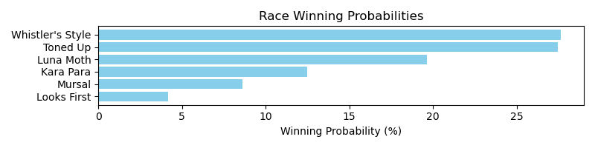

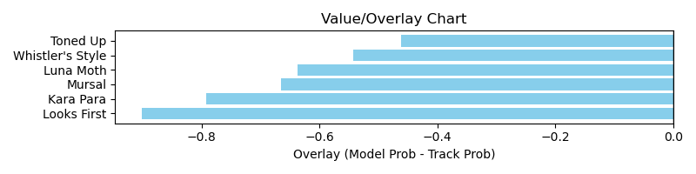

NOTE: GCSF - Global Combined Speed Figure

# Race: AQU | 2025-03-28 | Race #6 | Post: 15:52 | Track: AQUEDUCT

Track: AQUEDUCT

|  |  |  |  |  |  |
| --- | --- | --- | --- | --- | --- |
| Program # | Horse Name | Morn Odds | GCSF | Model Score | Win Prob (%) |
| 1 | To Be Loved by You | 8-1 | 93.1 | 1.07 | 6.81 |
| 2 | That'sthefactjack | 10-1 | 114.4 | 1.10 | 8.06 |
| 3 | Troubled Luck | 12-1 | 119.6 | 0.86 | 2.22 |
| 4 | Lucky and Gorgeous | 5-1 | 91.5 | 1.03 | 5.69 |
| 5 | Focus Pocus | 7-2 | 92.0 | 0.97 | 4.20 |
| 6 | Mia Nipotina | 8-1 | 117.6 | 0.84 | 1.98 |
| 7 | Accelerina | 10-1 | 105.5 | 0.96 | 4.07 |
| 8 | Lem Me Drink | 3-1 | 98.3 | 1.15 | 9.98 |
| 9 | Montauk Mystique | 6-1 | 90.7 | 1.61 | 56.98 |

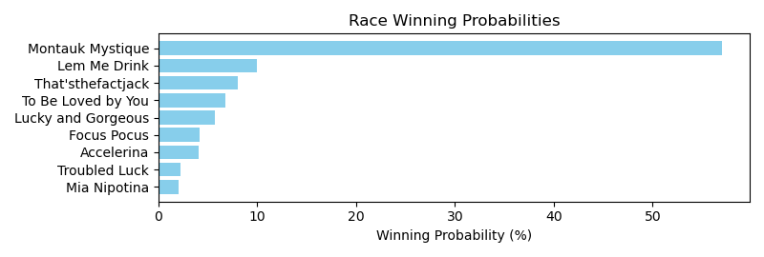

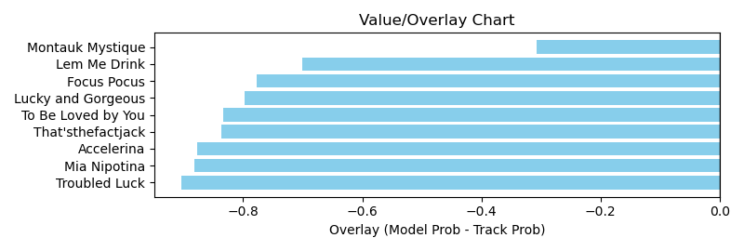

NOTE: GCSF - Global Combined Speed Figure

# Race: AQU | 2025-03-29 | Race #2 | Post: 13:10 | Track: AQUEDUCT

Track: AQUEDUCT

|  |  |  |  |  |  |
| --- | --- | --- | --- | --- | --- |
| Program # | Horse Name | Morn Odds | GCSF | Model Score | Win Prob (%) |
| 1 | Save Us Melania | 2-1 | 100.3 | 1.57 | 25.50 |
| 1A | Our Liberty Belle | 2-1 | 101.7 | 1.18 | 5.87 |
| 2 | Gone and Forgotten | 5-1 | 97.9 | 1.34 | 11.54 |
| 2B | Gridlock | 5-1 | 106.1 | 1.16 | 5.52 |
| 3 | I'm Buzzy | 8-1 | 94.8 | 1.22 | 7.04 |
| 4 | Adeleke | 7-2 | 109.6 | 1.11 | 4.45 |
| 5 | Pistol Liz Ablazen | 8-1 | 99.8 | 1.47 | 18.71 |
| 6 | Smokin' Hot Kitty | 4-1 | 92.6 | 1.44 | 16.43 |
| 7 | Spring Magic | 20-1 | 95.2 | 0.96 | 2.09 |
| 8 | Backstretch Rose | 12-1 | 89.7 | 1.02 | 2.85 |

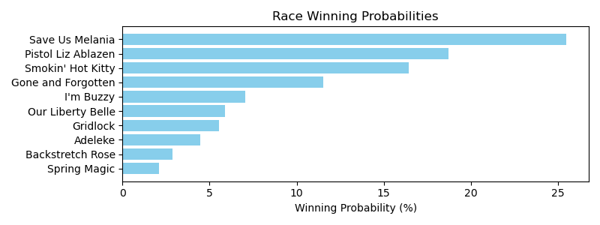

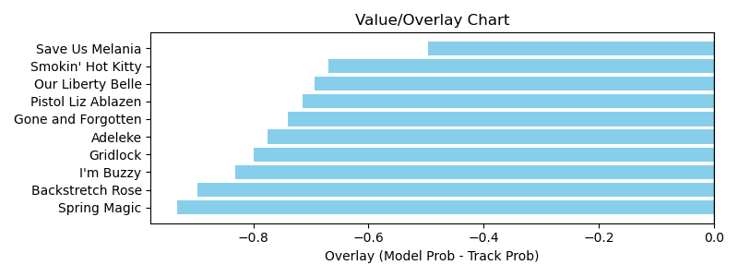

NOTE: GCSF - Global Combined Speed Figure

# Race: AQU | 2025-03-29 | Race #3 | Post: 13:40 | Track: AQUEDUCT

Track: AQUEDUCT

|  |  |  |  |  |  |
| --- | --- | --- | --- | --- | --- |
| Program # | Horse Name | Morn Odds | GCSF | Model Score | Win Prob (%) |
| 1 | Liberte de Bayeux | 13-8 | 90.0 | 1.53 | 16.16 |
| 1A | Just Call Ray | 13-8 | 91.8 | 1.39 | 9.91 |
| 2 | Dot's Dollar | 8-1 | 115.7 | 1.25 | 5.65 |
| 3 | Cold as Hell | 6-1 | 95.9 | 1.13 | 3.36 |
| 4 | I See You Lookin | 30-1 | 103.5 | 0.88 | 0.97 |
| 5 | Graywing | 9-2 | 102.8 | 1.81 | 37.81 |
| 6 | Bad Larry | 50-1 | 87.5 | 0.96 | 1.51 |
| 7 | Chuck Willis (IRE) | 15-1 | 118.0 | 1.10 | 3.04 |
| 8 | Tetsu | 8-1 | 98.8 | 1.53 | 16.00 |
| 9 | Latta | 7-2 | 112.0 | 1.24 | 5.60 |

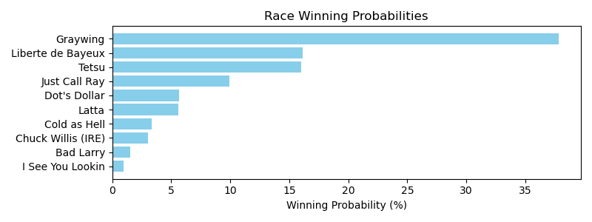

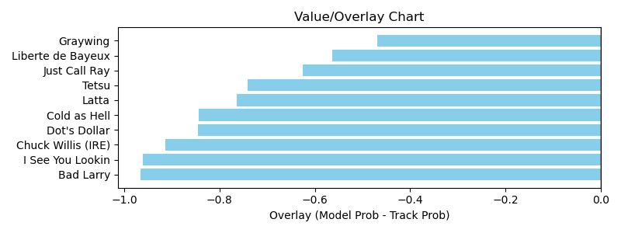

NOTE: GCSF - Global Combined Speed Figure

# Race: AQU | 2025-03-29 | Race #5 | Post: 14:44 | Track: AQUEDUCT

Track: AQUEDUCT

|  |  |  |  |  |  |
| --- | --- | --- | --- | --- | --- |
| Program # | Horse Name | Morn Odds | GCSF | Model Score | Win Prob (%) |
| 1 | Mo Rhodes | 4-1 | 88.0 | 1.39 | 19.99 |
| 2 | Taparino | 50-1 | 108.3 | 1.01 | 4.02 |
| 3 | Winnin'onweekends | 6-1 | 89.3 | 1.09 | 5.94 |
| 4 | Strapped | 4-1 | 111.6 | 1.14 | 7.44 |
| 5 | Bold Endeavor | 7-2 | 88.1 | 1.62 | 44.98 |
| 6 | Scat Tu Tap | 12-1 | 108.9 | 0.80 | 1.23 |
| 7 | First Trumpet | 30-1 | 88.6 | 0.76 | 0.93 |
| 8 | Seeking Unity | 5-1 | 114.7 | 1.08 | 5.51 |
| 9 | Colloquy | 6-1 | 113.8 | 1.16 | 8.05 |
| 10 | Double Your Money | 12-1 | 118.4 | 0.88 | 1.89 |

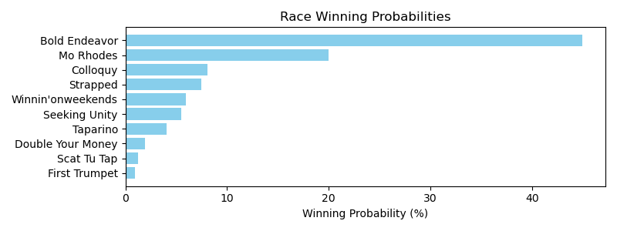

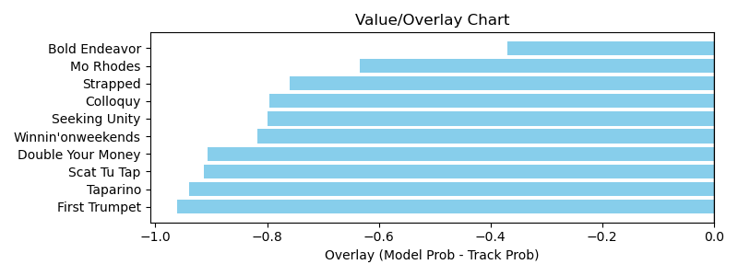

NOTE: GCSF - Global Combined Speed Figure

# Race: FON | 2025-03-28 | Race #1 | Post: 16:00 | Track: FONNER PARK

Track: FONNER PARK

|  |  |  |  |  |  |
| --- | --- | --- | --- | --- | --- |
| Program # | Horse Name | Morn Odds | GCSF | Model Score | Win Prob (%) |
| 2 | Macho Striker | 8-1 | 86.1 | 0.89 | 23.49 |
| 5 | Baytown Sundance | 5-2 | 95.2 | 1.08 | 63.14 |
| 7 | Prix de West | 12-1 | 99.9 | 0.80 | 13.37 |

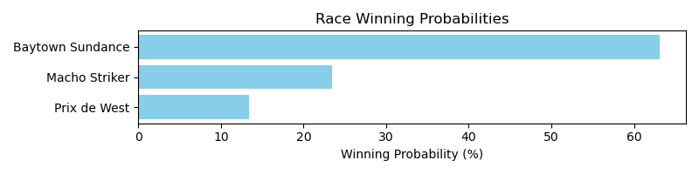

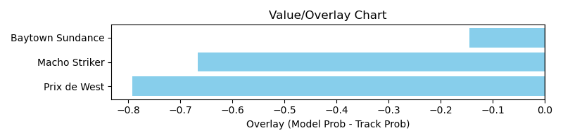

NOTE: GCSF - Global Combined Speed Figure

# Race: FON | 2025-03-28 | Race #2 | Post: 16:27 | Track: FONNER PARK

Track: FONNER PARK

|  |  |  |  |  |  |
| --- | --- | --- | --- | --- | --- |
| Program # | Horse Name | Morn Odds | GCSF | Model Score | Win Prob (%) |
| 5 | Flat Out Nice | 20-1 | 93.4 | 0.84 | 10.88 |
| 8 | Flintlock | 9-5 | 91.8 | 1.26 | 89.12 |

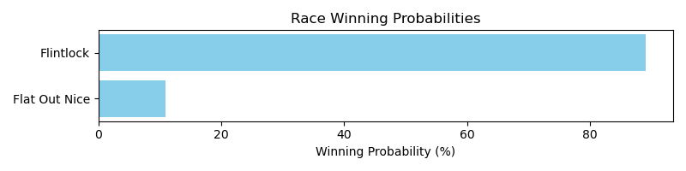

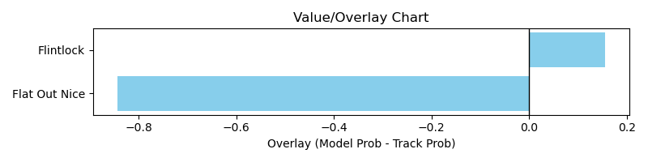

NOTE: GCSF - Global Combined Speed Figure

# Race: FON | 2025-03-28 | Race #3 | Post: 16:54 | Track: FONNER PARK

Track: FONNER PARK

|  |  |  |  |  |  |
| --- | --- | --- | --- | --- | --- |
| Program # | Horse Name | Morn Odds | GCSF | Model Score | Win Prob (%) |
| 5 | Cream Puff Reaper | 3-1 | 95.8 | 0.98 | 40.00 |
| 7 | Woody's Choice | 6-1 | 92.3 | 1.06 | 60.00 |

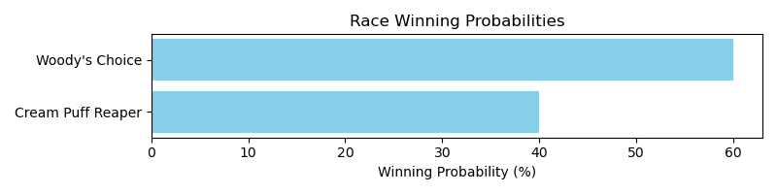

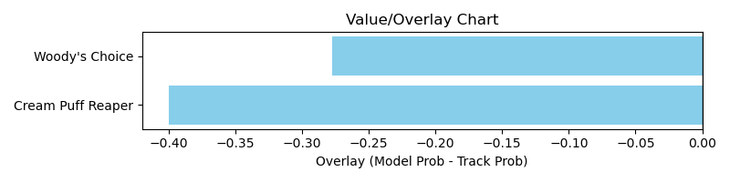

NOTE: GCSF - Global Combined Speed Figure

# Race: FON | 2025-03-28 | Race #4 | Post: 17:21 | Track: FONNER PARK

Track: FONNER PARK

|  |  |  |  |  |  |
| --- | --- | --- | --- | --- | --- |
| Program # | Horse Name | Morn Odds | GCSF | Model Score | Win Prob (%) |
| 4 | Schmooze | 7-2 | 107.5 | 1.13 | 42.33 |
| 5 | Wrong Direction | 10-1 | 97.6 | 1.20 | 57.67 |

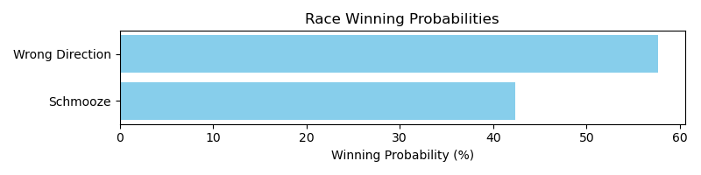

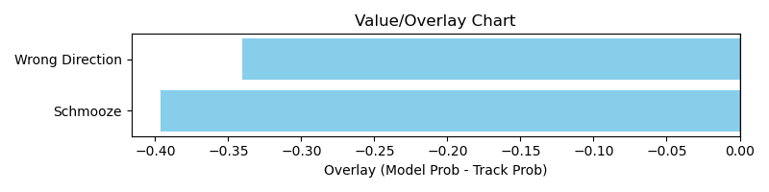

NOTE: GCSF - Global Combined Speed Figure

# Race: FON | 2025-03-28 | Race #7 | Post: 18:42 | Track: FONNER PARK

Track: FONNER PARK

|  |  |  |  |  |  |
| --- | --- | --- | --- | --- | --- |
| Program # | Horse Name | Morn Odds | GCSF | Model Score | Win Prob (%) |
| 5 | Berea | 3-1 | 96.6 | 1.12 | 89.52 |
| 7 | Collier | 15-1 | 96.9 | 0.74 | 10.48 |

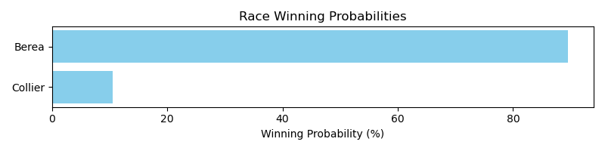

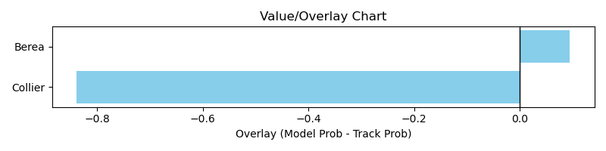

NOTE: GCSF - Global Combined Speed Figure

# Race: FON | 2025-03-29 | Race #1 | Post: 13:30 | Track: FONNER PARK

Track: FONNER PARK

|  |  |  |  |  |  |
| --- | --- | --- | --- | --- | --- |
| Program # | Horse Name | Morn Odds | GCSF | Model Score | Win Prob (%) |
| 4 | Celtics Wildcat | 5-2 | 97.4 | 1.00 | 11.76 |
| 7 | Liking It Twisted | 7-2 | 93.0 | 1.49 | 88.24 |

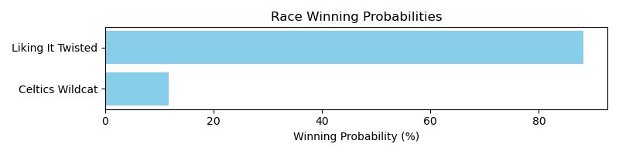

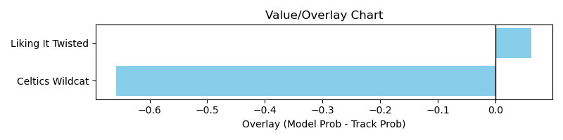

NOTE: GCSF - Global Combined Speed Figure

# Race: FON | 2025-03-29 | Race #2 | Post: 13:59 | Track: FONNER PARK

Track: FONNER PARK

|  |  |  |  |  |  |
| --- | --- | --- | --- | --- | --- |
| Program # | Horse Name | Morn Odds | GCSF | Model Score | Win Prob (%) |
| 2 | Moorea Time | 12-1 | 91.9 | 0.96 | 81.15 |
| 3 | Hazardtoyourhealth | 15-1 | 118.7 | 0.72 | 18.85 |

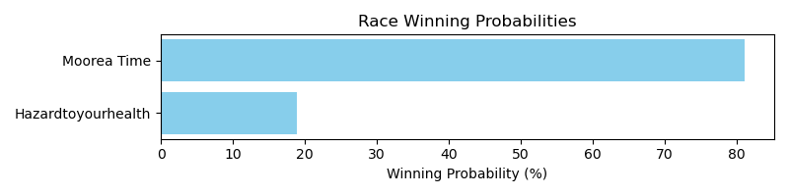

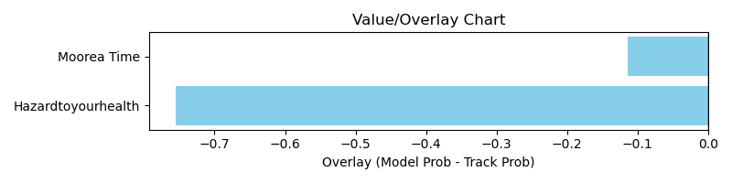

NOTE: GCSF - Global Combined Speed Figure

# Race: FON | 2025-03-29 | Race #3 | Post: 14:28 | Track: FONNER PARK

Track: FONNER PARK

|  |  |  |  |  |  |
| --- | --- | --- | --- | --- | --- |
| Program # | Horse Name | Morn Odds | GCSF | Model Score | Win Prob (%) |
| 3 | Miss You No More | 12-1 | 102.1 | 0.87 | 15.54 |
| 6 | Extra Indy | 5-2 | 95.6 | 1.16 | 66.70 |
| 8 | Princess Vanellope | 5-1 | 99.5 | 0.89 | 17.76 |

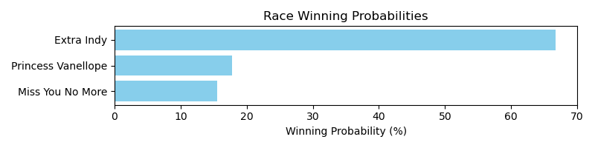

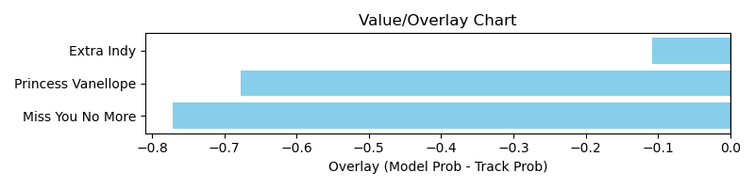

NOTE: GCSF - Global Combined Speed Figure

# Race: FON | 2025-03-29 | Race #6 | Post: 15:55 | Track: FONNER PARK

Track: FONNER PARK

|  |  |  |  |  |  |
| --- | --- | --- | --- | --- | --- |
| Program # | Horse Name | Morn Odds | GCSF | Model Score | Win Prob (%) |
| 1 | Burn Boss | 6-1 | 95.2 | 1.00 | 14.94 |
| 5 | B L's Concerto | 5-1 | 95.1 | 1.12 | 26.82 |
| 7 | Sweet Music Man | 10-1 | 106.6 | 1.11 | 25.42 |
| 8 | After the Game | 15-1 | 103.7 | 0.73 | 2.90 |
| 9 | American Cause | 12-1 | 106.6 | 1.15 | 29.93 |

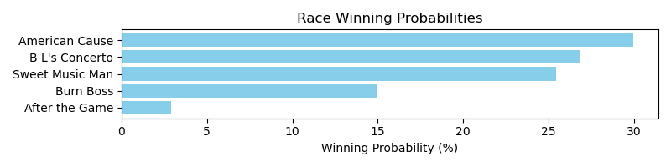

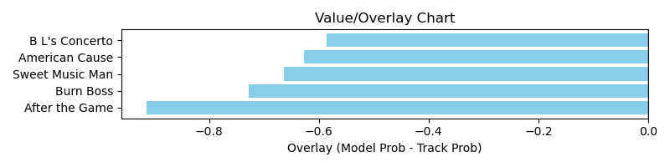

NOTE: GCSF - Global Combined Speed Figure

# Race: FON | 2025-03-29 | Race #7 | Post: 16:24 | Track: FONNER PARK

Track: FONNER PARK

|  |  |  |  |  |  |
| --- | --- | --- | --- | --- | --- |
| Program # | Horse Name | Morn Odds | GCSF | Model Score | Win Prob (%) |
| 3 | Bless d'South | 5-1 | 94.3 | 0.95 | 66.62 |
| 6 | Ocean Bird | 5-2 | 102.5 | 0.83 | 33.38 |

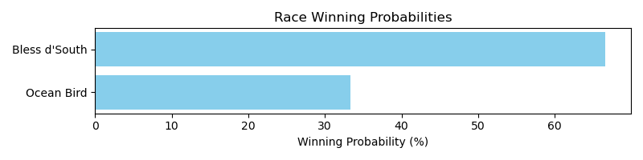

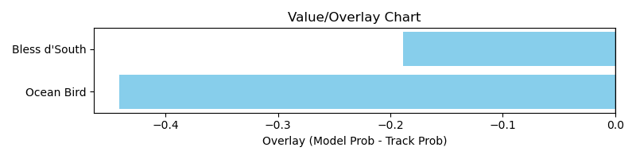

NOTE: GCSF - Global Combined Speed Figure

# Race: FON | 2025-03-29 | Race #8 | Post: 16:53 | Track: FONNER PARK

Track: FONNER PARK

|  |  |  |  |  |  |
| --- | --- | --- | --- | --- | --- |
| Program # | Horse Name | Morn Odds | GCSF | Model Score | Win Prob (%) |
| 1 | Pervasive | 15-1 | 96.5 | 1.03 | 24.77 |
| 2 | Knighted | 10-1 | 93.5 | 1.14 | 40.60 |
| 4 | Street Art | 5-1 | 102.1 | 0.91 | 12.75 |
| 7 | Incitatus | 8-1 | 94.0 | 1.01 | 21.88 |

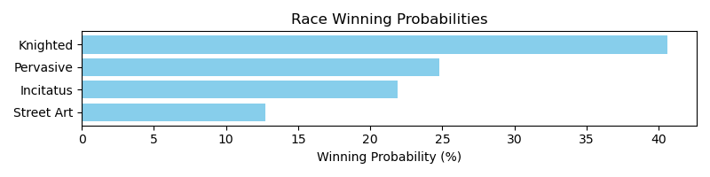

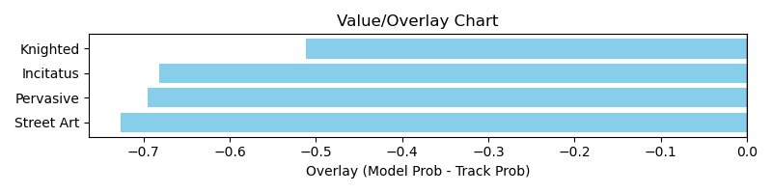

NOTE: GCSF - Global Combined Speed Figure

# Race: FON | 2025-03-29 | Race #9 | Post: 17:22 | Track: FONNER PARK

Track: FONNER PARK

|  |  |  |  |  |  |
| --- | --- | --- | --- | --- | --- |
| Program # | Horse Name | Morn Odds | GCSF | Model Score | Win Prob (%) |
| 3 | Tavaline | 20-1 | 100.0 | 0.93 | 8.30 |
| 5 | Tennessee Moon | 1-1 | 108.8 | 1.42 | 72.48 |
| 6 | Connectable | 10-1 | 88.9 | 1.10 | 19.22 |

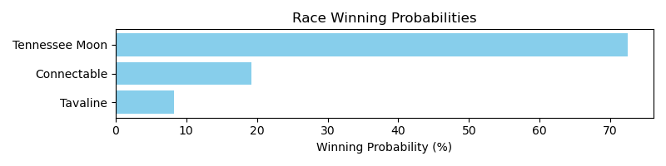

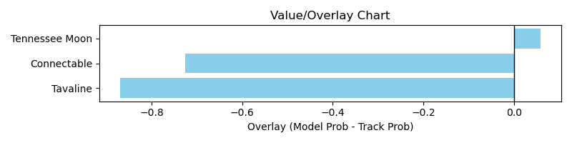

NOTE: GCSF - Global Combined Speed Figure

# Race: FON | 2025-03-29 | Race #10 | Post: 17:51 | Track: FONNER PARK

Track: FONNER PARK

|  |  |  |  |  |  |
| --- | --- | --- | --- | --- | --- |
| Program # | Horse Name | Morn Odds | GCSF | Model Score | Win Prob (%) |
| 1 | Carpe Horseshoe | 7-2 | 93.4 | 1.42 | 78.99 |
| 4 | Checkcashingconnie | 3-1 | 112.8 | 1.10 | 21.01 |

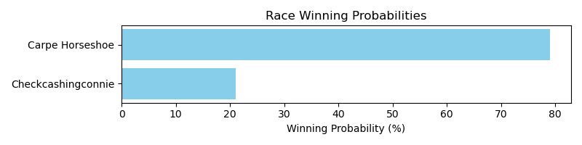

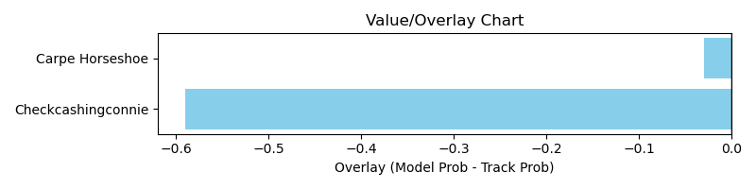

NOTE: GCSF - Global Combined Speed Figure

# Race: FON | 2025-03-30 | Race #1 | Post: 13:30 | Track: FONNER PARK

Track: FONNER PARK

|  |  |  |  |  |  |
| --- | --- | --- | --- | --- | --- |
| Program # | Horse Name | Morn Odds | GCSF | Model Score | Win Prob (%) |
| 1 | Donnas Final Word | 7-2 | 94.4 | 1.03 | 100.00 |

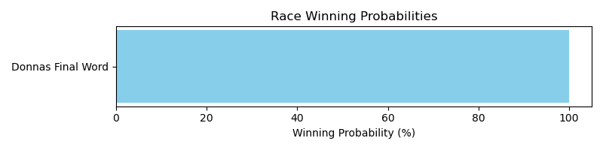

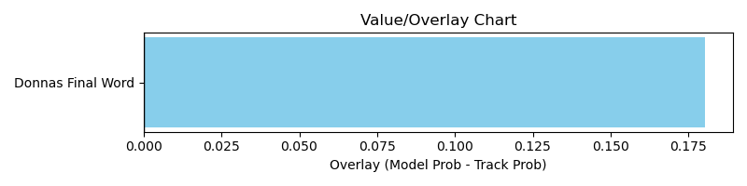

NOTE: GCSF - Global Combined Speed Figure

# Race: FON | 2025-03-30 | Race #2 | Post: 13:57 | Track: FONNER PARK

Track: FONNER PARK

|  |  |  |  |  |  |
| --- | --- | --- | --- | --- | --- |
| Program # | Horse Name | Morn Odds | GCSF | Model Score | Win Prob (%) |
| 1 | I Am Mila | 12-1 | 95.2 | 0.85 | 3.13 |
| 2 | Scoot Along | 5-2 | 93.4 | 1.32 | 30.66 |
| 3 | Miss Charge It | 13-8 | 94.0 | 1.30 | 27.67 |
| 4 | Global Risk | 15-1 | 102.4 | 0.73 | 1.45 |
| 5 | Motown Dynamic | 3-1 | 102.4 | 1.35 | 34.41 |
| 6 | Just Win Baby | 4-1 | 112.1 | 0.82 | 2.67 |

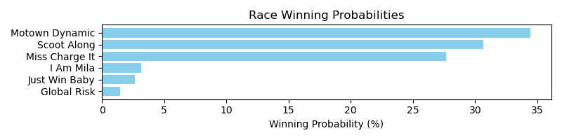

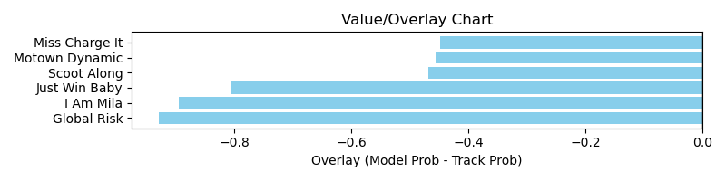

NOTE: GCSF - Global Combined Speed Figure

# Race: FON | 2025-03-30 | Race #3 | Post: 14:24 | Track: FONNER PARK

Track: FONNER PARK

|  |  |  |  |  |  |
| --- | --- | --- | --- | --- | --- |
| Program # | Horse Name | Morn Odds | GCSF | Model Score | Win Prob (%) |
| 2 | I'm So Funny | 12-1 | 95.2 | 0.88 | 13.15 |
| 3 | By Request | 5-1 | 110.5 | 0.89 | 14.37 |
| 4 | Secretly Sweet | 2-1 | 98.7 | 1.23 | 72.48 |

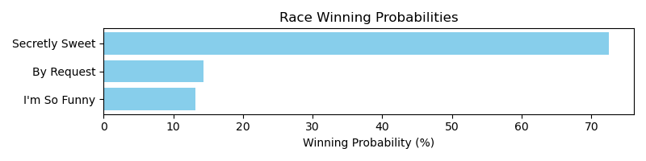

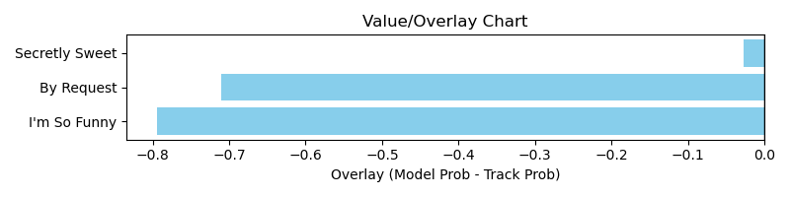

NOTE: GCSF - Global Combined Speed Figure

# Race: FON | 2025-03-30 | Race #4 | Post: 14:51 | Track: FONNER PARK

Track: FONNER PARK

|  |  |  |  |  |  |
| --- | --- | --- | --- | --- | --- |
| Program # | Horse Name | Morn Odds | GCSF | Model Score | Win Prob (%) |
| 1 | Mischievous Miss | 3-1 | 95.4 | 0.98 | 12.62 |
| 2 | Master Jane | 4-1 | 103.6 | 1.18 | 32.96 |
| 3 | Miz Cali | 5-1 | 94.8 | 1.23 | 40.64 |
| 4 | Funtimegirl | 6-1 | 111.3 | 0.99 | 13.77 |

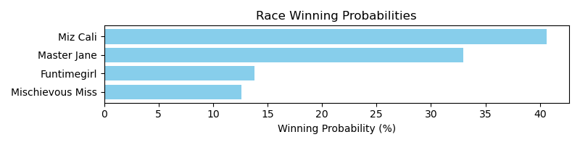

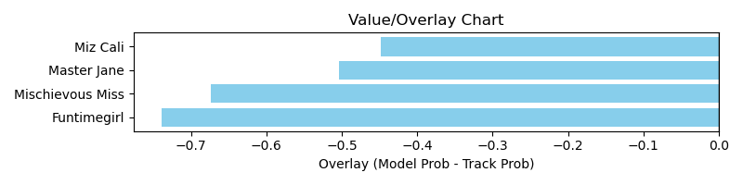

NOTE: GCSF - Global Combined Speed Figure

# Race: FON | 2025-03-30 | Race #5 | Post: 15:18 | Track: FONNER PARK

Track: FONNER PARK

|  |  |  |  |  |  |
| --- | --- | --- | --- | --- | --- |
| Program # | Horse Name | Morn Odds | GCSF | Model Score | Win Prob (%) |
| 1 | Prints Money | 8-1 | 91.6 | 1.10 | 40.17 |
| 4 | Willie Cat | 3-1 | 91.3 | 0.81 | 8.49 |
| 5 | Oro | 8-1 | 102.7 | 1.16 | 51.34 |

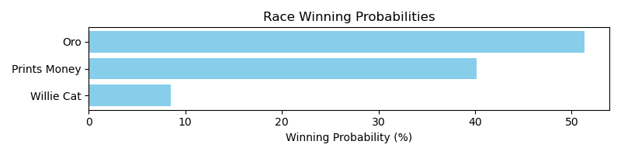

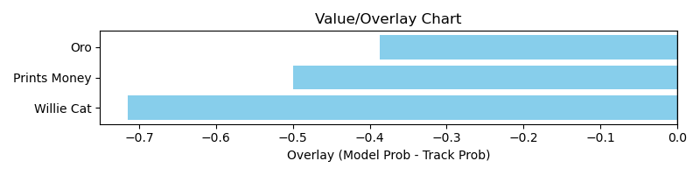

NOTE: GCSF - Global Combined Speed Figure

# Race: FON | 2025-03-30 | Race #7 | Post: 16:12 | Track: FONNER PARK

Track: FONNER PARK

|  |  |  |  |  |  |
| --- | --- | --- | --- | --- | --- |
| Program # | Horse Name | Morn Odds | GCSF | Model Score | Win Prob (%) |
| 1 | Hit the Seam | 15-1 | 99.8 | 1.04 | 22.23 |
| 6 | Serendip Ruler | 5-1 | 94.6 | 1.17 | 40.78 |
| 7 | Oro Azteca | 4-1 | 93.1 | 1.14 | 36.99 |

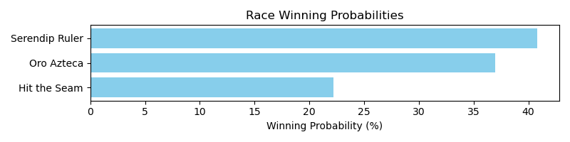

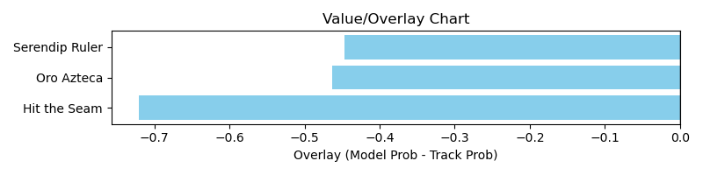

NOTE: GCSF - Global Combined Speed Figure

# Race: FON | 2025-03-30 | Race #8 | Post: 16:39 | Track: FONNER PARK

Track: FONNER PARK

|  |  |  |  |  |  |
| --- | --- | --- | --- | --- | --- |
| Program # | Horse Name | Morn Odds | GCSF | Model Score | Win Prob (%) |
| 2 | Summer All Year | 15-1 | 95.6 | 0.85 | 18.18 |
| 3 | Hangin' Tuff | 15-1 | 110.7 | 0.69 | 6.50 |
| 5 | Prince Is My Boy | 3-1 | 94.4 | 0.99 | 40.47 |
| 6 | Proof of Purchase | 10-1 | 104.7 | 0.84 | 17.45 |
| 9 | Red Cheeks | 15-1 | 106.6 | 0.84 | 17.40 |

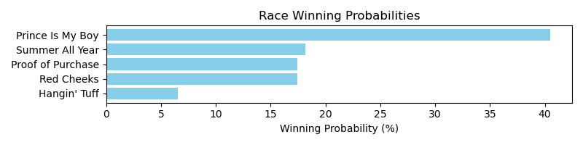

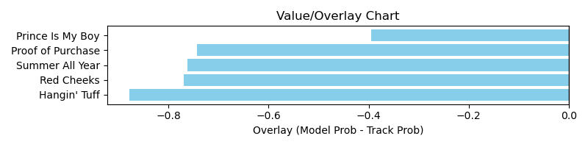

NOTE: GCSF - Global Combined Speed Figure

# Race: TGP | 2025-03-28 | Race #3 | Post: 13:52 | Track: GULFSTREAM PARK

Track: GULFSTREAM PARK

|  |  |  |  |  |  |
| --- | --- | --- | --- | --- | --- |
| Program # | Horse Name | Morn Odds | GCSF | Model Score | Win Prob (%) |
| 1 | Love Paradox | 15-1 | 97.7 | 0.98 | 1.24 |
| 2 | Bubbly Champagne | 5-2 | 94.5 | 1.29 | 4.94 |
| 3 | Smart Jenny | 5-1 | 91.4 | 1.05 | 1.75 |
| 4 | One Smokin' Rita | 12-1 | 96.2 | 1.08 | 1.99 |
| 5 | Peggysue I Love U | 3-1 | 92.7 | 1.27 | 4.55 |
| 6 | Spirit of Victory | 6-1 | 97.3 | 1.07 | 1.91 |
| 7 | Mama Maria | 10-1 | 93.9 | 1.23 | 3.81 |
| 8 | Fields of Green | 6-1 | 109.5 | 2.20 | 76.50 |
| 9 | Jurassic Chick | 12-1 | 98.9 | 1.19 | 3.30 |

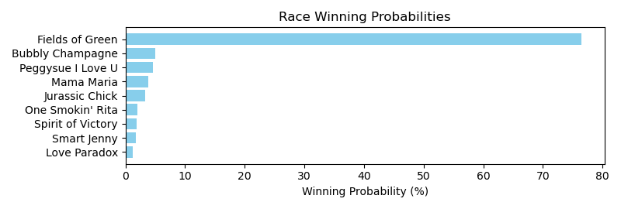

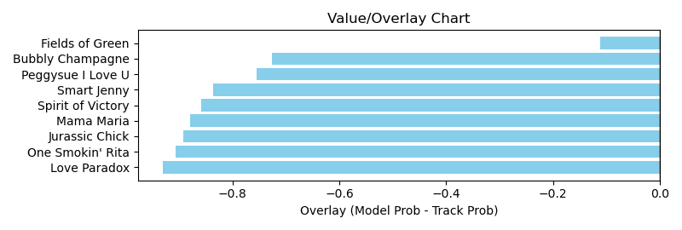

NOTE: GCSF - Global Combined Speed Figure

# Race: TGP | 2025-03-28 | Race #4 | Post: 14:25 | Track: GULFSTREAM PARK

Track: GULFSTREAM PARK

|  |  |  |  |  |  |
| --- | --- | --- | --- | --- | --- |
| Program # | Horse Name | Morn Odds | GCSF | Model Score | Win Prob (%) |
| 1 | Test Factor | 2-1 | 94.5 | 2.16 | 58.82 |
| 2 | Foxtrotanna | 15-1 | 90.8 | 1.13 | 2.10 |
| 3 | Extendo | 3-1 | 89.9 | 1.21 | 2.99 |
| 4 | Artemus Citylimits | 8-1 | 99.2 | 1.17 | 2.48 |
| 5 | Abrir Caminos (CHI) | 7-2 | 97.4 | 1.37 | 5.72 |
| 6 | Asher's Edge | 5-2 | 110.5 | 1.87 | 27.87 |

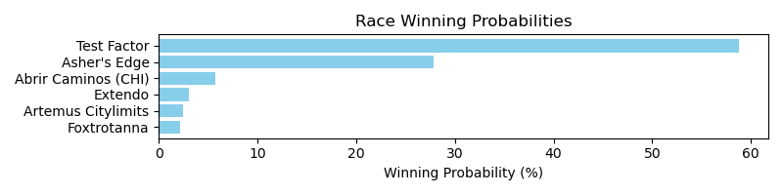

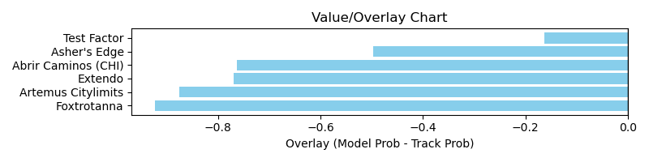

NOTE: GCSF - Global Combined Speed Figure

# Race: TGP | 2025-03-28 | Race #5 | Post: 15:09 | Track: GULFSTREAM PARK

Track: GULFSTREAM PARK

|  |  |  |  |  |  |
| --- | --- | --- | --- | --- | --- |
| Program # | Horse Name | Morn Odds | GCSF | Model Score | Win Prob (%) |
| 1 | Picture This | 20-1 | 109.0 | 0.96 | 1.78 |
| 2 | My Sea Cottage (IRE) | 10-1 | 100.7 | 1.27 | 7.47 |
| 3 | Drakon | 7-2 | 99.5 | 1.38 | 11.49 |
| 4 | Rock the Stars | 12-1 | 95.2 | 1.32 | 9.08 |
| 5 | Clear Vision | 6-1 | 110.4 | 1.28 | 7.68 |
| 6 | Souper Watson | 5-1 | 94.2 | 1.37 | 10.96 |
| 7 | Swashbuckle | 15-1 | 96.1 | 1.14 | 4.27 |
| 8 | Uncle John | 6-1 | 114.7 | 1.18 | 5.08 |
| 9 | Battle of Dover | 20-1 | 110.8 | 1.27 | 7.48 |
| 10 | Spy Novel | 4-1 | 89.6 | 1.41 | 12.52 |
| 11 | Baytown Parfait | 20-1 | 99.5 | 1.04 | 2.62 |
| 12 | Jerry's Turn | 30-1 | 95.5 | 1.07 | 3.13 |
| 13 | Kerouac | 6-1 | 89.8 | 1.18 | 5.03 |
| 14 | Betterdaysrcoming (IRE) | 6-1 | 105.5 | 0.93 | 1.54 |
| 15 | Victory Dash | 12-1 | 111.9 | 1.16 | 4.63 |
| 16 | Lights of Broadway | 20-1 | 97.4 | 1.19 | 5.23 |

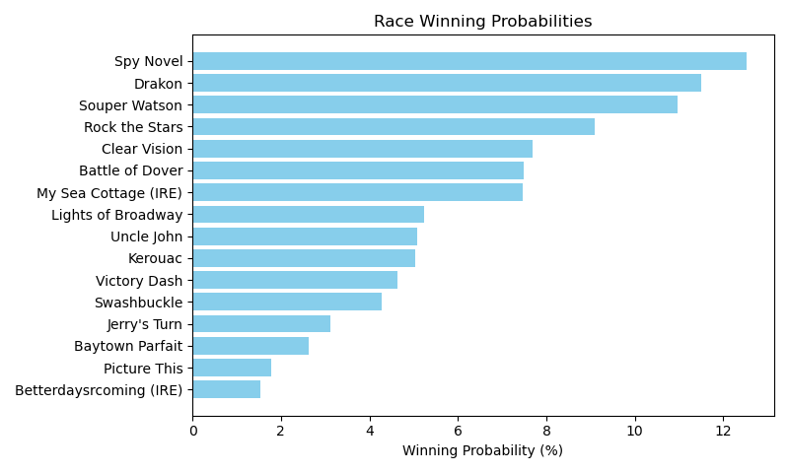

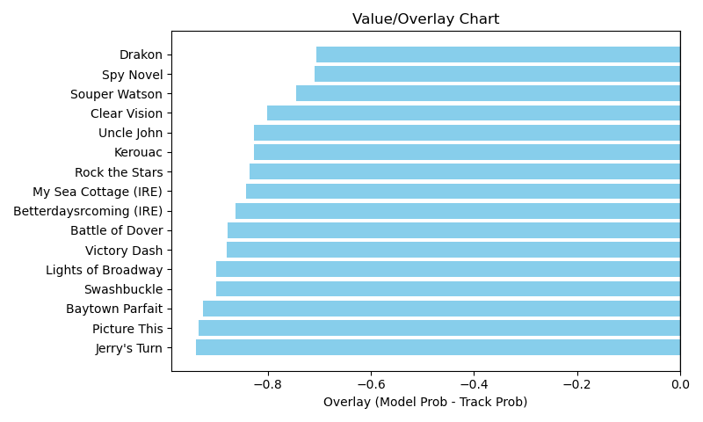

NOTE: GCSF - Global Combined Speed Figure

# Race: TGP | 2025-03-28 | Race #7 | Post: 16:14 | Track: GULFSTREAM PARK

Track: GULFSTREAM PARK

|  |  |  |  |  |  |
| --- | --- | --- | --- | --- | --- |
| Program # | Horse Name | Morn Odds | GCSF | Model Score | Win Prob (%) |
| 1 | Hits Different | 4-1 | 122.6 | 1.21 | 12.42 |
| 2 | Princess Bu Cherro | 30-1 | 111.2 | 0.65 | 0.50 |
| 3 | Mexican Sugar | 10-1 | 95.0 | 1.28 | 16.50 |
| 4 | Lady Monique | 5-2 | 96.5 | 1.50 | 37.34 |
| 5 | Shining Skye | 3-1 | 95.7 | 1.08 | 7.07 |
| 6 | Wow Lucky | 12-1 | 90.7 | 1.07 | 6.59 |
| 7 | Sheila's Mission | 9-2 | 102.4 | 1.07 | 6.55 |
| 8 | Citrus Belle | 15-1 | 97.3 | 0.97 | 4.04 |
| 9 | What a Knockout | 8-1 | 96.4 | 1.14 | 8.99 |

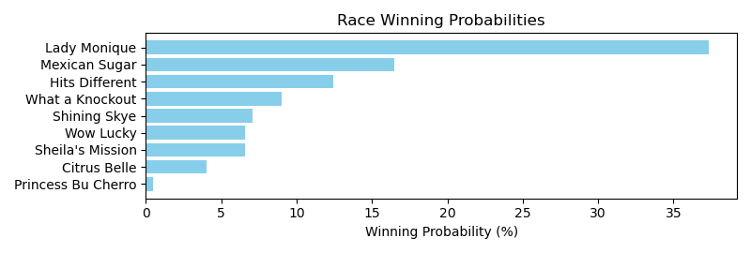

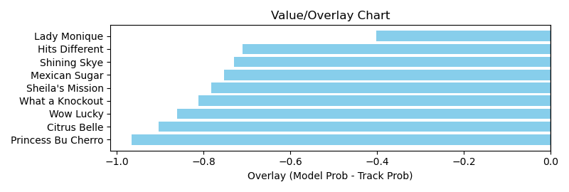

NOTE: GCSF - Global Combined Speed Figure

# Race: TGP | 2025-03-28 | Race #8 | Post: 16:47 | Track: GULFSTREAM PARK

Track: GULFSTREAM PARK

|  |  |  |  |  |  |
| --- | --- | --- | --- | --- | --- |
| Program # | Horse Name | Morn Odds | GCSF | Model Score | Win Prob (%) |
| 1 | Dorth Vader | 13-8 | 105.5 | 1.47 | 7.77 |
| 2 | Gallop d'Hermes | 12-1 | 110.0 | 0.98 | 0.97 |
| 3 | Uphill Dance | 12-1 | 93.5 | 1.28 | 3.86 |
| 4 | My Happy Holiday | 30-1 | 90.9 | 0.88 | 0.57 |
| 5 | Grand Job | 7-5 | 94.6 | 2.30 | 77.34 |
| 6 | Miles of Smiles | 15-1 | 110.6 | 1.14 | 2.08 |
| 7 | Dream Concert | 7-2 | 94.0 | 1.46 | 7.41 |

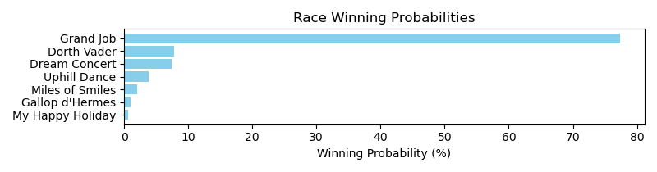

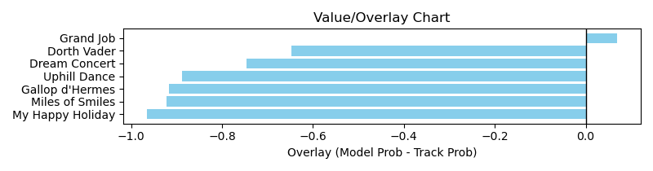

NOTE: GCSF - Global Combined Speed Figure

# Race: TGP | 2025-03-29 | Race #6 | Post: 13:56 | Track: GULFSTREAM PARK

Track: GULFSTREAM PARK

|  |  |  |  |  |  |
| --- | --- | --- | --- | --- | --- |
| Program # | Horse Name | Morn Odds | GCSF | Model Score | Win Prob (%) |
| 1 | Corruption | 20-1 | 108.4 | 2.01 | 42.42 |
| 2 | Better Bet | 20-1 | 111.7 | 1.11 | 1.99 |
| 3 | Cash Equity (FR) | 7-2 | 89.7 | 1.44 | 7.76 |
| 4 | Far Bridge | 7-5 | 81.5 | 1.71 | 18.31 |
| 5 | Tawny Port | 6-1 | 98.6 | 1.30 | 4.44 |
| 6 | Padiddle | 30-1 | 116.6 | 1.21 | 3.13 |
| 7 | Capture the Flag | 3-1 | 88.4 | 1.67 | 16.31 |
| 8 | Il Siciliano | 20-1 | 96.4 | 1.28 | 4.25 |
| 9 | Lorenz (BRZ) | 15-1 | 120.2 | 1.03 | 1.38 |

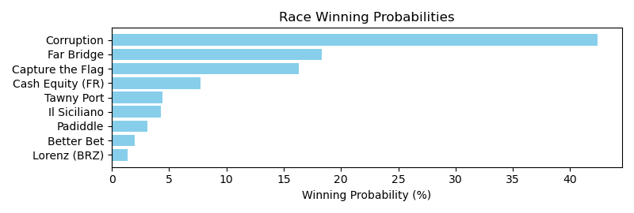

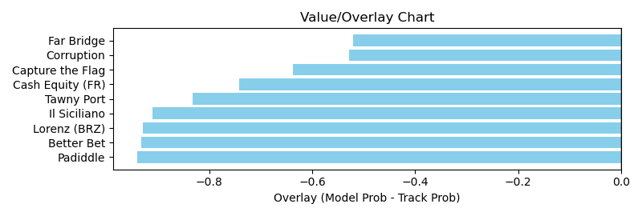

NOTE: GCSF - Global Combined Speed Figure

# Race: TGP | 2025-03-29 | Race #8 | Post: 14:56 | Track: GULFSTREAM PARK

Track: GULFSTREAM PARK

|  |  |  |  |  |  |
| --- | --- | --- | --- | --- | --- |
| Program # | Horse Name | Morn Odds | GCSF | Model Score | Win Prob (%) |
| 1 | Union Trail | 12-1 | 85.3 | 1.16 | 2.08 |
| 2 | Drum Roll Please | 20-1 | 100.8 | 1.66 | 13.05 |
| 3 | Tiz Romantic | 6-1 | 93.6 | 1.44 | 6.29 |
| 4 | Beyond Stoked | 4-1 | 104.4 | 1.34 | 4.28 |
| 5 | Oscar's World | 10-1 | 93.2 | 1.11 | 1.66 |
| 6 | Swift Delivery | 10-1 | 98.0 | 1.72 | 15.81 |
| 7 | Kalik | 9-2 | 102.0 | 1.27 | 3.37 |
| 8 | Anamnestic | 15-1 | 96.0 | 1.22 | 2.69 |
| 9 | Sherlock's Jewel | 20-1 | 98.0 | 1.04 | 1.16 |
| 10 | Itsallcomintogetha | 6-1 | 111.8 | 1.69 | 14.45 |
| 11 | Saratoga Flash | 6-1 | 100.7 | 1.40 | 5.37 |
| 12 | Bonus Move | 15-1 | 118.9 | 1.02 | 1.06 |
| 13 | Enlighten | 6-1 | 100.6 | 1.78 | 18.83 |
| 14 | J P Hellish | 12-1 | 96.3 | 1.19 | 2.39 |
| 15 | Miranda Rights | 10-1 | 94.6 | 1.49 | 7.50 |

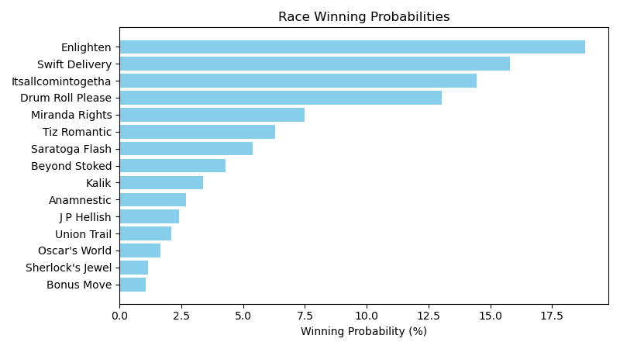

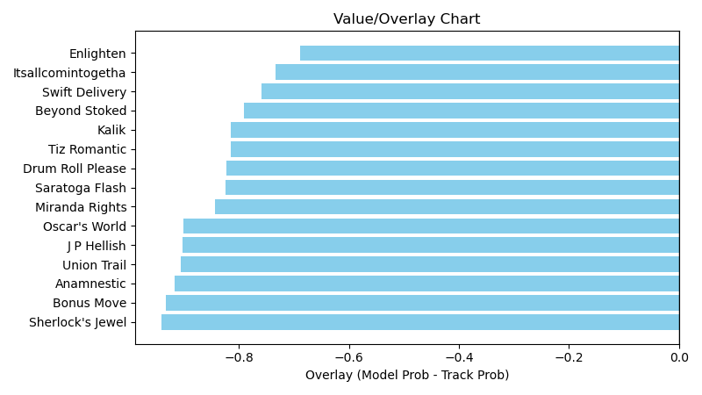

NOTE: GCSF - Global Combined Speed Figure

# Race: TGP | 2025-03-29 | Race #11 | Post: 16:40 | Track: GULFSTREAM PARK

Track: GULFSTREAM PARK

|  |  |  |  |  |  |
| --- | --- | --- | --- | --- | --- |
| Program # | Horse Name | Morn Odds | GCSF | Model Score | Win Prob (%) |
| 1 | Howgreatisnate | 10-1 | 88.4 | 1.45 | 13.82 |
| 2 | Loco Abarrio | 20-1 | 95.0 | 1.30 | 8.10 |
| 3 | Implementation | 9-2 | 107.6 | 1.49 | 16.11 |
| 4 | Knightsbridge | 9-5 | 93.4 | 1.22 | 5.83 |
| 5 | Gordian Knot | 6-1 | 102.9 | 1.62 | 24.72 |
| 6 | Of a Revolution | 10-1 | 112.0 | 1.03 | 2.44 |
| 7 | Great Navigator | 30-1 | 97.7 | 1.23 | 6.16 |
| 8 | Inveigled | 7-2 | 89.0 | 1.39 | 11.43 |
| 9 | Playmea Tune | 8-1 | 96.3 | 1.15 | 4.30 |
| 10 | Going Up | 30-1 | 115.2 | 1.27 | 7.10 |

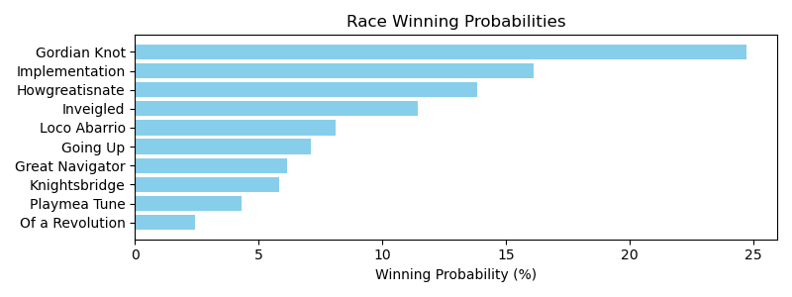

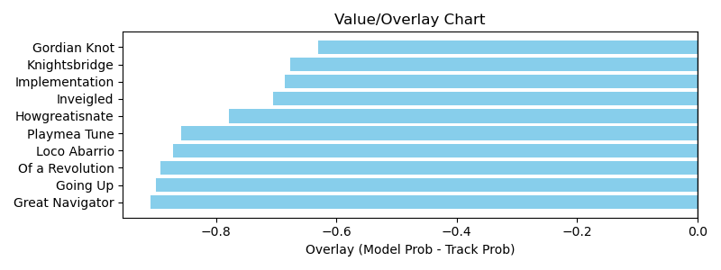

NOTE: GCSF - Global Combined Speed Figure

# Race: TGP | 2025-03-29 | Race #13 | Post: 17:57 | Track: GULFSTREAM PARK

Track: GULFSTREAM PARK

|  |  |  |  |  |  |
| --- | --- | --- | --- | --- | --- |
| Program # | Horse Name | Morn Odds | GCSF | Model Score | Win Prob (%) |
| 1 | Axthelm | 15-1 | 115.5 | 1.04 | 1.78 |
| 2 | Fly the W | 20-1 | 80.5 | 1.47 | 10.35 |
| 3 | Doctor Jeff | 30-1 | 117.5 | 1.47 | 10.34 |
| 4 | Portofino | 15-1 | 114.3 | 1.35 | 6.58 |
| 5 | Ruse | 20-1 | 93.2 | 1.12 | 2.60 |
| 6 | Abrumar | 4-1 | 93.8 | 1.72 | 23.10 |
| 7 | Seminole Chief | 8-1 | 97.8 | 1.10 | 2.38 |
| 8 | Brawn | 30-1 | 94.4 | 0.97 | 1.23 |
| 9 | Major Dude | 7-5 | 90.0 | 1.77 | 26.92 |
| 10 | Skyro | 15-1 | 92.9 | 1.28 | 5.16 |
| 11 | Ice Chocolat (BRZ) | 7-2 | 90.9 | 1.45 | 9.56 |

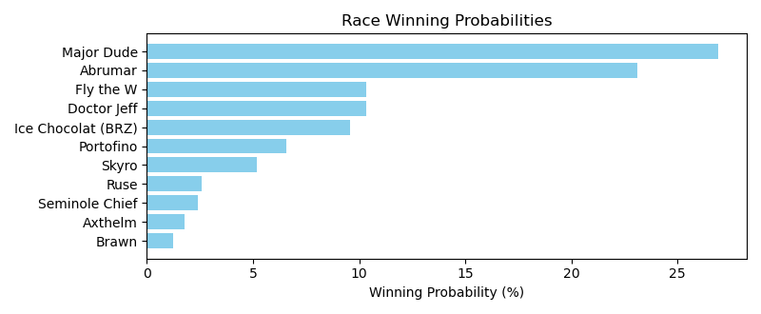

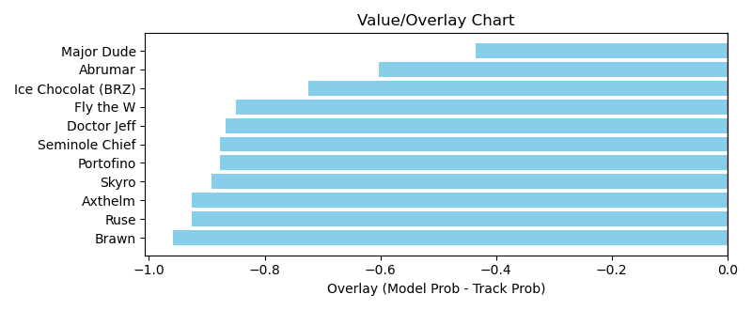

NOTE: GCSF - Global Combined Speed Figure

# Race: HAW | 2025-03-30 | Race #1 | Post: 14:40 | Track: HAWTHORNE

Track: HAWTHORNE

|  |  |  |  |  |  |
| --- | --- | --- | --- | --- | --- |
| Program # | Horse Name | Morn Odds | GCSF | Model Score | Win Prob (%) |
| 2 | Dixie Penny | 13-8 | 95.2 | 1.16 | 44.55 |
| 4 | Blazingly | 5-1 | 88.8 | 1.21 | 55.45 |

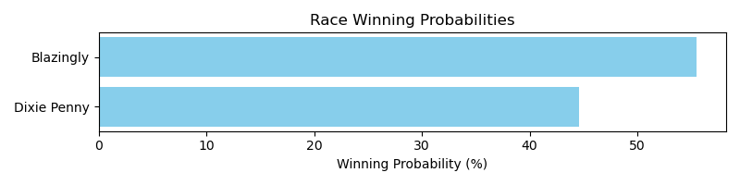

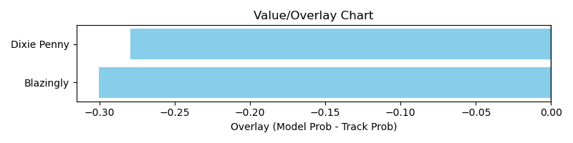

NOTE: GCSF - Global Combined Speed Figure

# Race: HAW | 2025-03-30 | Race #2 | Post: 15:05 | Track: HAWTHORNE

Track: HAWTHORNE

|  |  |  |  |  |  |
| --- | --- | --- | --- | --- | --- |
| Program # | Horse Name | Morn Odds | GCSF | Model Score | Win Prob (%) |
| 1 | Enticing Option | 12-1 | 93.4 | 0.89 | 35.16 |
| 2 | Golden Note | 3-1 | 100.5 | 0.92 | 42.55 |
| 5 | Illy Simz | 9-5 | 106.6 | 0.71 | 11.15 |
| 6 | Last Gasp | 5-2 | 110.6 | 0.71 | 11.14 |

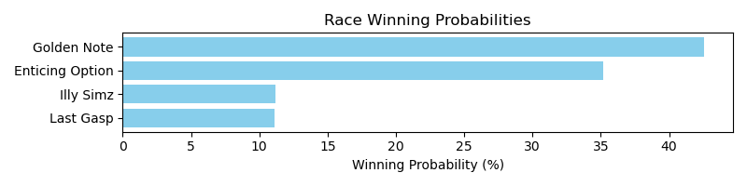

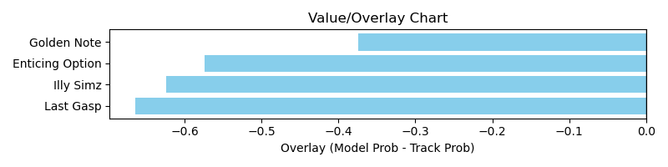

NOTE: GCSF - Global Combined Speed Figure

# Race: HAW | 2025-03-30 | Race #3 | Post: 15:30 | Track: HAWTHORNE

Track: HAWTHORNE

|  |  |  |  |  |  |
| --- | --- | --- | --- | --- | --- |
| Program # | Horse Name | Morn Odds | GCSF | Model Score | Win Prob (%) |
| 3 | Bigfoot Sighting | 4-1 | 105.0 | 1.56 | 89.08 |
| 6 | Red Rizzler | 7-2 | 95.3 | 1.03 | 10.92 |

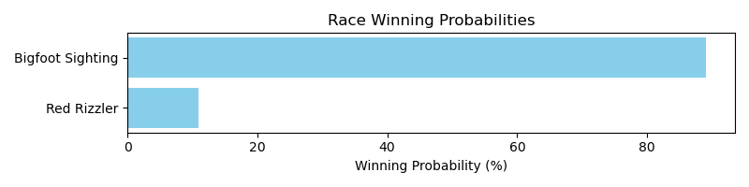

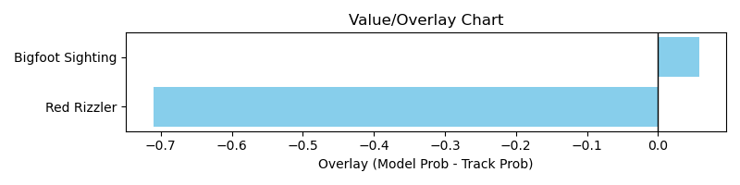

NOTE: GCSF - Global Combined Speed Figure

# Race: HAW | 2025-03-30 | Race #4 | Post: 15:55 | Track: HAWTHORNE

Track: HAWTHORNE

|  |  |  |  |  |  |
| --- | --- | --- | --- | --- | --- |
| Program # | Horse Name | Morn Odds | GCSF | Model Score | Win Prob (%) |
| 2 | General Issue (FR) | 5-1 | 92.2 | 1.13 | 20.55 |
| 3 | City of Clouds | 9-2 | 98.2 | 1.24 | 32.09 |
| 7 | King Anthony | 9-5 | 111.3 | 1.33 | 47.36 |

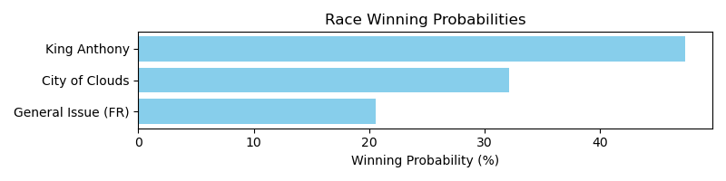

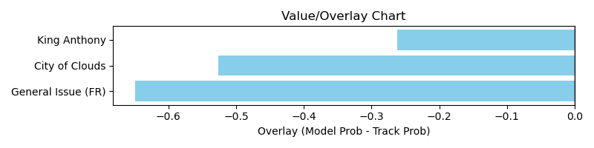

NOTE: GCSF - Global Combined Speed Figure

# Race: HAW | 2025-03-30 | Race #5 | Post: 16:21 | Track: HAWTHORNE

Track: HAWTHORNE

|  |  |  |  |  |  |
| --- | --- | --- | --- | --- | --- |
| Program # | Horse Name | Morn Odds | GCSF | Model Score | Win Prob (%) |
| 3 | Queen Anna T | 5-2 | 97.9 | 1.47 | 72.79 |
| 5 | Anna After Midnite | 10-1 | 91.0 | 0.96 | 8.11 |
| 6 | Echo Dreamer | 6-1 | 87.2 | 0.94 | 7.12 |
| 7 | Grace Candy | 3-1 | 98.0 | 1.04 | 11.97 |

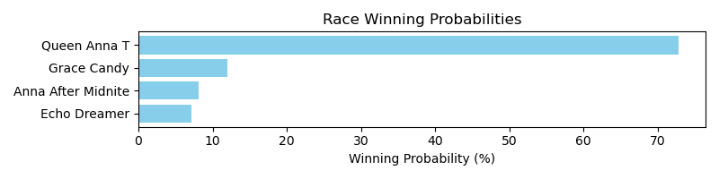

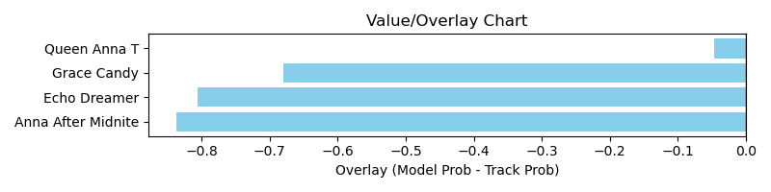

NOTE: GCSF - Global Combined Speed Figure

# Race: HAW | 2025-03-30 | Race #6 | Post: 16:47 | Track: HAWTHORNE

Track: HAWTHORNE

|  |  |  |  |  |  |
| --- | --- | --- | --- | --- | --- |
| Program # | Horse Name | Morn Odds | GCSF | Model Score | Win Prob (%) |
| 2 | Uptown Tom | 9-2 | 103.9 | 0.87 | 17.67 |
| 3 | Mischief Exposed | 7-2 | 92.5 | 0.86 | 16.80 |
| 6 | Ultimate Fighter | 6-1 | 92.1 | 0.89 | 20.52 |
| 7 | Tie Breaker Lennie | 9-5 | 97.0 | 1.04 | 45.02 |

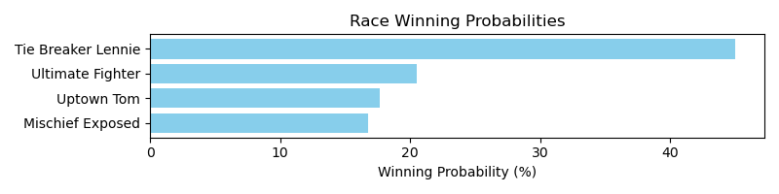

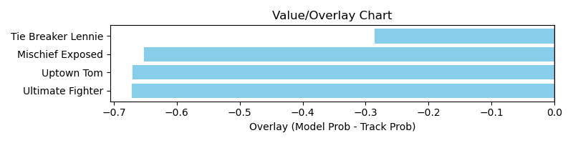

NOTE: GCSF - Global Combined Speed Figure

# Race: HAW | 2025-03-30 | Race #7 | Post: 17:13 | Track: HAWTHORNE

Track: HAWTHORNE

|  |  |  |  |  |  |
| --- | --- | --- | --- | --- | --- |
| Program # | Horse Name | Morn Odds | GCSF | Model Score | Win Prob (%) |
| 1 | Danville | 9-2 | 91.7 | 1.44 | 35.60 |
| 2 | Devils Red | 10-1 | 108.1 | 1.29 | 19.85 |
| 3 | Vanisky | 12-1 | 98.8 | 1.10 | 8.76 |
| 5 | Land Mark Deal | 8-1 | 95.4 | 1.29 | 19.67 |
| 9 | Gita's Lad | 7-2 | 92.2 | 1.24 | 16.13 |

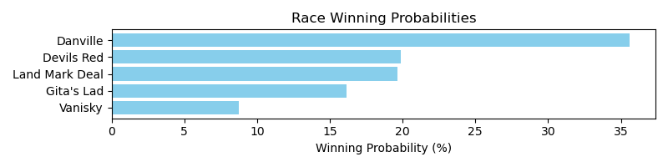

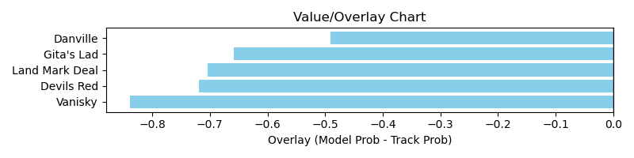

NOTE: GCSF - Global Combined Speed Figure

# Race: TCT | 2025-03-28 | Race #1 | Post: 19:00 | Track: HOLLYWOOD CASINO AT CHARLES TOWN RACES

Track: HOLLYWOOD CASINO AT CHARLES TOWN RACES

|  |  |  |  |  |  |
| --- | --- | --- | --- | --- | --- |
| Program # | Horse Name | Morn Odds | GCSF | Model Score | Win Prob (%) |
| 4 | Bull Rider | 6-1 | 88.8 | 0.99 | 31.26 |
| 8 | Destin's Rainbow | 2-1 | 108.7 | 1.15 | 68.74 |

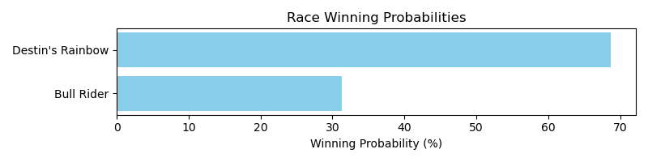

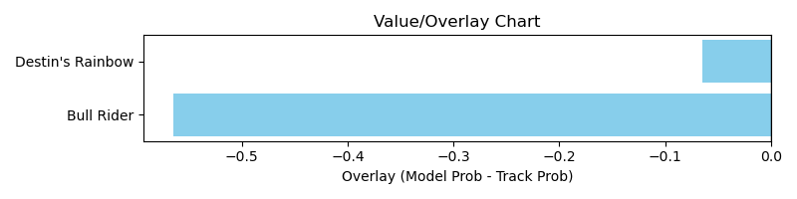

NOTE: GCSF - Global Combined Speed Figure

# Race: TCT | 2025-03-28 | Race #2 | Post: 19:32 | Track: HOLLYWOOD CASINO AT CHARLES TOWN RACES

Track: HOLLYWOOD CASINO AT CHARLES TOWN RACES

|  |  |  |  |  |  |
| --- | --- | --- | --- | --- | --- |
| Program # | Horse Name | Morn Odds | GCSF | Model Score | Win Prob (%) |
| 7 | Dream Force | 4-1 | 106.5 | 1.31 | 51.93 |
| 8 | Head Lad | 5-1 | 97.3 | 1.29 | 48.07 |

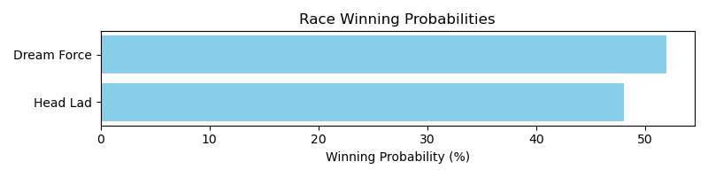

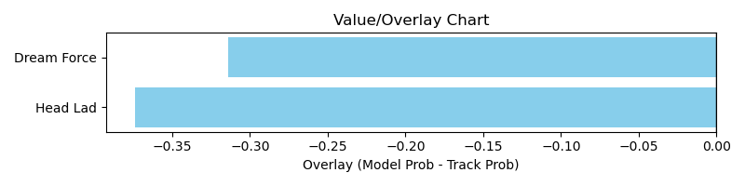

NOTE: GCSF - Global Combined Speed Figure

# Race: TCT | 2025-03-28 | Race #3 | Post: 20:02 | Track: HOLLYWOOD CASINO AT CHARLES TOWN RACES

Track: HOLLYWOOD CASINO AT CHARLES TOWN RACES

|  |  |  |  |  |  |
| --- | --- | --- | --- | --- | --- |
| Program # | Horse Name | Morn Odds | GCSF | Model Score | Win Prob (%) |
| 4 | Upswell | 9-2 | 121.8 | 1.06 | 44.46 |
| 6 | Congress Hall | 15-1 | 88.6 | 0.99 | 32.36 |
| 10 | Matoula | 15-1 | 99.3 | 0.93 | 23.18 |

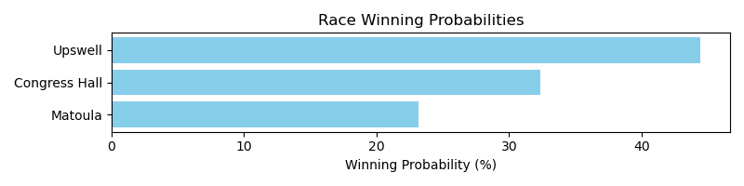

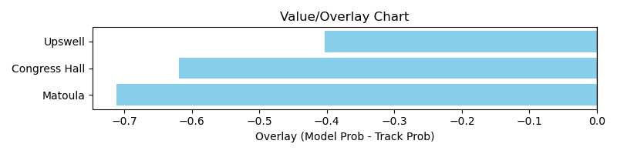

NOTE: GCSF - Global Combined Speed Figure

# Race: TCT | 2025-03-28 | Race #5 | Post: 21:02 | Track: HOLLYWOOD CASINO AT CHARLES TOWN RACES

Track: HOLLYWOOD CASINO AT CHARLES TOWN RACES

|  |  |  |  |  |  |
| --- | --- | --- | --- | --- | --- |
| Program # | Horse Name | Morn Odds | GCSF | Model Score | Win Prob (%) |
| 1 | Will Or Won't | 3-1 | 92.2 | 0.93 | 13.81 |
| 2 | Cora's Choice | 6-1 | 107.8 | 1.14 | 37.73 |
| 3 | Thencomemorning | 15-1 | 99.0 | 1.00 | 19.23 |
| 4 | Fancy Princess | 4-1 | 97.3 | 1.08 | 29.23 |

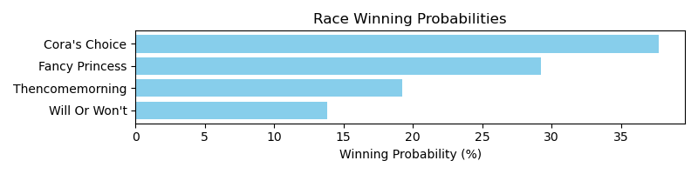

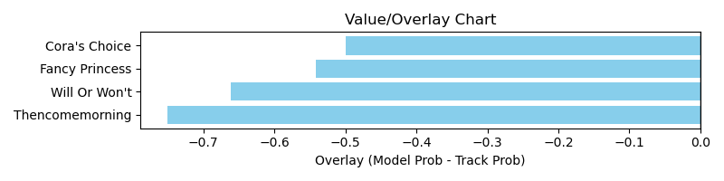

NOTE: GCSF - Global Combined Speed Figure

# Race: TCT | 2025-03-28 | Race #7 | Post: 22:02 | Track: HOLLYWOOD CASINO AT CHARLES TOWN RACES

Track: HOLLYWOOD CASINO AT CHARLES TOWN RACES

|  |  |  |  |  |  |
| --- | --- | --- | --- | --- | --- |
| Program # | Horse Name | Morn Odds | GCSF | Model Score | Win Prob (%) |
| 7 | Nico | 7-2 | 100.1 | 1.26 | 100.00 |

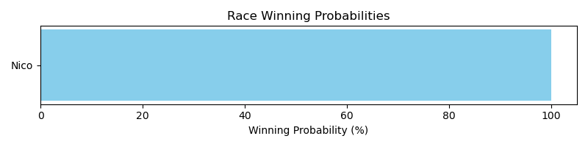

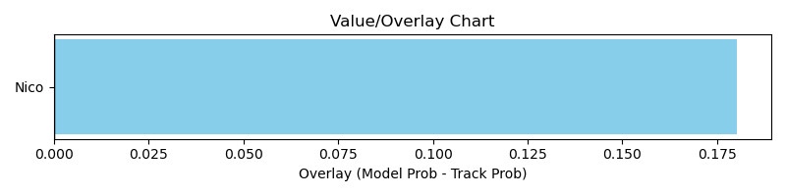

NOTE: GCSF - Global Combined Speed Figure

# Race: TCT | 2025-03-28 | Race #8 | Post: 22:32 | Track: HOLLYWOOD CASINO AT CHARLES TOWN RACES

Track: HOLLYWOOD CASINO AT CHARLES TOWN RACES

|  |  |  |  |  |  |
| --- | --- | --- | --- | --- | --- |
| Program # | Horse Name | Morn Odds | GCSF | Model Score | Win Prob (%) |
| 1 | Brewmaster | 10-1 | 106.6 | 0.94 | 7.45 |
| 2 | Costner | 5-1 | 88.3 | 1.30 | 39.12 |
| 5 | Fast Lane | 8-1 | 110.9 | 0.80 | 3.17 |
| 7 | Galactic Glory | 4-1 | 101.5 | 0.81 | 3.48 |
| 8 | Secret Soulmate | 30-1 | 97.1 | 0.67 | 1.28 |
| 9 | Cuchulain | 6-1 | 109.6 | 0.74 | 2.13 |
| 10 | Candy Corn | 7-2 | 94.5 | 1.31 | 41.40 |
| 11 | Scott Twentytwo | 10-1 | 106.5 | 0.73 | 1.96 |

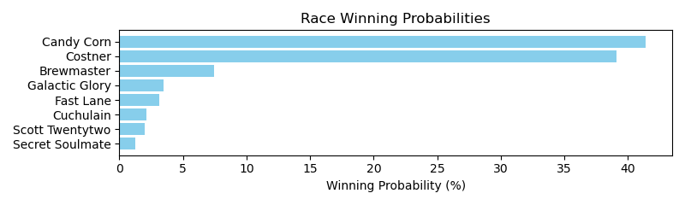

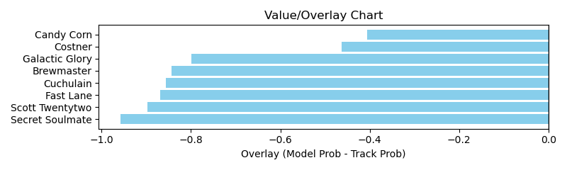

NOTE: GCSF - Global Combined Speed Figure

# Race: TCT | 2025-03-29 | Race #1 | Post: 19:00 | Track: HOLLYWOOD CASINO AT CHARLES TOWN RACES

Track: HOLLYWOOD CASINO AT CHARLES TOWN RACES

|  |  |  |  |  |  |
| --- | --- | --- | --- | --- | --- |
| Program # | Horse Name | Morn Odds | GCSF | Model Score | Win Prob (%) |
| 2 | Inferno | 20-1 | 98.7 | 0.59 | 6.12 |
| 3 | Sunshine Hazel | 6-5 | 100.0 | 0.94 | 67.73 |
| 5 | Florina | 3-1 | 92.3 | 0.78 | 26.15 |

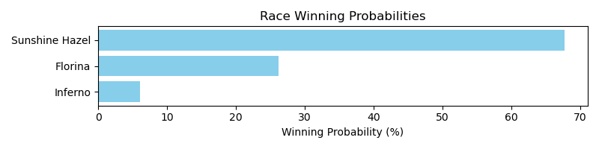

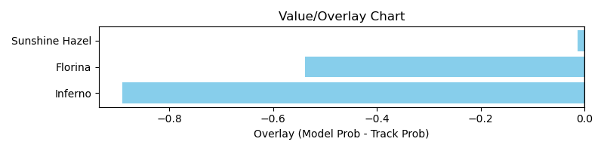

NOTE: GCSF - Global Combined Speed Figure

# Race: TCT | 2025-03-29 | Race #3 | Post: 20:02 | Track: HOLLYWOOD CASINO AT CHARLES TOWN RACES

Track: HOLLYWOOD CASINO AT CHARLES TOWN RACES

|  |  |  |  |  |  |
| --- | --- | --- | --- | --- | --- |
| Program # | Horse Name | Morn Odds | GCSF | Model Score | Win Prob (%) |
| 1 | Extra Dirty | 20-1 | 89.2 | 0.95 | 13.49 |
| 2 | Here's Gracie | 5-1 | 89.0 | 1.17 | 39.75 |
| 4 | Balala | 10-1 | 105.0 | 0.93 | 12.25 |
| 5 | Millie Jean | 9-5 | 100.9 | 1.14 | 34.51 |

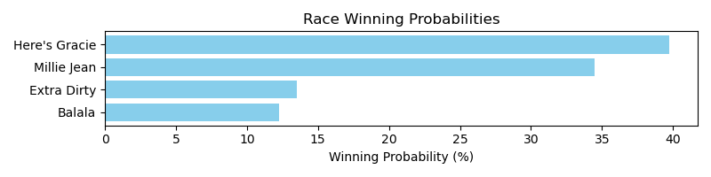

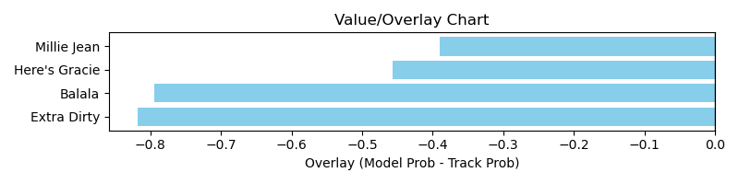

NOTE: GCSF - Global Combined Speed Figure

# Race: TCT | 2025-03-29 | Race #4 | Post: 20:32 | Track: HOLLYWOOD CASINO AT CHARLES TOWN RACES

Track: HOLLYWOOD CASINO AT CHARLES TOWN RACES

|  |  |  |  |  |  |
| --- | --- | --- | --- | --- | --- |
| Program # | Horse Name | Morn Odds | GCSF | Model Score | Win Prob (%) |
| 4 | Tino in Toga | 15-1 | 108.6 | 0.94 | 13.28 |
| 5 | Bee a Sky Beam | 5-8 | 98.0 | 1.22 | 51.44 |
| 7 | Annointed | 15-1 | 99.1 | 1.09 | 29.37 |
| 8 | Iron Tap | 5-1 | 97.3 | 0.80 | 5.91 |

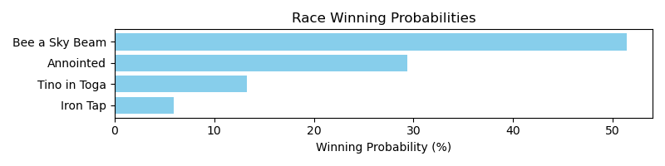

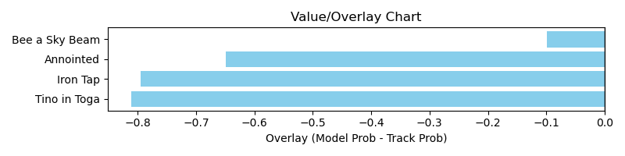

NOTE: GCSF - Global Combined Speed Figure

# Race: TCT | 2025-03-29 | Race #5 | Post: 21:02 | Track: HOLLYWOOD CASINO AT CHARLES TOWN RACES

Track: HOLLYWOOD CASINO AT CHARLES TOWN RACES

|  |  |  |  |  |  |
| --- | --- | --- | --- | --- | --- |
| Program # | Horse Name | Morn Odds | GCSF | Model Score | Win Prob (%) |
| 6 | Golden Girl Lena | 6-1 | 94.1 | 0.98 | 20.66 |
| 8 | Joyful Kitten | 2-1 | 110.9 | 1.28 | 79.34 |

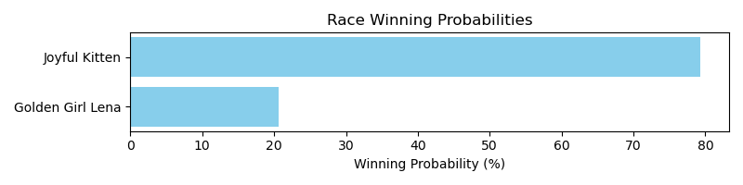

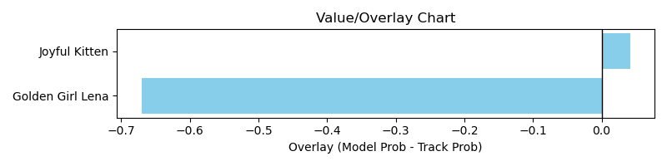

NOTE: GCSF - Global Combined Speed Figure

# Race: TCT | 2025-03-29 | Race #6 | Post: 21:32 | Track: HOLLYWOOD CASINO AT CHARLES TOWN RACES

Track: HOLLYWOOD CASINO AT CHARLES TOWN RACES

|  |  |  |  |  |  |
| --- | --- | --- | --- | --- | --- |
| Program # | Horse Name | Morn Odds | GCSF | Model Score | Win Prob (%) |
| 2 | Funny She Fired Me | 10-1 | 105.4 | 1.03 | 50.54 |
| 4 | Saturn's Ghost | 8-1 | 112.6 | 0.82 | 15.04 |
| 6 | Tia Mayin | 10-1 | 92.5 | 0.80 | 13.19 |
| 9 | Centimorgan | 2-1 | 102.9 | 0.87 | 21.23 |

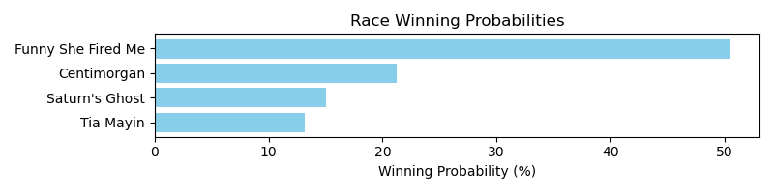

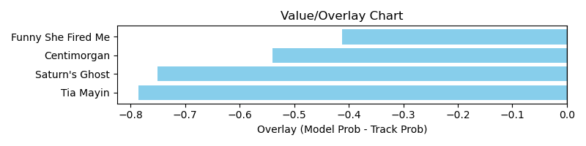

NOTE: GCSF - Global Combined Speed Figure

# Race: TCT | 2025-03-29 | Race #7 | Post: 22:02 | Track: HOLLYWOOD CASINO AT CHARLES TOWN RACES

Track: HOLLYWOOD CASINO AT CHARLES TOWN RACES

|  |  |  |  |  |  |
| --- | --- | --- | --- | --- | --- |
| Program # | Horse Name | Morn Odds | GCSF | Model Score | Win Prob (%) |
| 1 | True Blue Pearl | 12-1 | 90.8 | 1.17 | 81.77 |
| 7 | Make It a Double | 12-1 | 124.6 | 0.88 | 18.23 |

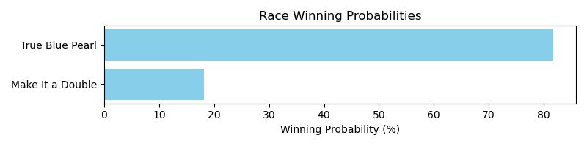

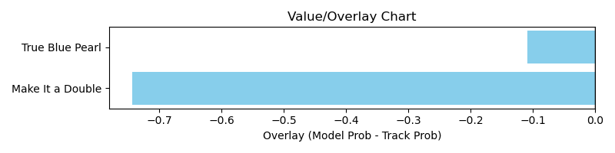

NOTE: GCSF - Global Combined Speed Figure

# Race: TCT | 2025-03-29 | Race #8 | Post: 22:32 | Track: HOLLYWOOD CASINO AT CHARLES TOWN RACES

Track: HOLLYWOOD CASINO AT CHARLES TOWN RACES

|  |  |  |  |  |  |
| --- | --- | --- | --- | --- | --- |
| Program # | Horse Name | Morn Odds | GCSF | Model Score | Win Prob (%) |
| 8 | Hushion | 20-1 | 93.2 | 0.92 | 100.00 |

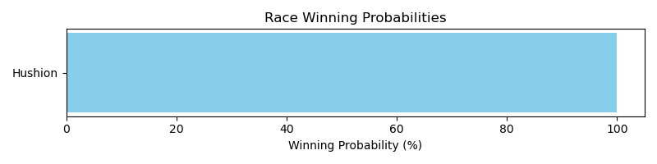

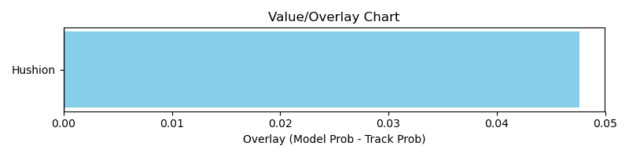

NOTE: GCSF - Global Combined Speed Figure

# Race: TCT | 2025-03-29 | Race #9 | Post: 23:02 | Track: HOLLYWOOD CASINO AT CHARLES TOWN RACES

Track: HOLLYWOOD CASINO AT CHARLES TOWN RACES

|  |  |  |  |  |  |
| --- | --- | --- | --- | --- | --- |
| Program # | Horse Name | Morn Odds | GCSF | Model Score | Win Prob (%) |
| 2 | Honey B B | 10-1 | 95.4 | 0.93 | 100.00 |

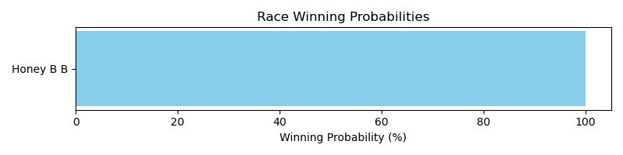

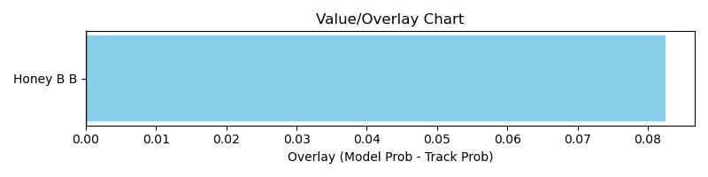

NOTE: GCSF - Global Combined Speed Figure

# Race: LRL | 2025-03-28 | Race #1 | Post: 12:10 | Track: LAUREL PARK

Track: LAUREL PARK

|  |  |  |  |  |  |
| --- | --- | --- | --- | --- | --- |
| Program # | Horse Name | Morn Odds | GCSF | Model Score | Win Prob (%) |
| 1 | Mister Lincoln | 13-8 | 97.6 | 1.11 | 7.40 |
| 1A | J J Valentin | 13-8 | 104.0 | 1.31 | 17.75 |
| 2 | Irish Nitro | 20-1 | 106.6 | 0.74 | 0.95 |
| 3 | Twice Gold | 12-1 | 90.6 | 0.94 | 3.26 |
| 4 | Betta Go Go Go | 6-1 | 98.7 | 1.28 | 15.91 |
| 5 | Gatto Be Proud | 8-1 | 93.9 | 1.22 | 12.44 |
| 6 | Medagooch | 9-2 | 118.5 | 1.31 | 17.68 |
| 7 | Bold Ambition | 2-1 | 89.9 | 1.40 | 24.61 |

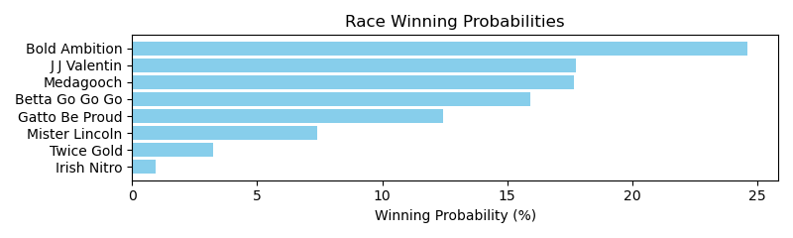

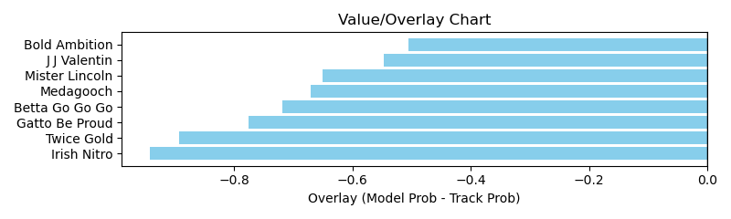

NOTE: GCSF - Global Combined Speed Figure

# Race: LRL | 2025-03-28 | Race #2 | Post: 12:42 | Track: LAUREL PARK

Track: LAUREL PARK

|  |  |  |  |  |  |
| --- | --- | --- | --- | --- | --- |
| Program # | Horse Name | Morn Odds | GCSF | Model Score | Win Prob (%) |
| 1 | Peyton Elizabeth | 6-5 | 95.5 | 1.26 | 8.75 |
| 2 | dq-Royal Whisper | 3-1 | 93.3 | 1.49 | 20.59 |
| 3 | Divine Grace | 5-2 | 88.9 | 1.08 | 4.00 |
| 4 | Next Episode | 10-1 | 94.8 | 1.17 | 5.89 |
| 5 | Skip Thru Da Fire | 12-1 | 113.3 | 1.03 | 3.05 |
| 6 | Isabella's Glory | 8-1 | 110.6 | 1.82 | 57.71 |

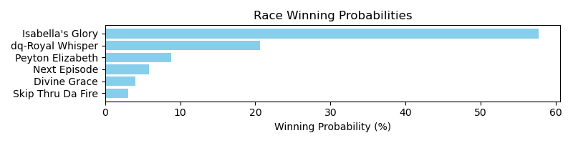

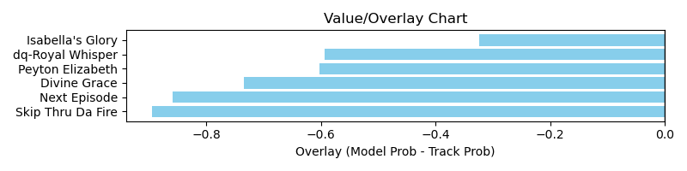

NOTE: GCSF - Global Combined Speed Figure

# Race: LRL | 2025-03-28 | Race #4 | Post: 13:47 | Track: LAUREL PARK

Track: LAUREL PARK

|  |  |  |  |  |  |
| --- | --- | --- | --- | --- | --- |
| Program # | Horse Name | Morn Odds | GCSF | Model Score | Win Prob (%) |
| 1 | Society Ball | 8-1 | 90.1 | 1.25 | 8.57 |
| 2 | Beachfront Breeze | 7-2 | 106.5 | 1.45 | 18.52 |
| 3 | Concrete Faze | 5-2 | 92.7 | 1.29 | 9.96 |
| 4 | Kilo Road | 6-1 | 102.0 | 1.39 | 14.87 |
| 5 | Just Great | 3-1 | 92.5 | 1.41 | 15.60 |
| 6 | Dwelling Legacy | 12-1 | 104.4 | 1.08 | 3.95 |
| 7 | Lady Sriracha | 9-2 | 112.6 | 1.58 | 28.53 |

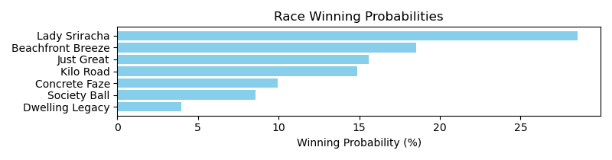

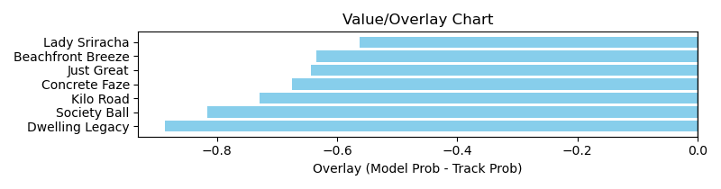

NOTE: GCSF - Global Combined Speed Figure

# Race: LRL | 2025-03-28 | Race #6 | Post: 14:53 | Track: LAUREL PARK

Track: LAUREL PARK

|  |  |  |  |  |  |
| --- | --- | --- | --- | --- | --- |
| Program # | Horse Name | Morn Odds | GCSF | Model Score | Win Prob (%) |
| 1 | Sneaking Suspicion | 6-1 | 97.4 | 0.96 | 4.60 |
| 2 | Silent Roar | 4-1 | 97.3 | 0.89 | 3.03 |
| 3 | Uncle Georgy | 20-1 | 105.1 | 0.78 | 1.57 |
| 4 | The Heights | 8-1 | 119.1 | 1.17 | 12.30 |
| 5 | Maximus Speed | 5-2 | 111.7 | 1.49 | 42.83 |
| 6 | Ifeelbadforyouson | 8-1 | 98.8 | 1.00 | 5.56 |
| 7 | Thedingoateyobaby | 9-2 | 99.1 | 1.14 | 11.18 |
| 8 | Long Astride | 10-1 | 113.1 | 0.95 | 4.20 |
| 9 | Return Fire | 12-1 | 95.5 | 1.10 | 9.08 |
| 10 | Tap Anchor | 15-1 | 88.0 | 1.00 | 5.65 |

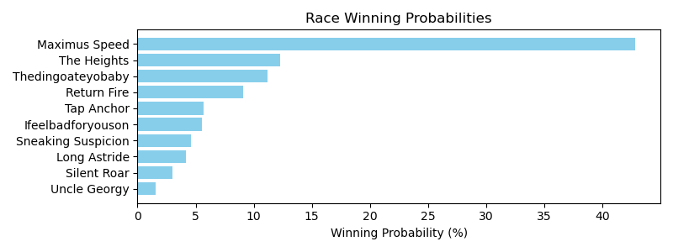

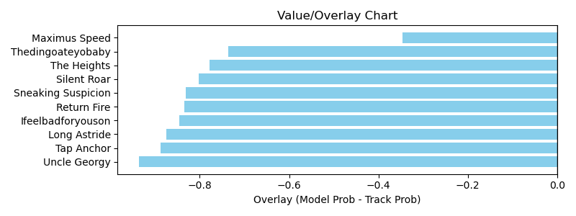

NOTE: GCSF - Global Combined Speed Figure

# Race: LRL | 2025-03-29 | Race #3 | Post: 13:05 | Track: LAUREL PARK

Track: LAUREL PARK

|  |  |  |  |  |  |
| --- | --- | --- | --- | --- | --- |
| Program # | Horse Name | Morn Odds | GCSF | Model Score | Win Prob (%) |
| 1 | Papa Funny | 4-1 | 99.4 | 0.84 | 4.04 |
| 2 | Get Like Mike | 15-1 | 103.5 | 0.86 | 4.56 |
| 3 | Ascendance | 8-1 | 99.3 | 1.13 | 18.67 |
| 4 | Admit Nothing | 5-1 | 93.9 | 1.00 | 9.84 |
| 5 | Run for Your Life | 7-2 | 94.4 | 1.28 | 35.22 |
| 6 | Forrest City | 2-1 | 112.2 | 1.11 | 16.79 |
| 7 | Earl of Dassel | 9-2 | 100.7 | 1.02 | 10.88 |

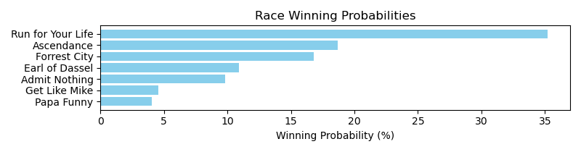

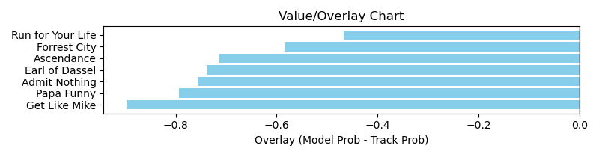

NOTE: GCSF - Global Combined Speed Figure

# Race: LRL | 2025-03-29 | Race #4 | Post: 13:35 | Track: LAUREL PARK

Track: LAUREL PARK

|  |  |  |  |  |  |
| --- | --- | --- | --- | --- | --- |
| Program # | Horse Name | Morn Odds | GCSF | Model Score | Win Prob (%) |
| 1 | Coringa | 7-2 | 94.5 | 1.85 | 36.53 |
| 2 | Magic Express | 13-8 | 103.2 | 1.92 | 44.17 |
| 3 | Laddie Dance | 8-1 | 120.4 | 1.03 | 1.86 |
| 4 | Three Captains | 15-1 | 96.8 | 1.22 | 4.36 |
| 5 | Bermuda Run | 12-1 | 94.3 | 0.90 | 0.89 |
| 6 | Swifty Devil | 6-1 | 108.5 | 1.23 | 4.46 |
| 7 | War Master | 5-2 | 86.1 | 1.37 | 7.74 |

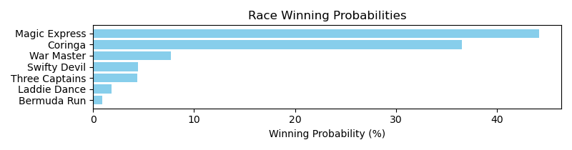

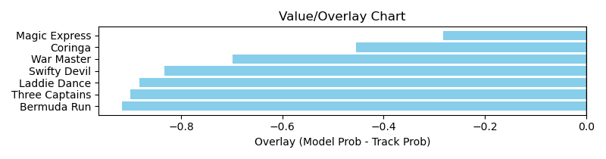

NOTE: GCSF - Global Combined Speed Figure

# Race: LRL | 2025-03-29 | Race #5 | Post: 14:07 | Track: LAUREL PARK

Track: LAUREL PARK

|  |  |  |  |  |  |
| --- | --- | --- | --- | --- | --- |
| Program # | Horse Name | Morn Odds | GCSF | Model Score | Win Prob (%) |
| 1 | Gerrys Gem | 7-2 | 94.6 | 1.20 | 7.11 |
| 2 | He's Orientate | 15-1 | 93.6 | 0.96 | 2.30 |
| 3 | Magic Spin | 6-1 | 89.1 | 0.97 | 2.41 |
| 4 | Full Irish | 2-1 | 97.8 | 1.83 | 61.71 |
| 5 | Whiskey and You | 8-1 | 98.2 | 1.28 | 9.78 |
| 6 | He's in Charge | 9-5 | 100.0 | 1.42 | 16.69 |

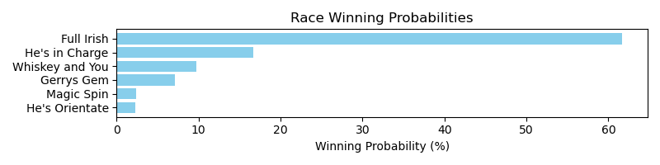

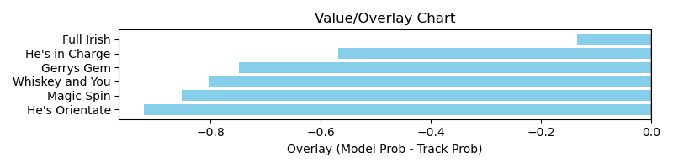

NOTE: GCSF - Global Combined Speed Figure

# Race: LRL | 2025-03-29 | Race #6 | Post: 14:38 | Track: LAUREL PARK

Track: LAUREL PARK

|  |  |  |  |  |  |
| --- | --- | --- | --- | --- | --- |
| Program # | Horse Name | Morn Odds | GCSF | Model Score | Win Prob (%) |
| 1 | Loose Goose | 10-1 | 92.5 | 1.01 | 3.18 |
| 2 | Alilnalot | 4-1 | 97.8 | 1.13 | 5.69 |
| 3 | Minister for Magic | 2-1 | 97.6 | 1.74 | 52.94 |
| 4 | Captain Cardo | 20-1 | 89.9 | 1.10 | 5.03 |
| 5 | Caerus | 15-1 | 108.5 | 0.88 | 1.56 |
| 6 | Cajun Dream | 8-1 | 107.6 | 1.30 | 11.53 |
| 7 | Midnight Renegade | 3-1 | 92.1 | 1.24 | 9.37 |
| 8 | Sumo | 9-2 | 109.5 | 1.28 | 10.71 |

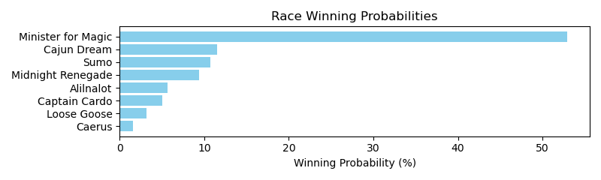

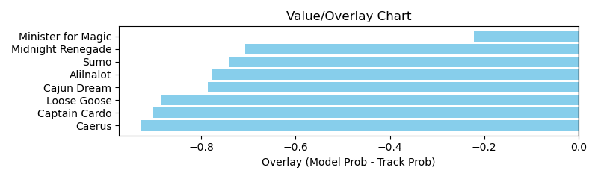

NOTE: GCSF - Global Combined Speed Figure

# Race: LRL | 2025-03-29 | Race #8 | Post: 15:46 | Track: LAUREL PARK

Track: LAUREL PARK

|  |  |  |  |  |  |
| --- | --- | --- | --- | --- | --- |
| Program # | Horse Name | Morn Odds | GCSF | Model Score | Win Prob (%) |
| 1 | Radical Right | 3-1 | 93.3 | 1.45 | 9.67 |
| 2 | Tenebris | 9-2 | 99.8 | 1.67 | 20.30 |
| 3 | Classic Joke | 6-1 | 103.7 | 1.24 | 4.42 |
| 4 | Don't Wait Up | 8-1 | 90.9 | 1.09 | 2.24 |
| 5 | S S Sinatra | 2-1 | 106.8 | 2.00 | 50.69 |
| 6 | Bouncer | 4-1 | 92.8 | 1.48 | 10.64 |
| 7 | Heaven's Got Fire | 20-1 | 98.6 | 1.07 | 2.05 |

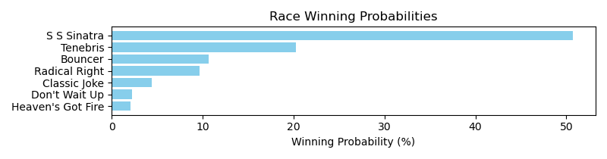

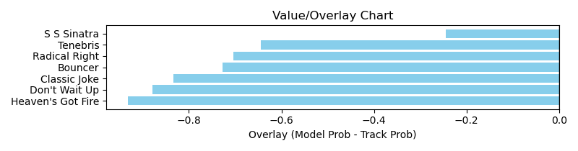

NOTE: GCSF - Global Combined Speed Figure

# Race: MVR | 2025-03-30 | Race #1 | Post: 12:15 | Track: MAHONING VALLEY RACE COURSE

Track: MAHONING VALLEY RACE COURSE

|  |  |  |  |  |  |
| --- | --- | --- | --- | --- | --- |
| Program # | Horse Name | Morn Odds | GCSF | Model Score | Win Prob (%) |
| 1 | Uncle's the Banker | 20-1 | 107.1 | 1.00 | 10.02 |
| 2 | One Red Cent | 4-1 | 100.8 | 0.99 | 9.45 |
| 3 | Notorious Sixohtwo | 5-2 | 95.6 | 1.19 | 24.58 |
| 4 | Zippin Gigi | 6-1 | 98.1 | 1.14 | 19.72 |
| 5 | Bailamos | 8-1 | 104.4 | 0.99 | 9.67 |
| 6 | Big Bucksalot | 6-5 | 98.9 | 1.21 | 26.55 |

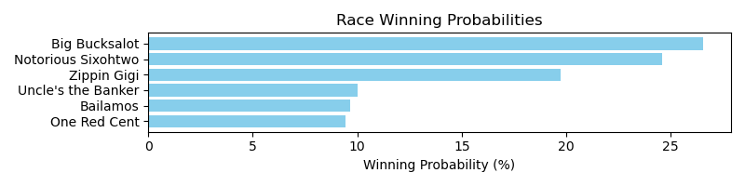

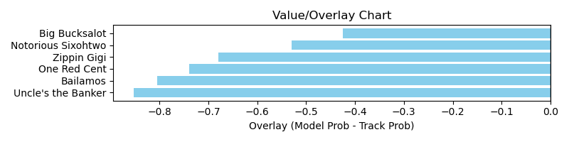

NOTE: GCSF - Global Combined Speed Figure

# Race: MVR | 2025-03-30 | Race #4 | Post: 13:39 | Track: MAHONING VALLEY RACE COURSE

Track: MAHONING VALLEY RACE COURSE

|  |  |  |  |  |  |
| --- | --- | --- | --- | --- | --- |
| Program # | Horse Name | Morn Odds | GCSF | Model Score | Win Prob (%) |
| 1 | American Hero | 3-1 | 101.3 | 1.36 | 24.92 |
| 2 | Torrefactor | 15-1 | 109.9 | 0.82 | 1.87 |
| 3 | Chaps Knight | 10-1 | 113.7 | 1.23 | 15.30 |
| 4 | Puff'smagicdragon | 2-1 | 111.1 | 1.19 | 12.63 |
| 5 | Arrebato | 4-1 | 95.8 | 1.19 | 12.66 |
| 6 | Ramsey | 5-2 | 103.8 | 1.38 | 27.00 |
| 7 | Color Me Legendary | 20-1 | 101.9 | 1.02 | 5.63 |

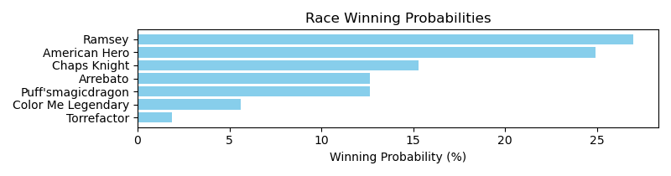

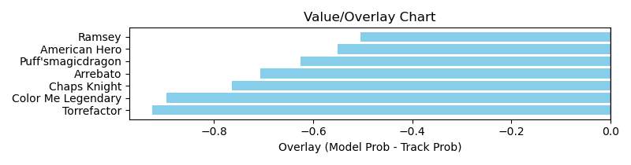

NOTE: GCSF - Global Combined Speed Figure

# Race: MVR | 2025-03-30 | Race #6 | Post: 14:35 | Track: MAHONING VALLEY RACE COURSE

Track: MAHONING VALLEY RACE COURSE

|  |  |  |  |  |  |
| --- | --- | --- | --- | --- | --- |
| Program # | Horse Name | Morn Odds | GCSF | Model Score | Win Prob (%) |
| 1 | Devra Warrior | 10-1 | 92.7 | 0.88 | 9.11 |
| 2 | Kaiyas Song | 6-1 | 109.9 | 0.83 | 6.91 |
| 3 | Redwhiteandtacos | 4-1 | 96.5 | 1.07 | 24.81 |
| 4 | Battle Tested | 7-2 | 100.5 | 0.97 | 15.03 |
| 5 | Torrey Street | 5-1 | 103.6 | 1.01 | 19.15 |
| 6 | Just Stay Home | 9-2 | 81.5 | 0.91 | 11.06 |
| 7 | Sacred Connection | 3-1 | 88.4 | 0.95 | 13.93 |

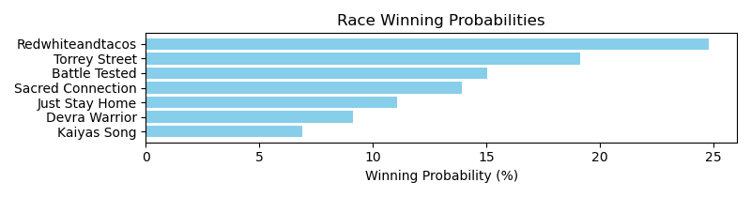

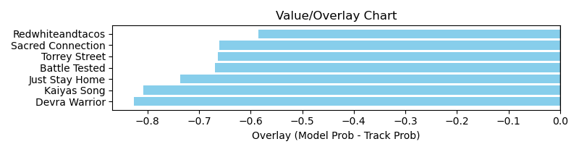

NOTE: GCSF - Global Combined Speed Figure

# Race: MVR | 2025-03-31 | Race #1 | Post: 12:15 | Track: MAHONING VALLEY RACE COURSE

Track: MAHONING VALLEY RACE COURSE

|  |  |  |  |  |  |
| --- | --- | --- | --- | --- | --- |
| Program # | Horse Name | Morn Odds | GCSF | Model Score | Win Prob (%) |
| 1 | Blazing Zenna | 20-1 | 91.0 | 1.20 | 17.13 |
| 2 | Secret Seduction | 8-1 | 107.7 | 0.83 | 2.56 |
| 3 | Girl Bye | 5-2 | 115.7 | 1.36 | 32.91 |
| 4 | Big Java | 15-1 | 95.3 | 1.06 | 9.21 |
| 5 | Hot Carol | 5-1 | 113.2 | 1.10 | 11.12 |
| 6 | Constitutionalist | 4-5 | 93.2 | 1.31 | 27.07 |

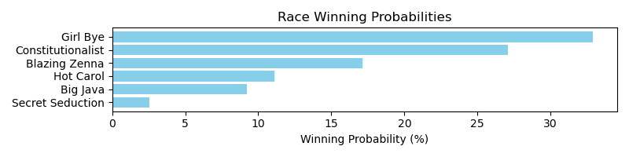

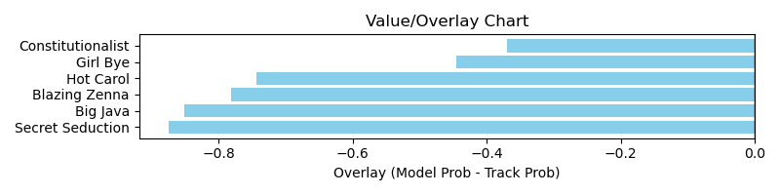

NOTE: GCSF - Global Combined Speed Figure

# Race: MVR | 2025-03-31 | Race #2 | Post: 12:43 | Track: MAHONING VALLEY RACE COURSE

Track: MAHONING VALLEY RACE COURSE

|  |  |  |  |  |  |
| --- | --- | --- | --- | --- | --- |
| Program # | Horse Name | Morn Odds | GCSF | Model Score | Win Prob (%) |
| 1 | Scratchoff | 6-1 | 109.9 | 1.44 | 26.25 |
| 2 | dq-Monterey Peninsula | 4-5 | 106.8 | 1.39 | 22.34 |
| 3 | Jareth | 5-1 | 90.3 | 1.39 | 22.30 |
| 4 | Kosciuszko | 6-1 | 108.6 | 1.14 | 7.99 |
| 5 | Nosey Power | 20-1 | 88.8 | 0.87 | 2.03 |
| 6 | Charger | 7-2 | 96.1 | 1.35 | 19.09 |

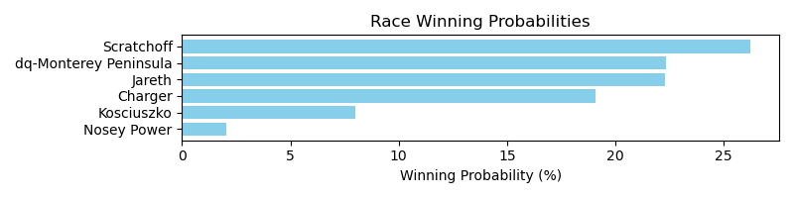

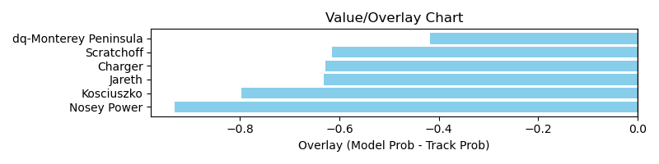

NOTE: GCSF - Global Combined Speed Figure

# Race: MVR | 2025-03-31 | Race #4 | Post: 13:39 | Track: MAHONING VALLEY RACE COURSE

Track: MAHONING VALLEY RACE COURSE

|  |  |  |  |  |  |
| --- | --- | --- | --- | --- | --- |
| Program # | Horse Name | Morn Odds | GCSF | Model Score | Win Prob (%) |
| 1 | Yehawmemaw | 15-1 | 103.0 | 0.71 | 1.63 |
| 2 | Beatiful Karla | 3-1 | 103.1 | 1.02 | 10.23 |
| 3 | Grace and Glory | 7-2 | 105.8 | 1.13 | 17.07 |
| 4 | Alter the Stars | 12-1 | 103.1 | 0.95 | 7.31 |
| 5 | Pacific View | 2-1 | 87.3 | 1.15 | 18.96 |
| 6 | Kantbackoff | 9-2 | 101.6 | 1.09 | 14.65 |
| 7 | Living in Style | 6-1 | 100.2 | 1.26 | 30.15 |

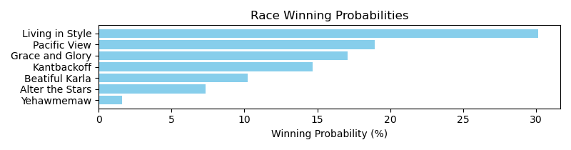

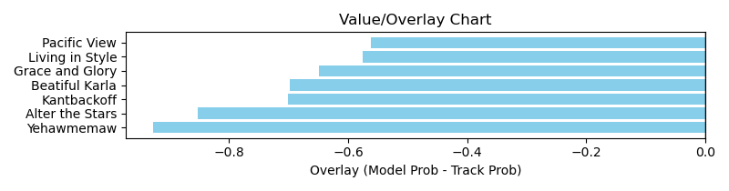

NOTE: GCSF - Global Combined Speed Figure

# Race: MVR | 2025-04-01 | Race #4 | Post: 13:39 | Track: MAHONING VALLEY RACE COURSE

Track: MAHONING VALLEY RACE COURSE

|  |  |  |  |  |  |
| --- | --- | --- | --- | --- | --- |
| Program # | Horse Name | Morn Odds | GCSF | Model Score | Win Prob (%) |
| 1 | Magic Palace | 12-1 | 92.4 | 1.10 | 5.35 |
| 2 | Yoga Queen | 5-1 | 98.8 | 1.09 | 5.16 |
| 3 | Honey Bella | 9-5 | 99.6 | 1.52 | 28.89 |
| 4 | Loaded Once More | 13-8 | 97.3 | 1.71 | 53.27 |
| 5 | Larimar | 3-1 | 101.0 | 1.16 | 7.32 |

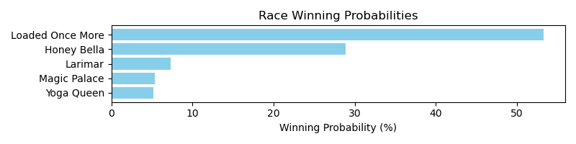

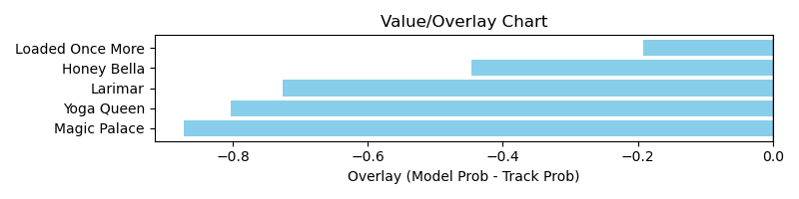

NOTE: GCSF - Global Combined Speed Figure

# Race: MVR | 2025-04-01 | Race #6 | Post: 14:35 | Track: MAHONING VALLEY RACE COURSE

Track: MAHONING VALLEY RACE COURSE

|  |  |  |  |  |  |
| --- | --- | --- | --- | --- | --- |
| Program # | Horse Name | Morn Odds | GCSF | Model Score | Win Prob (%) |
| 1 | Sage Runner | 10-1 | 94.9 | 0.90 | 6.56 |
| 2 | Capture Mi | 5-1 | 102.4 | 1.13 | 21.08 |
| 3 | Time the Avenger | 3-1 | 96.2 | 0.93 | 7.72 |
| 4 | Don't Stop | 2-1 | 99.3 | 0.94 | 8.16 |
| 5 | Run for Reagan | 5-2 | 93.9 | 1.10 | 18.32 |
| 6 | A Bit of Captain | 8-1 | 107.4 | 0.98 | 10.19 |
| 7 | Mexitexafornia | 12-1 | 96.4 | 1.19 | 27.98 |

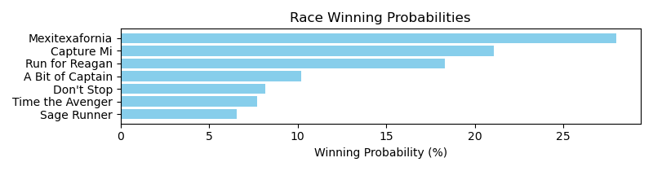

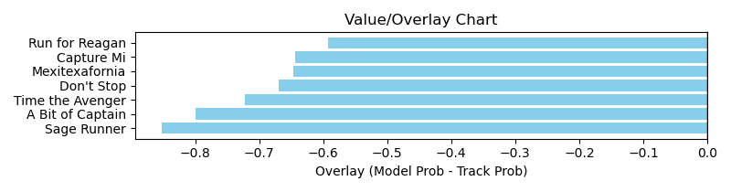

NOTE: GCSF - Global Combined Speed Figure

# Race: TOP | 2025-03-28 | Race #2 | Post: 13:00 | Track: OAKLAWN PARK

Track: OAKLAWN PARK

|  |  |  |  |  |  |
| --- | --- | --- | --- | --- | --- |
| Program # | Horse Name | Morn Odds | GCSF | Model Score | Win Prob (%) |
| 1 | Evocation | 6-5 | 91.0 | 1.13 | 21.38 |
| 2 | Ifuaintfirsturlast | 8-1 | 95.5 | 0.87 | 5.64 |
| 3 | Grace Given | 6-1 | 93.1 | 0.92 | 7.33 |
| 4 | Bump in the Night | 15-1 | 112.9 | 0.93 | 7.70 |
| 5 | Miss Analyzed | 30-1 | 113.3 | 0.84 | 4.63 |
| 6 | Blue Ember | 15-1 | 96.6 | 0.91 | 6.95 |
| 7 | Kara | 7-2 | 84.0 | 1.20 | 28.58 |
| 8 | Cosmic Chic | 12-1 | 118.4 | 0.80 | 3.66 |
| 9 | Yes to Champagne | 8-1 | 119.5 | 1.04 | 14.12 |

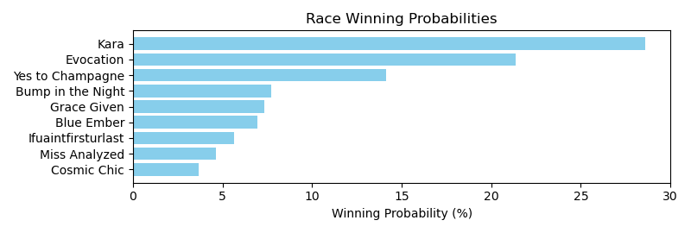

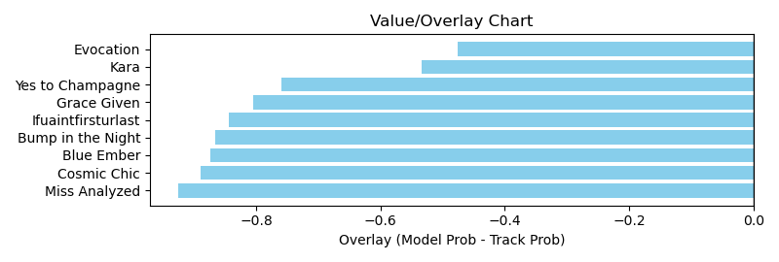

NOTE: GCSF - Global Combined Speed Figure

# Race: TOP | 2025-03-28 | Race #4 | Post: 14:05 | Track: OAKLAWN PARK

Track: OAKLAWN PARK

|  |  |  |  |  |  |
| --- | --- | --- | --- | --- | --- |
| Program # | Horse Name | Morn Odds | GCSF | Model Score | Win Prob (%) |
| 1 | Interstella | 15-1 | 96.2 | 1.06 | 5.19 |
| 2 | Lady Commander | 5-1 | 86.3 | 1.16 | 8.22 |
| 3 | Lady Dreamer | 20-1 | 93.4 | 1.00 | 3.83 |
| 4 | Self Isolation | 3-1 | 100.0 | 1.26 | 12.52 |
| 5 | Insightful Miss | 9-2 | 110.8 | 1.37 | 19.28 |
| 6 | Austrian Navy | 8-1 | 99.9 | 1.05 | 4.86 |
| 7 | Awesome Annmarie | 9-5 | 104.3 | 1.27 | 13.28 |
| 8 | Dance My Way | 15-1 | 106.3 | 0.98 | 3.49 |
| 9 | Miss Jeopardy | 12-1 | 95.6 | 1.49 | 29.32 |

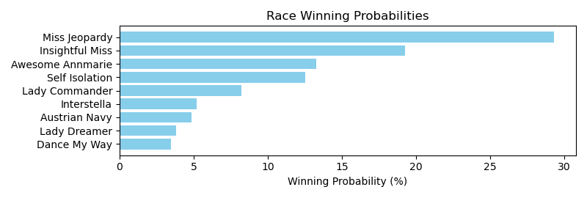

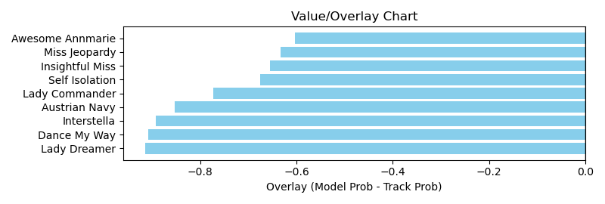

NOTE: GCSF - Global Combined Speed Figure

# Race: TOP | 2025-03-28 | Race #5 | Post: 14:37 | Track: OAKLAWN PARK

Track: OAKLAWN PARK

|  |  |  |  |  |  |
| --- | --- | --- | --- | --- | --- |
| Program # | Horse Name | Morn Odds | GCSF | Model Score | Win Prob (%) |
| 1 | Cajun Eddie | 5-2 | 101.4 | 1.29 | 18.44 |
| 1A | Dynamic Sun | 5-2 | 94.8 | 0.85 | 2.10 |
| 2 | Enjoy It Strait | 2-1 | 102.9 | 1.37 | 24.42 |
| 3 | Lucky Boss | 12-1 | 106.0 | 0.96 | 4.00 |
| 4 | Quick Buck | 30-1 | 90.8 | 0.78 | 1.37 |
| 5 | Mr. Thunderstruck | 15-1 | 102.6 | 1.08 | 7.31 |
| 6 | Sunrise Drive | 7-2 | 105.1 | 1.21 | 13.14 |
| 7 | Lions Not Sheep | 15-1 | 97.7 | 0.92 | 3.29 |
| 8 | Granada Flavor | 12-1 | 109.4 | 1.10 | 8.08 |
| 9 | Fire Bryan | 20-1 | 118.2 | 1.05 | 6.36 |
| 10 | Pizza Charlie | 20-1 | 115.9 | 0.80 | 1.53 |
| 11 | Candy for Carmel | 8-1 | 97.9 | 1.15 | 9.94 |

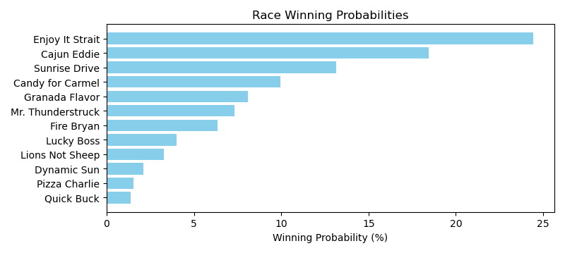

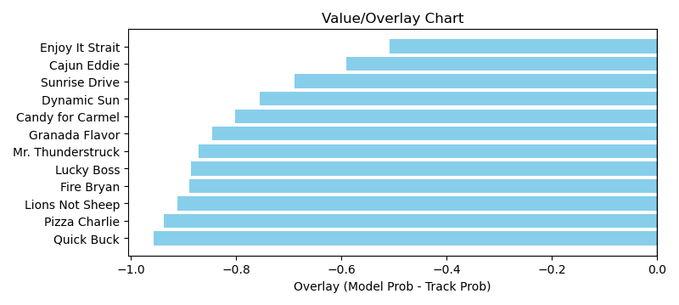

NOTE: GCSF - Global Combined Speed Figure

# Race: TOP | 2025-03-28 | Race #7 | Post: 15:41 | Track: OAKLAWN PARK

Track: OAKLAWN PARK

|  |  |  |  |  |  |
| --- | --- | --- | --- | --- | --- |
| Program # | Horse Name | Morn Odds | GCSF | Model Score | Win Prob (%) |
| 1 | Parkway | 12-1 | 114.9 | 1.07 | 2.96 |
| 2 | Gatlinburg | 20-1 | 114.0 | 0.95 | 1.66 |
| 3 | Tornado Road | 15-1 | 97.6 | 0.91 | 1.32 |
| 4 | Phreddie Mac | 9-2 | 105.1 | 1.10 | 3.46 |
| 5 | Big Gain | 15-1 | 95.8 | 1.81 | 44.65 |
| 6 | Gluckstadt | 15-1 | 99.1 | 1.09 | 3.29 |
| 7 | Rivetage | 4-1 | 100.7 | 1.21 | 5.58 |
| 8 | Rivalry | 12-1 | 91.6 | 1.08 | 3.12 |
| 9 | Stellar Vino | 7-2 | 96.4 | 1.44 | 13.72 |
| 10 | Bettera | 5-1 | 94.4 | 1.21 | 5.66 |
| 11 | Charbon | 15-1 | 100.9 | 0.99 | 2.05 |
| 12 | Ultimate Strike | 6-1 | 94.9 | 0.97 | 1.80 |
| 13 | Sound of Victory | 20-1 | 105.7 | 1.37 | 10.72 |

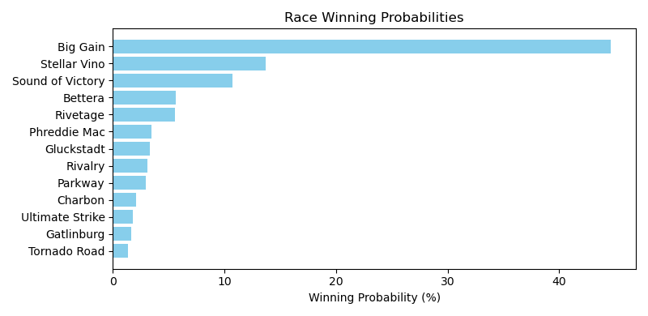

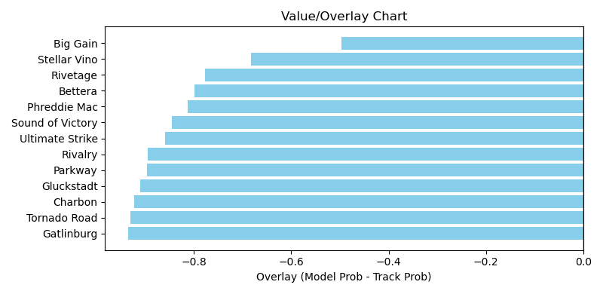

NOTE: GCSF - Global Combined Speed Figure

# Race: TOP | 2025-03-28 | Race #8 | Post: 16:13 | Track: OAKLAWN PARK

Track: OAKLAWN PARK

|  |  |  |  |  |  |
| --- | --- | --- | --- | --- | --- |
| Program # | Horse Name | Morn Odds | GCSF | Model Score | Win Prob (%) |
| 1 | Best Seller | 8-1 | 93.3 | 1.07 | 3.57 |
| 2 | Peignoir | 5-1 | 100.0 | 1.32 | 10.35 |
| 3 | Miss Hebrides | 5-2 | 106.4 | 1.48 | 18.51 |
| 4 | In Just My Heels | 2-1 | 106.5 | 1.46 | 17.44 |
| 5 | Tripolina | 4-1 | 97.9 | 1.57 | 25.37 |
| 6 | Rose Palace | 20-1 | 115.9 | 1.11 | 4.35 |
| 7 | Mercy Warren | 8-1 | 98.7 | 1.49 | 18.98 |
| 8 | Bow Draw | 30-1 | 96.0 | 0.90 | 1.43 |

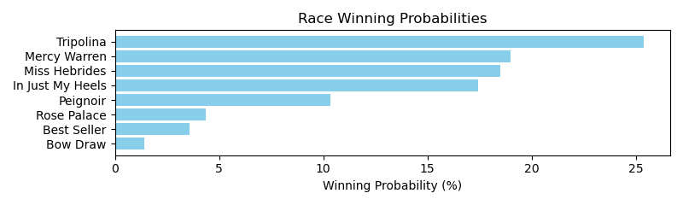

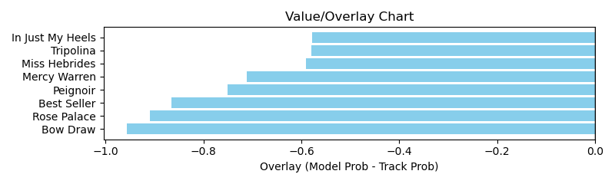

NOTE: GCSF - Global Combined Speed Figure

# Race: TOP | 2025-03-28 | Race #10 | Post: 17:19 | Track: OAKLAWN PARK

Track: OAKLAWN PARK

|  |  |  |  |  |  |
| --- | --- | --- | --- | --- | --- |
| Program # | Horse Name | Morn Odds | GCSF | Model Score | Win Prob (%) |
| 1 | Dai Vernon | 15-1 | 104.8 | 1.13 | 5.40 |
| 2 | One Giant Leap | 15-1 | 108.9 | 1.16 | 6.30 |
| 3 | Time for Trouble | 6-1 | 103.0 | 1.32 | 12.21 |
| 4 | Masqueparade | 9-2 | 77.9 | 1.14 | 5.62 |
| 5 | Shattuck | 20-1 | 101.0 | 1.03 | 3.37 |
| 6 | Game Warden | 4-1 | 106.2 | 1.04 | 3.55 |
| 7 | Confidence Game | 15-1 | 122.7 | 0.96 | 2.31 |
| 8 | Rock'n a Halo | 12-1 | 107.1 | 1.09 | 4.50 |
| 9 | Red Run | 20-1 | 106.7 | 1.29 | 10.60 |
| 10 | Sir Greylind | 5-2 | 96.7 | 1.59 | 31.79 |
| 11 | Lambeth | 5-1 | 109.3 | 1.37 | 14.36 |

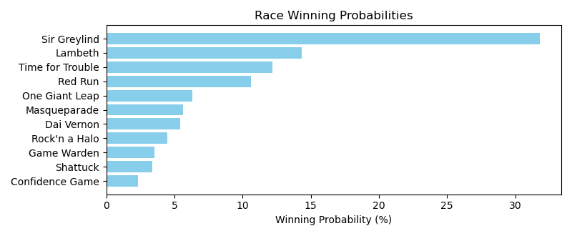

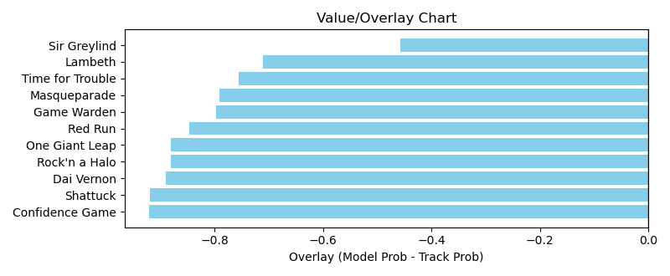

NOTE: GCSF - Global Combined Speed Figure

# Race: TOP | 2025-03-29 | Race #1 | Post: 11:20 | Track: OAKLAWN PARK

Track: OAKLAWN PARK

|  |  |  |  |  |  |
| --- | --- | --- | --- | --- | --- |
| Program # | Horse Name | Morn Odds | GCSF | Model Score | Win Prob (%) |
| 1 | Boogie Bode | 20-1 | 97.6 | 1.07 | 2.47 |
| 2 | Face Value | 12-1 | 95.1 | 1.12 | 3.10 |
| 3 | Ember | 9-2 | 102.1 | 1.24 | 5.24 |
| 4 | Seas of Normandy | 15-1 | 104.4 | 1.09 | 2.64 |
| 5 | Mad Adam | 10-1 | 100.0 | 1.24 | 5.14 |
| 6 | Hess | 20-1 | 95.0 | 1.53 | 15.14 |
| 7 | Icarus | 4-1 | 98.6 | 1.29 | 6.35 |
| 8 | Pittsburgh | 30-1 | 123.1 | 0.79 | 0.51 |
| 9 | Executive Action | 6-1 | 93.4 | 1.22 | 4.77 |
| 10 | Cashmeup | 7-5 | 91.6 | 1.96 | 54.66 |

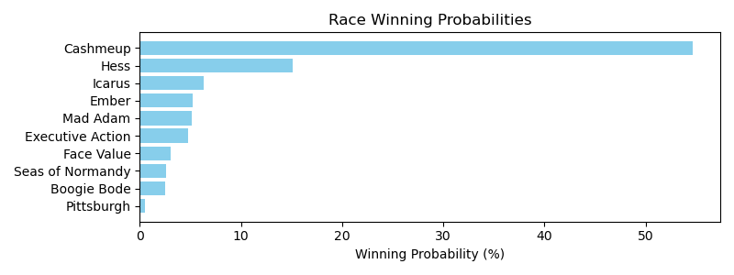

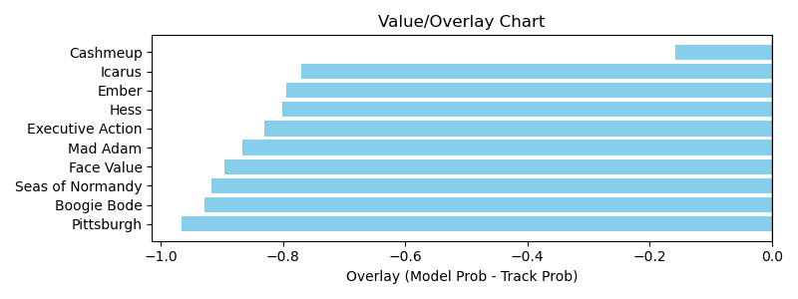

NOTE: GCSF - Global Combined Speed Figure

# Race: TOP | 2025-03-29 | Race #6 | Post: 14:04 | Track: OAKLAWN PARK

Track: OAKLAWN PARK

|  |  |  |  |  |  |
| --- | --- | --- | --- | --- | --- |
| Program # | Horse Name | Morn Odds | GCSF | Model Score | Win Prob (%) |
| 1 | Benedetta | 4-1 | 100.2 | 1.62 | 8.50 |
| 2 | Holly Dolly | 15-1 | 111.5 | 1.26 | 2.35 |
| 3 | Lady Moscato | 12-1 | 98.2 | 1.33 | 3.06 |
| 4 | Almostgone Rocket | 5-8 | 93.4 | 2.49 | 77.06 |
| 5 | American Band | 20-1 | 97.0 | 1.29 | 2.58 |
| 6 | Haulin Ice | 7-2 | 86.0 | 1.54 | 6.45 |

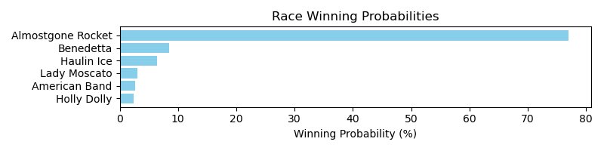

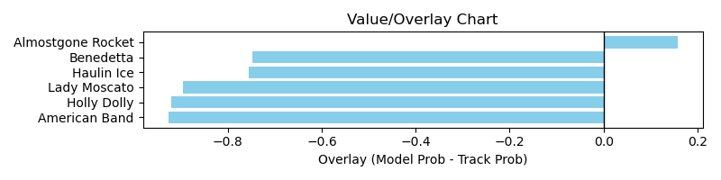

NOTE: GCSF - Global Combined Speed Figure

# Race: TOP | 2025-03-29 | Race #7 | Post: 14:40 | Track: OAKLAWN PARK

Track: OAKLAWN PARK

|  |  |  |  |  |  |
| --- | --- | --- | --- | --- | --- |
| Program # | Horse Name | Morn Odds | GCSF | Model Score | Win Prob (%) |
| 1 | Bohemian Bo | 4-1 | 93.4 | 1.35 | 8.06 |
| 2 | Disco Ball | 3-1 | 98.4 | 1.41 | 10.08 |
| 3 | Clear the Air | 20-1 | 96.5 | 0.93 | 1.19 |
| 4 | King Cab | 20-1 | 95.8 | 1.00 | 1.69 |
| 5 | Zambezi | 9-2 | 95.7 | 1.78 | 32.96 |
| 6 | Echo Again | 10-1 | 104.3 | 1.37 | 8.57 |
| 7 | Navy Seal | 10-1 | 98.1 | 1.20 | 4.37 |
| 8 | Carbone | 20-1 | 104.2 | 1.02 | 1.89 |
| 9 | Friar Laurence | 5-1 | 94.1 | 1.10 | 2.76 |
| 10 | Favorite Outlaw | 6-1 | 91.7 | 1.33 | 7.52 |
| 11 | Eglise | 15-1 | 96.8 | 1.53 | 15.44 |
| 12 | dh-Distorted Pro | 15-1 | 93.9 | 1.25 | 5.48 |

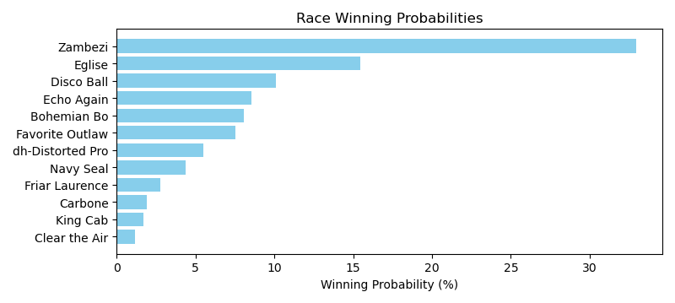

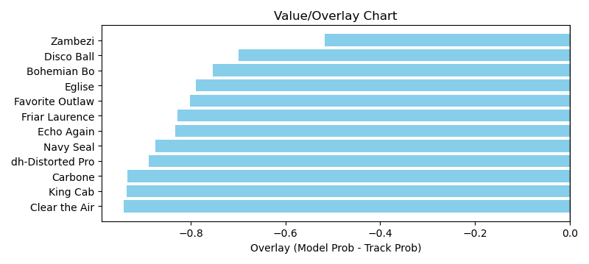

NOTE: GCSF - Global Combined Speed Figure

# Race: TOP | 2025-03-29 | Race #8 | Post: 15:17 | Track: OAKLAWN PARK

Track: OAKLAWN PARK

|  |  |  |  |  |  |
| --- | --- | --- | --- | --- | --- |
| Program # | Horse Name | Morn Odds | GCSF | Model Score | Win Prob (%) |
| 1 | The Wine Steward | 4-1 | 89.1 | 1.53 | 17.49 |
| 2 | I'm McDreamy | 20-1 | 93.0 | 0.80 | 0.62 |
| 3 | Banishing | 9-5 | 113.6 | 1.77 | 36.99 |
| 4 | Just Steel | 15-1 | 117.3 | 1.25 | 6.26 |
| 5 | Dimatic | 20-1 | 96.8 | 1.07 | 2.77 |
| 6 | Emmanuel | 10-1 | 87.1 | 1.33 | 8.48 |
| 7 | Payne | 15-1 | 120.4 | 1.13 | 3.69 |
| 8 | Saudi Crown | 7-5 | 90.4 | 1.62 | 23.70 |

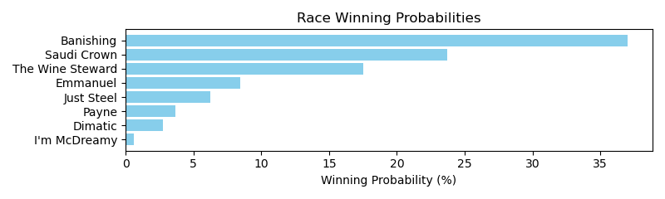

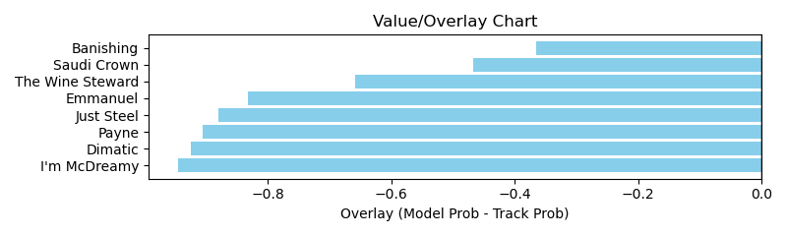

NOTE: GCSF - Global Combined Speed Figure

# Race: TOP | 2025-03-29 | Race #10 | Post: 16:32 | Track: OAKLAWN PARK

Track: OAKLAWN PARK

|  |  |  |  |  |  |
| --- | --- | --- | --- | --- | --- |
| Program # | Horse Name | Morn Odds | GCSF | Model Score | Win Prob (%) |
| 1 | Get Her Number | 15-1 | 98.0 | 1.08 | 3.01 |
| 2 | Just Steel | 12-1 | 99.6 | 1.31 | 8.22 |
| 3 | Durante | 7-2 | 103.6 | 1.33 | 8.88 |
| 4 | Osbourne | 8-1 | 98.8 | 1.51 | 16.98 |
| 5 | Wendelssohn | 9-5 | 98.8 | 1.59 | 22.11 |
| 6 | Ninja Warrior | 6-1 | 97.2 | 1.45 | 14.01 |
| 7 | Happy American | 4-1 | 83.9 | 1.42 | 12.32 |
| 8 | Willow Creek Road | 30-1 | 103.3 | 1.15 | 4.24 |
| 9 | Attache | 15-1 | 97.5 | 1.10 | 3.36 |
| 10 | Lunar Module | 15-1 | 95.6 | 1.26 | 6.85 |

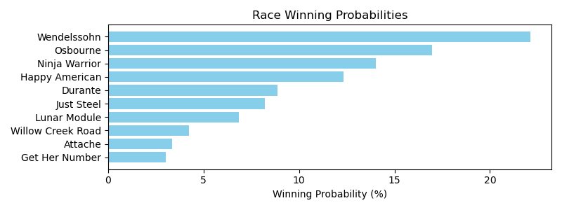

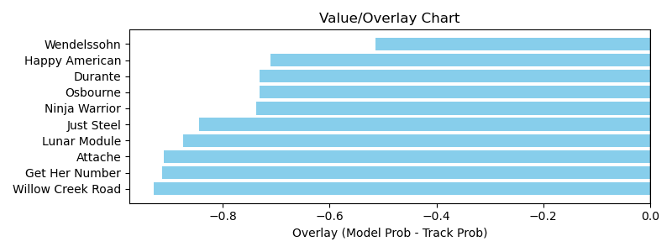

NOTE: GCSF - Global Combined Speed Figure

# Race: TOP | 2025-03-29 | Race #11 | Post: 17:12 | Track: OAKLAWN PARK

Track: OAKLAWN PARK

|  |  |  |  |  |  |
| --- | --- | --- | --- | --- | --- |
| Program # | Horse Name | Morn Odds | GCSF | Model Score | Win Prob (%) |
| 1 | Bishops Bay | 7-2 | 99.0 | 1.87 | 30.15 |
| 2 | Quality Chic | 10-1 | 108.2 | 1.23 | 3.62 |
| 3 | Bendoog | 4-1 | 98.4 | 1.55 | 11.56 |
| 4 | Magic Tap | 15-1 | 87.4 | 1.31 | 4.83 |
| 5 | Full Screen | 10-1 | 92.5 | 1.25 | 3.80 |
| 6 | Liberal Arts | 10-1 | 111.7 | 1.71 | 19.54 |
| 7 | Maycocks Bay | 3-1 | 106.7 | 1.62 | 14.44 |
| 8 | I'm McDreamy | 20-1 | 99.2 | 0.83 | 0.48 |
| 9 | Honor Marie | 5-1 | 89.8 | 1.37 | 6.11 |
| 10 | Black Powder | 12-1 | 95.8 | 1.34 | 5.48 |

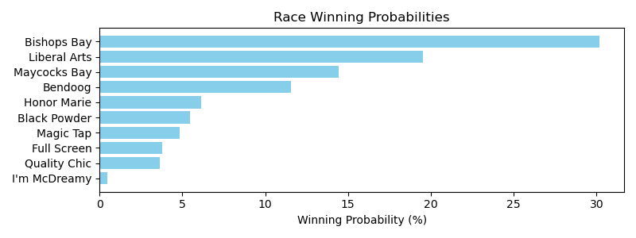

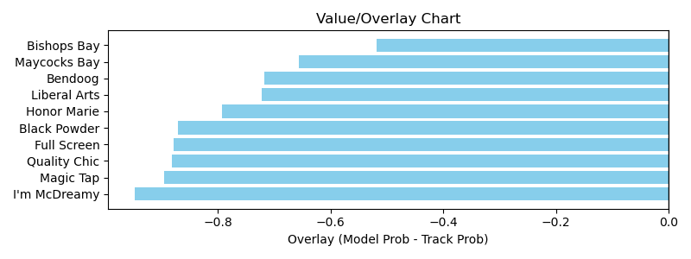

NOTE: GCSF - Global Combined Speed Figure

# Race: TOP | 2025-03-30 | Race #2 | Post: 13:07 | Track: OAKLAWN PARK

Track: OAKLAWN PARK

|  |  |  |  |  |  |
| --- | --- | --- | --- | --- | --- |
| Program # | Horse Name | Morn Odds | GCSF | Model Score | Win Prob (%) |
| 1 | Atta Party | 15-1 | 99.1 | 1.14 | 5.45 |
| 2 | Changing Times | 10-1 | 87.2 | 0.87 | 1.37 |
| 3 | Allo Enry | 4-1 | 88.4 | 1.17 | 6.25 |
| 4 | Macho Ronnie | 12-1 | 98.1 | 1.11 | 4.74 |
| 5 | Cooler King | 30-1 | 94.7 | 0.82 | 1.01 |
| 6 | I'm an Oak | 10-1 | 97.4 | 1.09 | 4.46 |
| 7 | Choctaw Zip | 5-2 | 102.5 | 1.66 | 37.72 |
| 8 | Reef's Destiny | 20-1 | 103.5 | 0.94 | 2.02 |
| 9 | Rocket Sanders | 8-1 | 100.1 | 1.41 | 16.32 |
| 10 | You Vee Cee | 6-1 | 99.9 | 0.98 | 2.58 |
| 11 | Holding Pattern | 5-1 | 100.0 | 1.44 | 18.07 |

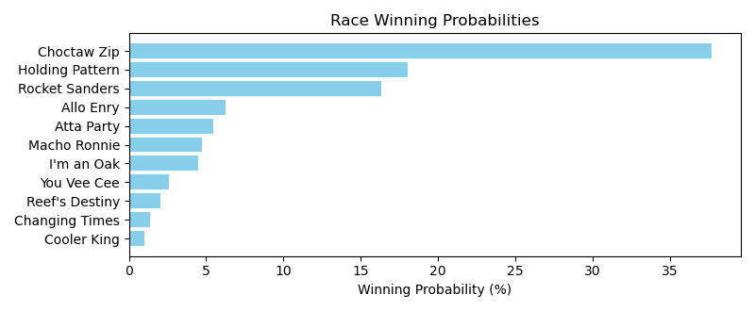

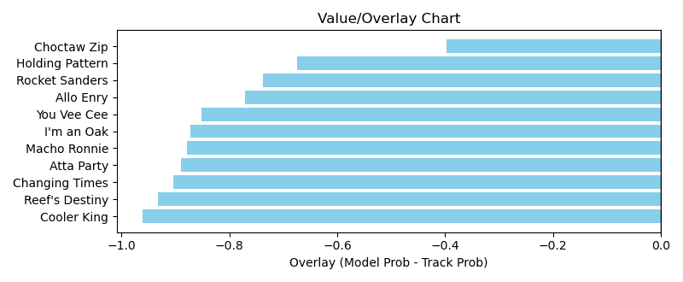

NOTE: GCSF - Global Combined Speed Figure

# Race: TOP | 2025-03-30 | Race #3 | Post: 13:39 | Track: OAKLAWN PARK

Track: OAKLAWN PARK

|  |  |  |  |  |  |
| --- | --- | --- | --- | --- | --- |
| Program # | Horse Name | Morn Odds | GCSF | Model Score | Win Prob (%) |
| 1 | Fashion Rage | 3-1 | 114.9 | 1.26 | 12.03 |
| 2 | Donya Know It | 15-1 | 96.6 | 1.11 | 6.29 |
| 3 | Sequin Lady | 7-2 | 96.9 | 1.32 | 15.40 |
| 4 | Adiva | 5-2 | 99.4 | 1.25 | 11.65 |
| 5 | Royal Blush | 20-1 | 98.2 | 1.14 | 7.23 |
| 6 | Singing Emma | 12-1 | 79.4 | 1.07 | 5.21 |
| 7 | H. T. Xena | 15-1 | 97.1 | 1.01 | 3.86 |
| 8 | Divine Gal | 10-1 | 98.6 | 1.06 | 4.91 |
| 9 | Floating | 8-1 | 97.6 | 1.47 | 26.88 |
| 10 | Miesha | 20-1 | 102.5 | 1.03 | 4.25 |
| 11 | Scrupulous | 15-1 | 99.1 | 0.91 | 2.28 |

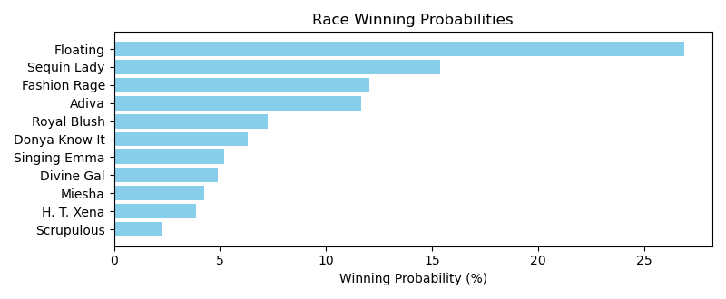

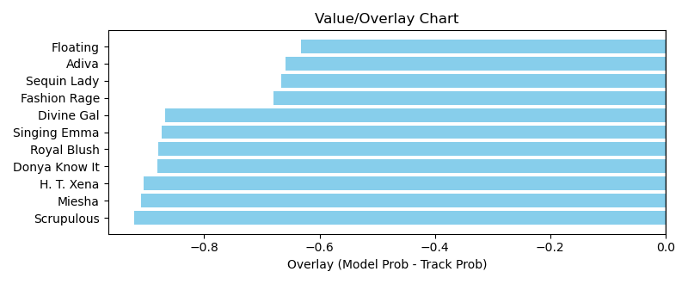

NOTE: GCSF - Global Combined Speed Figure

# Race: TOP | 2025-03-30 | Race #4 | Post: 14:10 | Track: OAKLAWN PARK

Track: OAKLAWN PARK

|  |  |  |  |  |  |
| --- | --- | --- | --- | --- | --- |
| Program # | Horse Name | Morn Odds | GCSF | Model Score | Win Prob (%) |
| 1 | On a Spree | 3-1 | 86.8 | 1.45 | 20.88 |
| 2 | Shot of Courage | 15-1 | 98.8 | 1.15 | 6.27 |
| 3 | Drifter | 15-1 | 117.9 | 0.95 | 2.35 |
| 4 | Seven Flat | 5-1 | 116.0 | 1.14 | 6.01 |
| 5 | Tiwanaku | 7-2 | 85.6 | 1.62 | 37.32 |
| 6 | Home Run Trick | 15-1 | 94.9 | 1.10 | 5.06 |
| 7 | Tie Breaker | 30-1 | 113.0 | 0.81 | 1.09 |
| 8 | Khozy My Boy | 30-1 | 90.6 | 0.88 | 1.63 |
| 9 | Vivir Con Alegria (CHI) | 2-1 | 100.7 | 1.35 | 14.47 |
| 10 | Chaos Reigns | 20-1 | 91.3 | 1.00 | 3.12 |
| 11 | Lions Not Sheep | 15-1 | 93.7 | 0.90 | 1.79 |

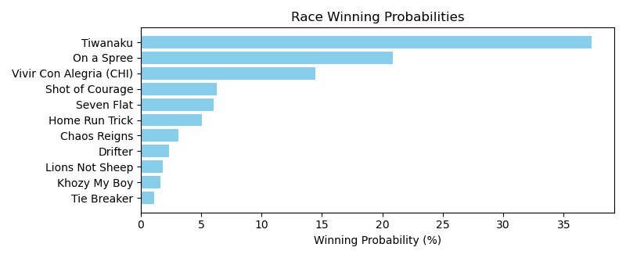

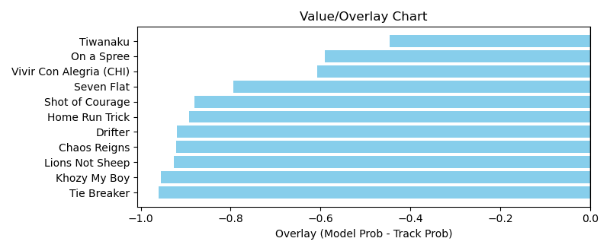

NOTE: GCSF - Global Combined Speed Figure

# Race: TOP | 2025-03-30 | Race #5 | Post: 14:42 | Track: OAKLAWN PARK

Track: OAKLAWN PARK

|  |  |  |  |  |  |
| --- | --- | --- | --- | --- | --- |
| Program # | Horse Name | Morn Odds | GCSF | Model Score | Win Prob (%) |
| 1 | Boltoro | 3-1 | 104.5 | 1.56 | 33.68 |
| 1A | Super Enticing | 3-1 | 96.3 | 1.11 | 5.86 |
| 2 | Royal Laughter | 6-1 | 108.3 | 0.94 | 2.53 |
| 3 | Undecoded | 30-1 | 94.7 | 0.85 | 1.46 |
| 4 | Big Bad Diva | 9-2 | 97.6 | 1.14 | 6.68 |
| 5 | Saranac Lake | 10-1 | 98.5 | 1.09 | 5.35 |
| 6 | Templar Red | 7-2 | 97.3 | 1.39 | 18.64 |
| 7 | Chai Tea | 30-1 | 127.5 | 0.82 | 1.24 |
| 8 | Lady Mercedes | 4-1 | 96.9 | 1.18 | 8.10 |
| 9 | Clearly Creeps | 12-1 | 96.1 | 1.07 | 4.87 |
| 10 | Butterfly Queen | 20-1 | 96.4 | 0.82 | 1.26 |
| 11 | It'sfiftyshadetime | 8-1 | 110.1 | 1.10 | 5.65 |
| 12 | Fearless Kristie | 20-1 | 116.0 | 1.01 | 3.66 |
| 13 | Right Trappe | 30-1 | 95.2 | 0.79 | 1.01 |

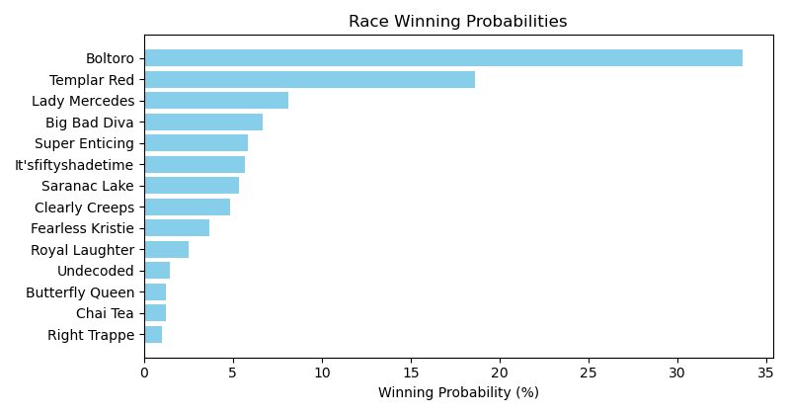

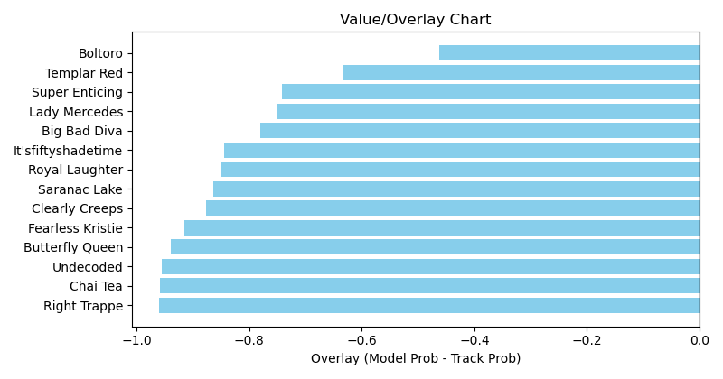

NOTE: GCSF - Global Combined Speed Figure

# Race: TOP | 2025-03-30 | Race #6 | Post: 15:13 | Track: OAKLAWN PARK

Track: OAKLAWN PARK

|  |  |  |  |  |  |
| --- | --- | --- | --- | --- | --- |
| Program # | Horse Name | Morn Odds | GCSF | Model Score | Win Prob (%) |
| 1 | Dinner At Crumpies | 15-1 | 119.9 | 1.04 | 2.40 |
| 2 | Ready Shoes | 10-1 | 92.5 | 0.88 | 1.04 |
| 3 | Afleet Sky | 20-1 | 89.3 | 0.97 | 1.67 |
| 4 | Burlsworth | 5-2 | 109.8 | 1.91 | 55.80 |
| 5 | Bellamys Roan | 30-1 | 113.9 | 0.90 | 1.14 |
| 6 | Hoppin John | 3-1 | 92.1 | 1.59 | 21.83 |
| 7 | Miri a Coincidence | 10-1 | 124.4 | 0.88 | 1.03 |
| 8 | King Peanut | 15-1 | 111.9 | 1.03 | 2.34 |
| 9 | Mansoura | 30-1 | 92.8 | 0.82 | 0.72 |
| 10 | Cybertown | 7-2 | 89.4 | 1.22 | 5.65 |
| 11 | Reveille Valley | 15-1 | 104.2 | 0.88 | 1.02 |
| 12 | Devils Fork | 15-1 | 89.9 | 0.97 | 1.75 |
| 13 | dq-Where's Randy | 12-1 | 109.1 | 1.12 | 3.61 |

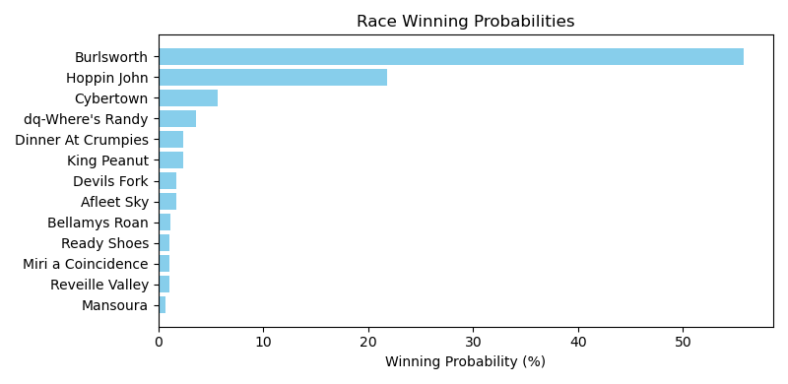

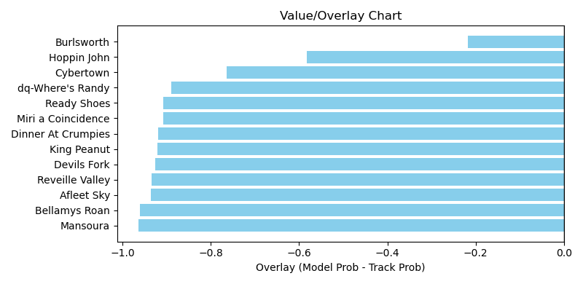

NOTE: GCSF - Global Combined Speed Figure

# Race: PRX | 2025-03-31 | Race #1 | Post: 12:40 | Track: PARX RACING

Track: PARX RACING

|  |  |  |  |  |  |
| --- | --- | --- | --- | --- | --- |
| Program # | Horse Name | Morn Odds | GCSF | Model Score | Win Prob (%) |
| 1 | Yes Point | 13-8 | 102.6 | 1.27 | 100.00 |

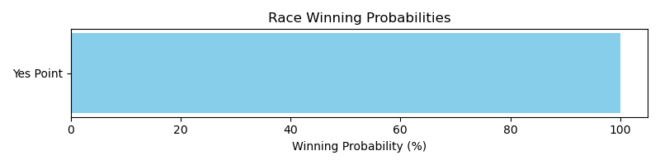

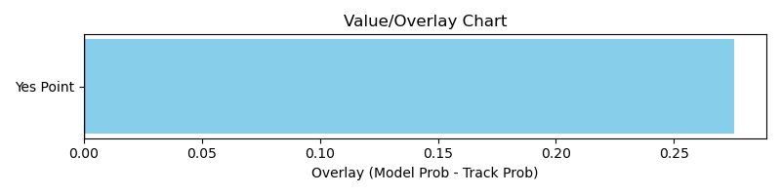

NOTE: GCSF - Global Combined Speed Figure

# Race: PRX | 2025-03-31 | Race #2 | Post: 13:07 | Track: PARX RACING

Track: PARX RACING

|  |  |  |  |  |  |
| --- | --- | --- | --- | --- | --- |
| Program # | Horse Name | Morn Odds | GCSF | Model Score | Win Prob (%) |
| 1 | You're Forever | 5-2 | 92.4 | 1.18 | 77.88 |
| 7 | Wild Girl | 10-1 | 94.3 | 0.92 | 22.12 |

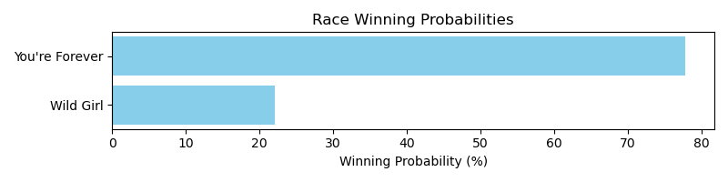

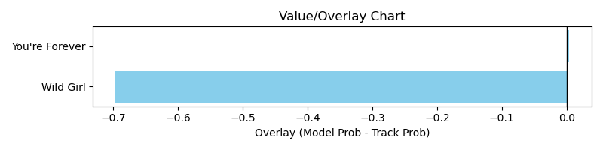

NOTE: GCSF - Global Combined Speed Figure

# Race: PRX | 2025-03-31 | Race #3 | Post: 13:34 | Track: PARX RACING

Track: PARX RACING

|  |  |  |  |  |  |
| --- | --- | --- | --- | --- | --- |
| Program # | Horse Name | Morn Odds | GCSF | Model Score | Win Prob (%) |
| 4 | Red Haired Gal | 8-1 | 105.6 | 1.27 | 71.56 |
| 6 | Eleanor Rigby | 8-1 | 103.6 | 1.06 | 28.44 |

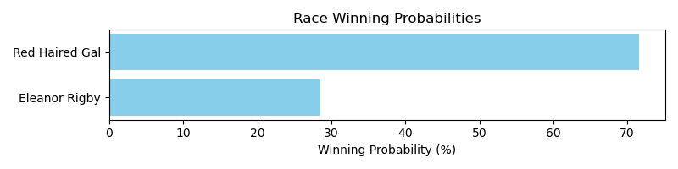

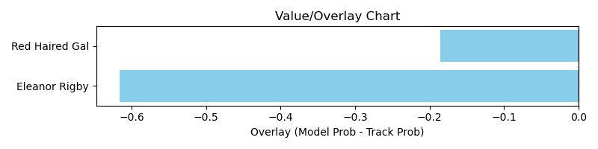

NOTE: GCSF - Global Combined Speed Figure

# Race: PRX | 2025-03-31 | Race #4 | Post: 14:01 | Track: PARX RACING

Track: PARX RACING

|  |  |  |  |  |  |
| --- | --- | --- | --- | --- | --- |
| Program # | Horse Name | Morn Odds | GCSF | Model Score | Win Prob (%) |
| 5 | Chiquita Mosca | 6-5 | 104.6 | 1.26 | 70.09 |
| 6 | My Jo Jo | 8-1 | 94.7 | 1.07 | 29.91 |

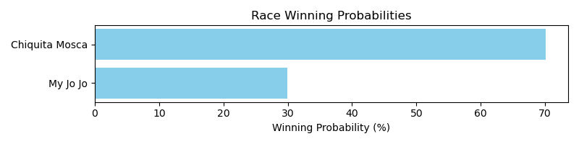

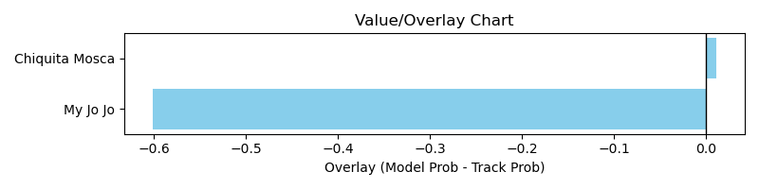

NOTE: GCSF - Global Combined Speed Figure

# Race: PRX | 2025-03-31 | Race #5 | Post: 14:28 | Track: PARX RACING

Track: PARX RACING

|  |  |  |  |  |  |
| --- | --- | --- | --- | --- | --- |
| Program # | Horse Name | Morn Odds | GCSF | Model Score | Win Prob (%) |
| 6 | Giant's Audible | 2-1 | 89.9 | 1.00 | 100.00 |

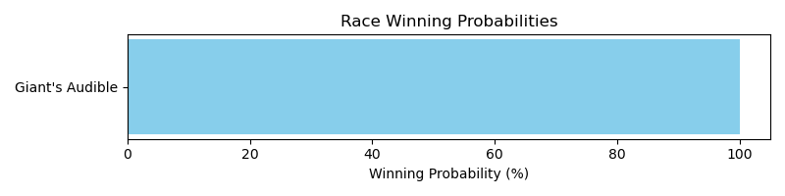

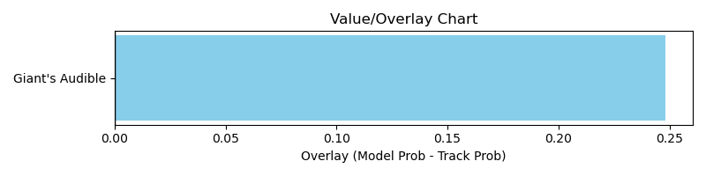

NOTE: GCSF - Global Combined Speed Figure

# Race: PRX | 2025-03-31 | Race #6 | Post: 14:59 | Track: PARX RACING

Track: PARX RACING

|  |  |  |  |  |  |
| --- | --- | --- | --- | --- | --- |
| Program # | Horse Name | Morn Odds | GCSF | Model Score | Win Prob (%) |
| 1 | Melittlefrostgirl | 12-1 | 95.0 | 0.77 | 100.00 |

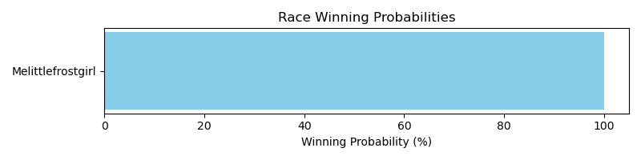

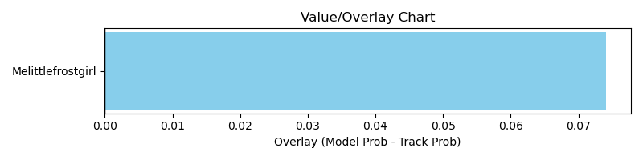

NOTE: GCSF - Global Combined Speed Figure

# Race: PRX | 2025-03-31 | Race #7 | Post: 15:26 | Track: PARX RACING

Track: PARX RACING

|  |  |  |  |  |  |
| --- | --- | --- | --- | --- | --- |
| Program # | Horse Name | Morn Odds | GCSF | Model Score | Win Prob (%) |
| 1 | Bold Hoppertunity | 8-1 | 105.5 | 0.85 | 3.09 |
| 2 | Hey River | 8-1 | 99.2 | 1.15 | 14.52 |
| 3 | Top of the Street | 3-1 | 99.7 | 1.50 | 56.55 |
| 7 | Imaginized | 6-1 | 102.3 | 1.29 | 25.84 |

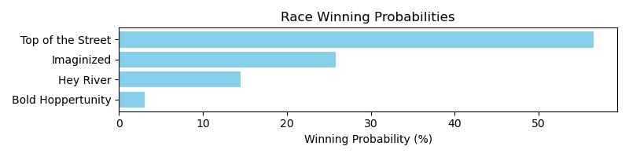

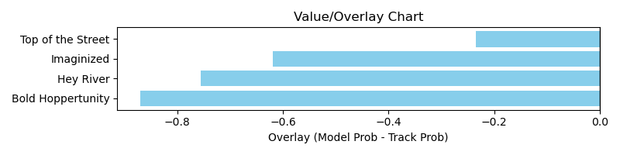

NOTE: GCSF - Global Combined Speed Figure

# Race: PRX | 2025-03-31 | Race #8 | Post: 15:53 | Track: PARX RACING

Track: PARX RACING

|  |  |  |  |  |  |
| --- | --- | --- | --- | --- | --- |
| Program # | Horse Name | Morn Odds | GCSF | Model Score | Win Prob (%) |
| 6 | Dancing On Air | 15-1 | 100.0 | 0.79 | 100.00 |

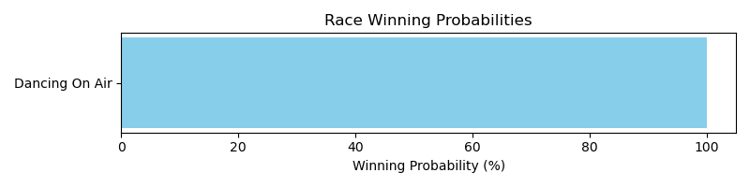

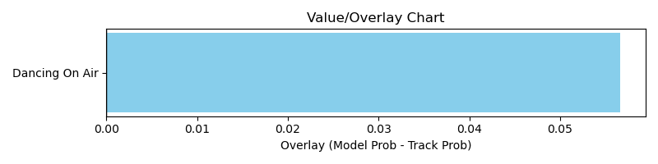

NOTE: GCSF - Global Combined Speed Figure

# Race: PRX | 2025-03-31 | Race #9 | Post: 16:20 | Track: PARX RACING

Track: PARX RACING

|  |  |  |  |  |  |
| --- | --- | --- | --- | --- | --- |
| Program # | Horse Name | Morn Odds | GCSF | Model Score | Win Prob (%) |
| 4 | Leftover Sushi | 12-1 | 97.5 | 0.94 | 7.21 |
| 6 | Been Real Busy | 6-1 | 96.6 | 1.12 | 18.09 |
| 8 | Filtered Light | 12-1 | 112.0 | 0.95 | 7.51 |
| 10 | Valiant Majesty | 6-1 | 119.8 | 1.45 | 67.19 |

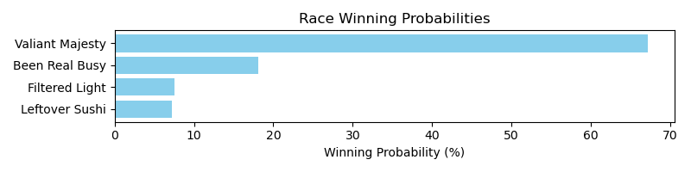

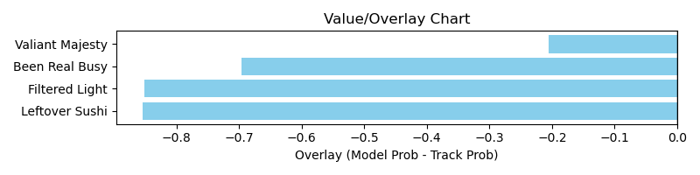

NOTE: GCSF - Global Combined Speed Figure

# Race: PRX | 2025-03-31 | Race #10 | Post: 16:47 | Track: PARX RACING

Track: PARX RACING

|  |  |  |  |  |  |
| --- | --- | --- | --- | --- | --- |
| Program # | Horse Name | Morn Odds | GCSF | Model Score | Win Prob (%) |
| 6 | Pressing Concern | 12-1 | 96.6 | 1.01 | 100.00 |

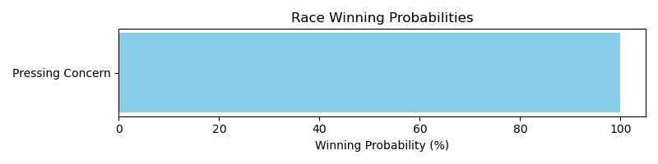

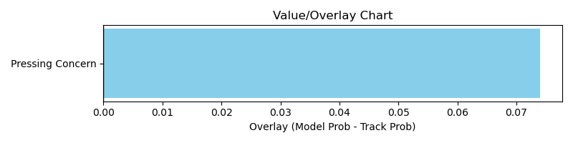

NOTE: GCSF - Global Combined Speed Figure

# Race: PRX | 2025-04-01 | Race #1 | Post: 12:40 | Track: PARX RACING

Track: PARX RACING

|  |  |  |  |  |  |
| --- | --- | --- | --- | --- | --- |
| Program # | Horse Name | Morn Odds | GCSF | Model Score | Win Prob (%) |
| 9 | Shake It Baby | 4-1 | 100.9 | 1.02 | 100.00 |

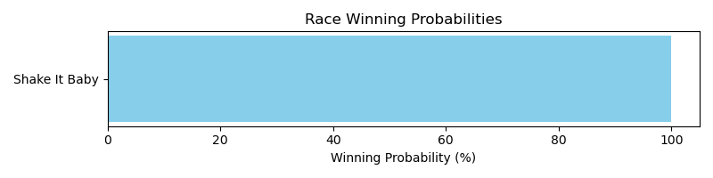

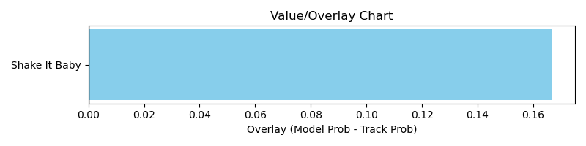

NOTE: GCSF - Global Combined Speed Figure

# Race: PRX | 2025-04-01 | Race #2 | Post: 13:07 | Track: PARX RACING

Track: PARX RACING

|  |  |  |  |  |  |
| --- | --- | --- | --- | --- | --- |
| Program # | Horse Name | Morn Odds | GCSF | Model Score | Win Prob (%) |
| 5 | Hardy Choice | 3-1 | 97.1 | 1.14 | 100.00 |

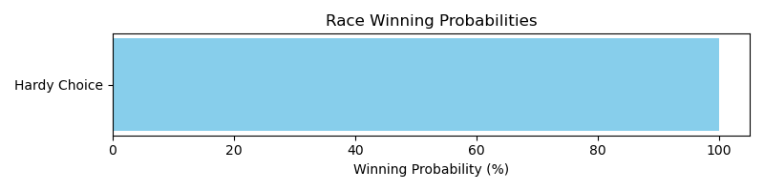

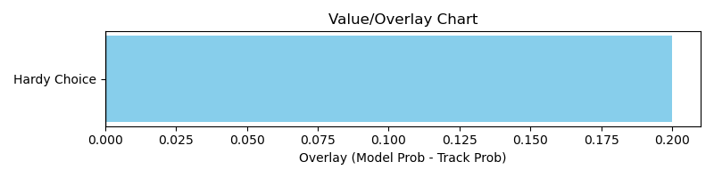

NOTE: GCSF - Global Combined Speed Figure

# Race: PRX | 2025-04-01 | Race #3 | Post: 13:34 | Track: PARX RACING

Track: PARX RACING

|  |  |  |  |  |  |
| --- | --- | --- | --- | --- | --- |
| Program # | Horse Name | Morn Odds | GCSF | Model Score | Win Prob (%) |
| 3 | Captain Crush | 4-1 | 106.6 | 1.06 | 44.79 |
| 7 | Sunny Magic | 3-1 | 100.6 | 1.11 | 55.21 |

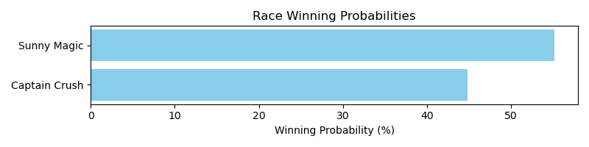

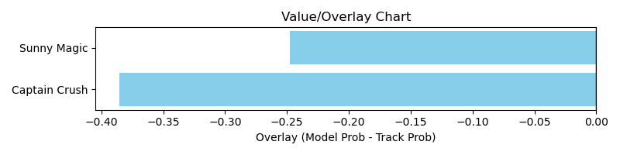

NOTE: GCSF - Global Combined Speed Figure

# Race: PRX | 2025-04-01 | Race #4 | Post: 14:01 | Track: PARX RACING

Track: PARX RACING

|  |  |  |  |  |  |
| --- | --- | --- | --- | --- | --- |
| Program # | Horse Name | Morn Odds | GCSF | Model Score | Win Prob (%) |
| 3 | Parkerness | 13-8 | 93.8 | 1.05 | 100.00 |

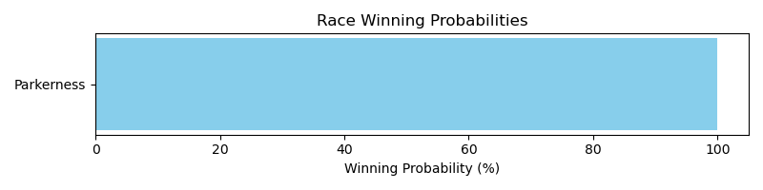

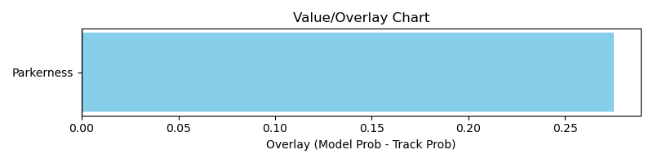

NOTE: GCSF - Global Combined Speed Figure

# Race: PRX | 2025-04-01 | Race #6 | Post: 14:59 | Track: PARX RACING

Track: PARX RACING

|  |  |  |  |  |  |
| --- | --- | --- | --- | --- | --- |
| Program # | Horse Name | Morn Odds | GCSF | Model Score | Win Prob (%) |
| 4 | Poppy's Pride | 5-2 | 84.9 | 1.39 | 33.69 |
| 5 | Ego Man | 6-1 | 103.9 | 1.06 | 8.45 |
| 9 | The Judge and Jury | 3-1 | 100.6 | 1.54 | 57.86 |

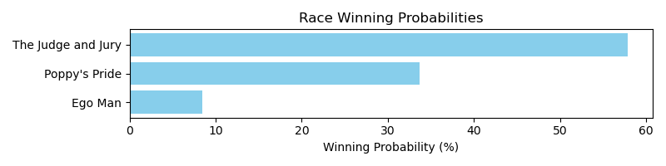

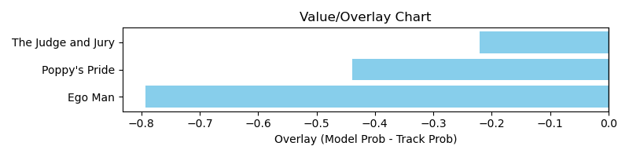

NOTE: GCSF - Global Combined Speed Figure

# Race: PRX | 2025-04-01 | Race #7 | Post: 15:26 | Track: PARX RACING

Track: PARX RACING

|  |  |  |  |  |  |
| --- | --- | --- | --- | --- | --- |
| Program # | Horse Name | Morn Odds | GCSF | Model Score | Win Prob (%) |
| 1 | Empress Deona | 7-2 | 119.4 | 1.14 | 53.63 |
| 5 | Tavin | 10-1 | 89.3 | 1.11 | 46.37 |

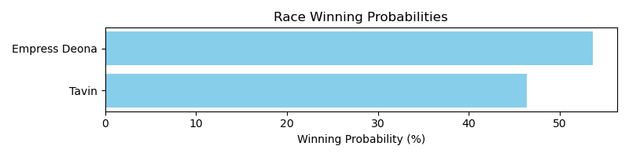

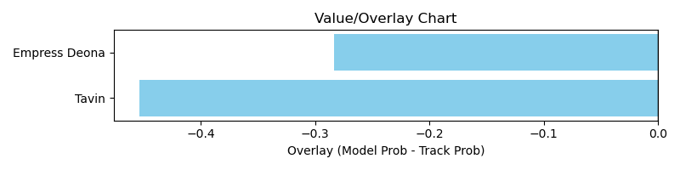

NOTE: GCSF - Global Combined Speed Figure

# Race: PRX | 2025-04-01 | Race #8 | Post: 15:53 | Track: PARX RACING

Track: PARX RACING

|  |  |  |  |  |  |
| --- | --- | --- | --- | --- | --- |
| Program # | Horse Name | Morn Odds | GCSF | Model Score | Win Prob (%) |
| 5 | Friday Surprise | 5-1 | 93.4 | 1.60 | 100.00 |

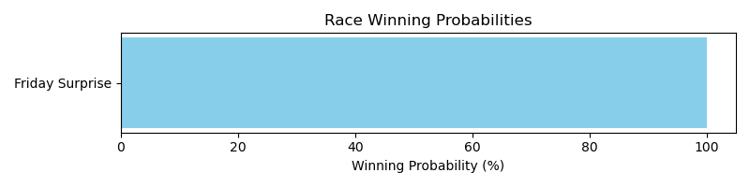

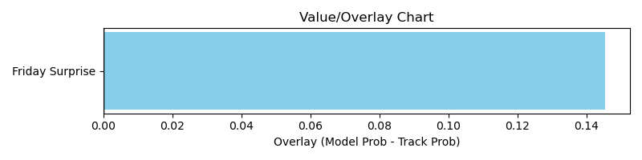

NOTE: GCSF - Global Combined Speed Figure

# Race: PRX | 2025-04-01 | Race #9 | Post: 16:20 | Track: PARX RACING

Track: PARX RACING

|  |  |  |  |  |  |
| --- | --- | --- | --- | --- | --- |
| Program # | Horse Name | Morn Odds | GCSF | Model Score | Win Prob (%) |
| 1 | Point Dume | 6-1 | 118.3 | 1.21 | 43.43 |
| 2 | Deposition | 12-1 | 93.0 | 0.83 | 6.19 |
| 3 | Duke of Gloucester | 5-2 | 90.6 | 1.25 | 50.38 |

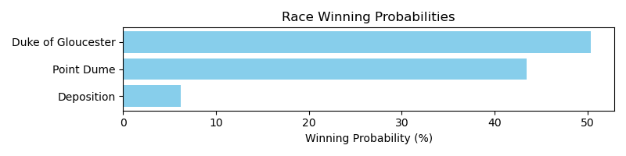

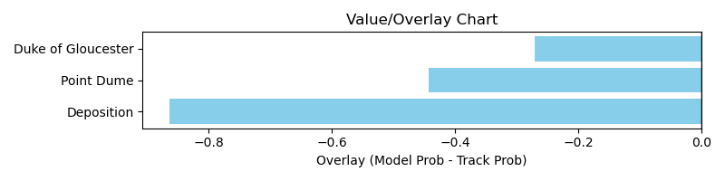

NOTE: GCSF - Global Combined Speed Figure

# Race: PRX | 2025-04-01 | Race #10 | Post: 16:47 | Track: PARX RACING

Track: PARX RACING

|  |  |  |  |  |  |
| --- | --- | --- | --- | --- | --- |
| Program # | Horse Name | Morn Odds | GCSF | Model Score | Win Prob (%) |
| 2 | Miracle Trip | 6-1 | 99.7 | 0.93 | 13.06 |
| 3 | O'Brien | 30-1 | 105.6 | 0.86 | 9.11 |
| 6 | Solo in Paris | 10-1 | 84.1 | 0.96 | 15.76 |
| 7 | One America | 12-1 | 97.4 | 1.05 | 24.35 |
| 10 | Zihuatanejo | 12-1 | 88.7 | 1.04 | 23.93 |
| 12 | Heavy Timber | 15-1 | 105.7 | 0.94 | 13.79 |

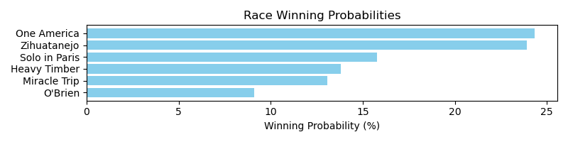

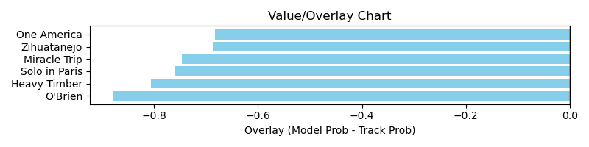

NOTE: GCSF - Global Combined Speed Figure

# Race: PEN | 2025-03-28 | Race #1 | Post: 17:45 | Track: PENN NATIONAL

Track: PENN NATIONAL

|  |  |  |  |  |  |
| --- | --- | --- | --- | --- | --- |
| Program # | Horse Name | Morn Odds | GCSF | Model Score | Win Prob (%) |
| 1 | First Glimpse | 9-2 | 94.3 | 1.52 | 29.58 |
| 2 | Debate | 6-1 | 94.9 | 1.02 | 3.72 |
| 3 | Tubtimsiam | 10-1 | 85.8 | 1.16 | 7.50 |
| 4 | Stormquist | 5-2 | 112.5 | 1.32 | 14.38 |
| 5 | My Redemption | 4-1 | 93.9 | 1.38 | 17.76 |
| 6 | Suzy Q the Queen | 30-1 | 88.5 | 0.93 | 2.38 |
| 7 | Tallahatchiebridge | 7-2 | 114.0 | 1.39 | 18.99 |
| 8 | Jayjaydee | 8-1 | 114.7 | 1.10 | 5.69 |

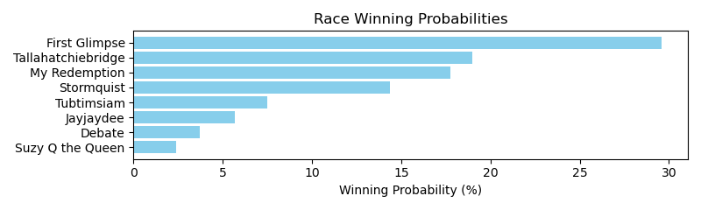

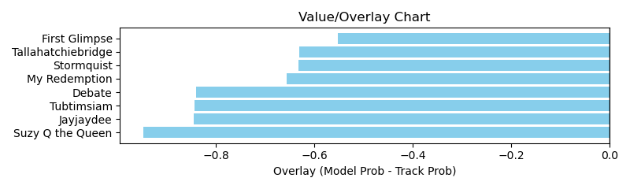

NOTE: GCSF - Global Combined Speed Figure

# Race: PEN | 2025-03-28 | Race #3 | Post: 18:43 | Track: PENN NATIONAL

Track: PENN NATIONAL

|  |  |  |  |  |  |
| --- | --- | --- | --- | --- | --- |
| Program # | Horse Name | Morn Odds | GCSF | Model Score | Win Prob (%) |
| 1 | Twixter | 6-1 | 94.4 | 1.17 | 2.42 |
| 2 | Rustys Gfivefifty | 8-1 | 99.3 | 1.75 | 18.87 |
| 3 | Midnight Act | 6-1 | 93.0 | 1.29 | 3.94 |
| 4 | Helms Deep | 5-2 | 99.4 | 1.11 | 1.81 |
| 5 | Lake Nakuru | 6-1 | 107.2 | 2.24 | 66.58 |
| 6 | Textpectation | 50-1 | 99.3 | 1.02 | 1.19 |
| 7 | Trivista | 50-1 | 95.0 | 0.91 | 0.67 |
| 8 | Lafitte's Fleet | 5-1 | 124.8 | 1.11 | 1.79 |
| 9 | Eye On the Candy | 7-2 | 85.1 | 1.10 | 1.77 |
| 10 | Mighty Minion | 30-1 | 116.0 | 0.99 | 0.98 |

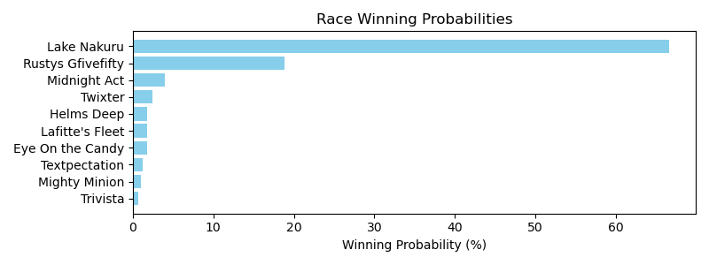

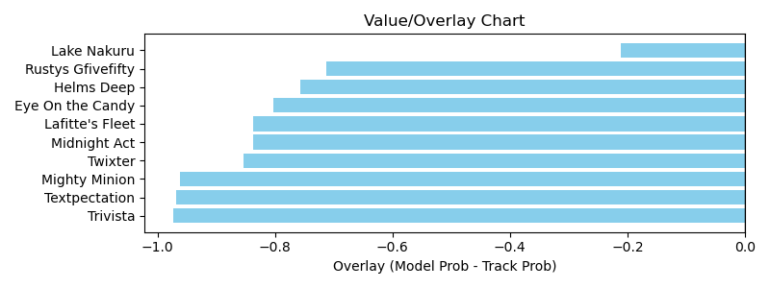

NOTE: GCSF - Global Combined Speed Figure

# Race: PEN | 2025-03-28 | Race #10 | Post: 22:06 | Track: PENN NATIONAL

Track: PENN NATIONAL

|  |  |  |  |  |  |
| --- | --- | --- | --- | --- | --- |
| Program # | Horse Name | Morn Odds | GCSF | Model Score | Win Prob (%) |
| 1 | Carly Hustle | 15-1 | 92.1 | 1.03 | 4.08 |
| 2 | Creme Caramel | 10-1 | 91.1 | 0.99 | 3.33 |
| 3 | Stephanie My Love | 8-1 | 103.7 | 1.20 | 8.81 |
| 4 | Phancy Philly | 8-1 | 109.0 | 1.10 | 5.54 |
| 5 | Kelly's Party Girl | 10-1 | 104.2 | 1.03 | 4.08 |
| 6 | Ribot's Valentine | 7-2 | 92.3 | 1.33 | 15.27 |
| 7 | Stormy Spell | 6-1 | 108.1 | 0.89 | 1.92 |
| 8 | For Cryin Out Loud | 5-2 | 103.8 | 1.66 | 46.20 |
| 9 | My Boss Lady | 5-1 | 103.2 | 1.25 | 10.78 |

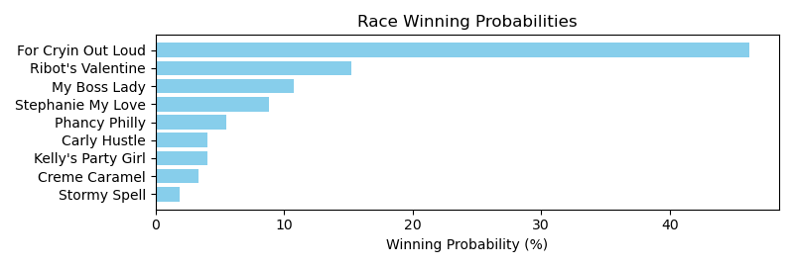

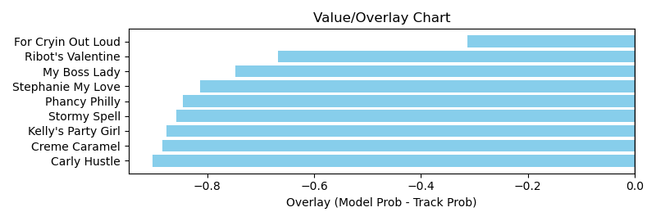

NOTE: GCSF - Global Combined Speed Figure

# Race: HOU | 2025-03-28 | Race #1 | Post: 18:30 | Track: SAM HOUSTON RACE PARK

Track: SAM HOUSTON RACE PARK

|  |  |  |  |  |  |
| --- | --- | --- | --- | --- | --- |
| Program # | Horse Name | Morn Odds | GCSF | Model Score | Win Prob (%) |
| 1 | Annamaria | 15-1 | 98.5 | 0.77 | 3.97 |
| 2 | Misty Mood | 8-1 | 109.1 | 0.99 | 14.83 |
| 3 | Miss Escapade | 5-2 | 92.1 | 0.91 | 9.57 |
| 4 | Catherine Blaze | 4-1 | 99.7 | 0.84 | 6.36 |
| 5 | Bossadusu | 7-2 | 115.1 | 0.98 | 13.90 |
| 6 | Highlander Honey | 13-8 | 95.4 | 1.27 | 51.36 |

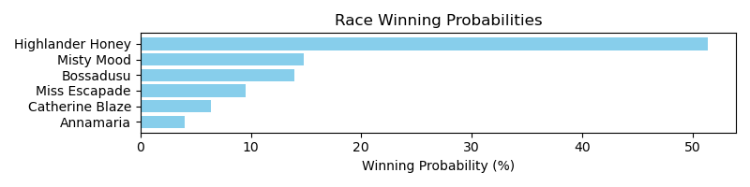

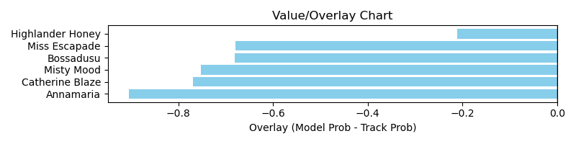

NOTE: GCSF - Global Combined Speed Figure

# Race: HOU | 2025-03-28 | Race #3 | Post: 19:30 | Track: SAM HOUSTON RACE PARK

Track: SAM HOUSTON RACE PARK

|  |  |  |  |  |  |
| --- | --- | --- | --- | --- | --- |
| Program # | Horse Name | Morn Odds | GCSF | Model Score | Win Prob (%) |
| 1 | Prince Rama | 2-1 | 111.1 | 1.39 | 36.99 |
| 2 | Empire's Best | 7-2 | 84.1 | 1.26 | 22.10 |
| 3 | Bandera Azteca | 6-1 | 115.3 | 1.11 | 11.42 |
| 4 | Just Okie | 6-5 | 97.3 | 1.16 | 14.33 |
| 5 | Imperial Hornet | 15-1 | 111.6 | 1.04 | 8.48 |
| 6 | Laridae | 20-1 | 87.1 | 1.00 | 6.69 |

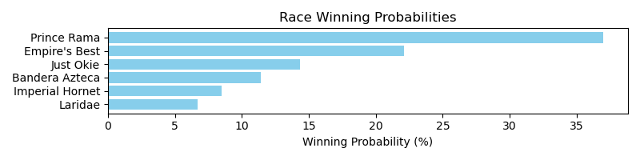

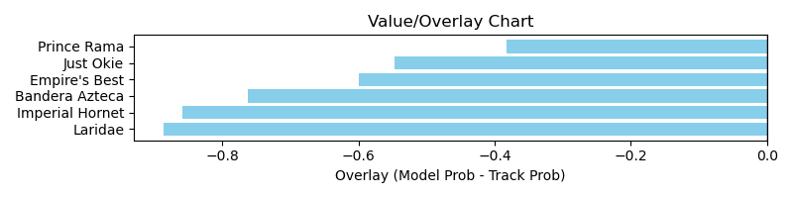

NOTE: GCSF - Global Combined Speed Figure

# Race: HOU | 2025-03-28 | Race #4 | Post: 20:00 | Track: SAM HOUSTON RACE PARK

Track: SAM HOUSTON RACE PARK

|  |  |  |  |  |  |
| --- | --- | --- | --- | --- | --- |
| Program # | Horse Name | Morn Odds | GCSF | Model Score | Win Prob (%) |
| 1 | Littlejohns Prayer | 10-1 | 93.4 | 1.11 | 20.24 |
| 2 | Rich Mountain | 6-1 | 99.3 | 0.80 | 3.71 |
| 3 | Fando | 8-1 | 101.0 | 0.84 | 4.83 |
| 4 | Take My Money | 5-2 | 90.7 | 1.17 | 26.18 |
| 5 | Going to Sanantone | 7-2 | 93.8 | 0.89 | 6.44 |
| 6 | Summer Help | 20-1 | 88.3 | 0.98 | 10.72 |
| 7 | Natural High | 30-1 | 92.3 | 0.80 | 3.74 |
| 8 | Pretty Macho | 8-1 | 103.8 | 1.03 | 13.78 |
| 9 | Too Intimidating | 5-1 | 95.2 | 0.98 | 10.37 |

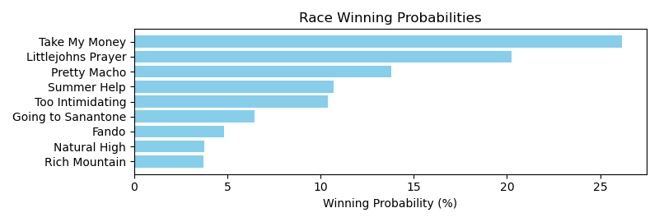

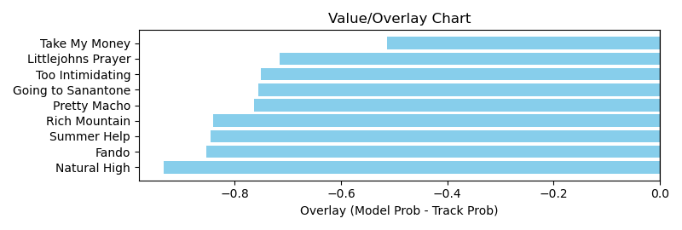

NOTE: GCSF - Global Combined Speed Figure

# Race: HOU | 2025-03-28 | Race #8 | Post: 22:00 | Track: SAM HOUSTON RACE PARK

Track: SAM HOUSTON RACE PARK

|  |  |  |  |  |  |
| --- | --- | --- | --- | --- | --- |
| Program # | Horse Name | Morn Odds | GCSF | Model Score | Win Prob (%) |
| 1 | Optimal Courage | 20-1 | 87.4 | 1.15 | 6.19 |
| 2 | dh-Balsa | 8-1 | 94.8 | 1.19 | 7.26 |
| 3 | Wild West Justice | 10-1 | 98.7 | 1.13 | 5.65 |
| 4 | Twentyone N Change | 9-5 | 100.8 | 1.38 | 15.87 |
| 5 | Jackman's Ride | 3-1 | 104.8 | 1.27 | 10.45 |
| 6 | Dark Afternoon | 9-2 | 98.3 | 1.56 | 30.10 |
| 7 | Campfire Creed | 15-1 | 95.9 | 1.30 | 11.57 |
| 8 | Carlea's Dream | 12-1 | 82.5 | 1.14 | 5.98 |
| 9 | Available Star | 10-1 | 105.8 | 1.17 | 6.93 |

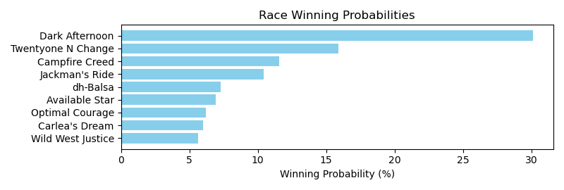

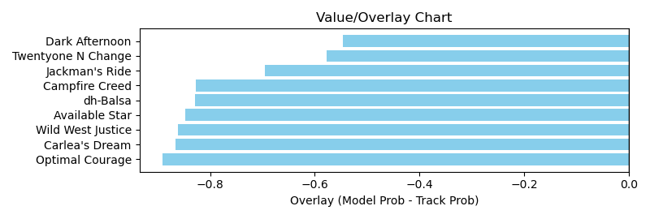

NOTE: GCSF - Global Combined Speed Figure

# Race: HOU | 2025-03-29 | Race #3 | Post: 14:00 | Track: SAM HOUSTON RACE PARK

Track: SAM HOUSTON RACE PARK

|  |  |  |  |  |  |
| --- | --- | --- | --- | --- | --- |
| Program # | Horse Name | Morn Odds | GCSF | Model Score | Win Prob (%) |
| 1 | Dulce Amanecer Yg | 20-1 | 91.6 | 0.81 | 1.35 |
| 2 | Speak Softly | 4-1 | 93.0 | 1.29 | 14.72 |
| 3 | Bling Baby | 3-1 | 100.9 | 1.31 | 15.50 |
| 4 | Texas Moon | 9-2 | 93.8 | 1.18 | 9.39 |
| 5 | Naval Woman | 5-2 | 106.6 | 1.24 | 11.97 |
| 6 | Cajun Doll | 8-1 | 110.0 | 1.57 | 39.91 |
| 7 | Queen of Thunder | 30-1 | 117.4 | 0.60 | 0.29 |
| 8 | Blue Heavenly | 6-1 | 93.1 | 1.12 | 6.88 |

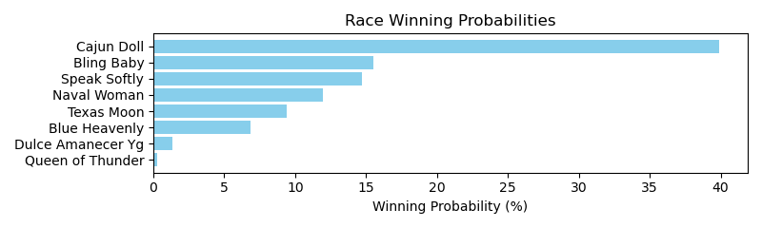

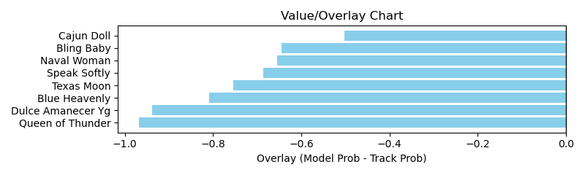

NOTE: GCSF - Global Combined Speed Figure

# Race: HOU | 2025-03-30 | Race #5 | Post: 15:00 | Track: SAM HOUSTON RACE PARK

Track: SAM HOUSTON RACE PARK

|  |  |  |  |  |  |
| --- | --- | --- | --- | --- | --- |
| Program # | Horse Name | Morn Odds | GCSF | Model Score | Win Prob (%) |
| 1 | Just Hangin Ridge | 30-1 | 98.8 | 0.66 | 0.44 |
| 2 | Silver Assassin | 3-1 | 89.6 | 1.37 | 18.61 |
| 3 | Ghurair's Warrior | 20-1 | 96.2 | 0.75 | 0.82 |
| 4 | Baby of the Family | 15-1 | 93.8 | 1.17 | 8.39 |
| 5 | The Devil's Bet | 5-2 | 105.9 | 1.64 | 47.01 |
| 6 | Texas Creed | 9-2 | 105.2 | 1.20 | 9.55 |
| 7 | Crazy Ridge | 20-1 | 95.5 | 0.94 | 2.70 |
| 8 | Daryls Trump Card | 6-1 | 101.3 | 1.14 | 7.23 |
| 9 | Flying Caesar | 12-1 | 101.2 | 0.97 | 3.15 |
| 10 | Sparra | 8-1 | 94.8 | 0.90 | 2.08 |

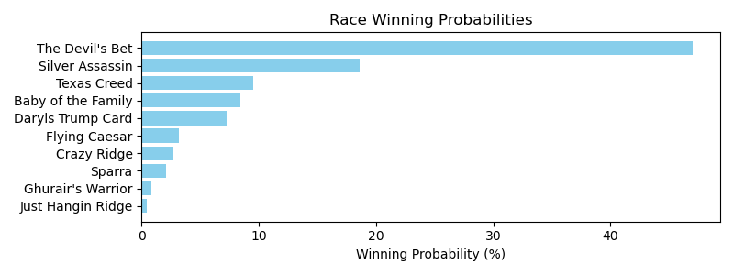

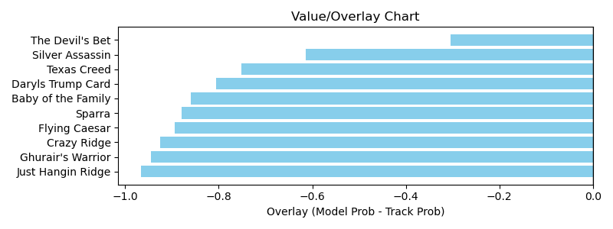

NOTE: GCSF - Global Combined Speed Figure

# Race: HOU | 2025-03-30 | Race #6 | Post: 15:35 | Track: SAM HOUSTON RACE PARK

Track: SAM HOUSTON RACE PARK

|  |  |  |  |  |  |
| --- | --- | --- | --- | --- | --- |
| Program # | Horse Name | Morn Odds | GCSF | Model Score | Win Prob (%) |
| 1 | Levy | 20-1 | 108.1 | 1.08 | 3.08 |
| 2 | United Patriot | 8-1 | 120.1 | 1.12 | 3.75 |
| 3 | Deanos Cape | 6-1 | 99.4 | 1.13 | 3.87 |
| 4 | Playboy Style | 30-1 | 90.8 | 0.91 | 1.33 |
| 5 | Special Moment | 8-1 | 95.4 | 1.23 | 6.18 |
| 6 | Cool Memory | 20-1 | 90.7 | 0.94 | 1.51 |
| 7 | Shamayim | 4-1 | 97.4 | 1.87 | 52.74 |
| 8 | Hamazing Wisdom | 12-1 | 99.2 | 1.04 | 2.53 |
| 9 | Catholic Guilt | 5-2 | 96.2 | 1.54 | 19.45 |
| 10 | Legendary Lore | 7-2 | 118.8 | 1.21 | 5.54 |

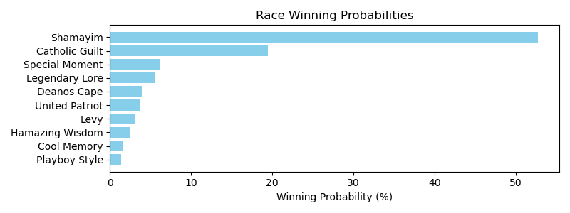

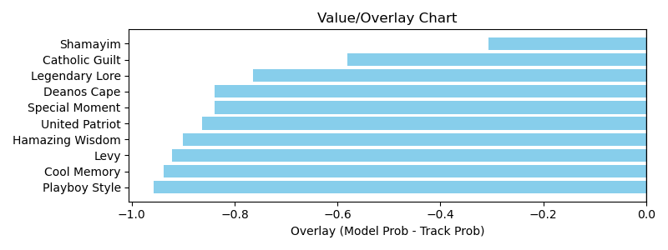

NOTE: GCSF - Global Combined Speed Figure

# Race: HOU | 2025-03-30 | Race #7 | Post: 16:05 | Track: SAM HOUSTON RACE PARK

Track: SAM HOUSTON RACE PARK

|  |  |  |  |  |  |
| --- | --- | --- | --- | --- | --- |
| Program # | Horse Name | Morn Odds | GCSF | Model Score | Win Prob (%) |
| 1 | Turn North | 6-5 | 91.4 | 1.78 | 52.65 |
| 2 | Texas Holdem | 6-1 | 101.0 | 1.26 | 9.05 |
| 3 | Essay | 20-1 | 92.6 | 0.81 | 0.92 |
| 4 | Tigers 'n Bears | 10-1 | 95.4 | 1.06 | 3.68 |
| 5 | My Little Prince | 8-1 | 112.0 | 0.85 | 1.18 |
| 6 | Fort Hood | 9-2 | 105.7 | 1.19 | 6.71 |
| 7 | Tx Code | 7-2 | 93.4 | 1.55 | 25.81 |

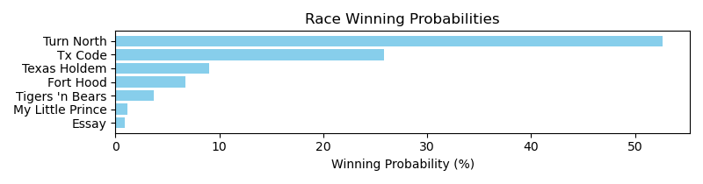

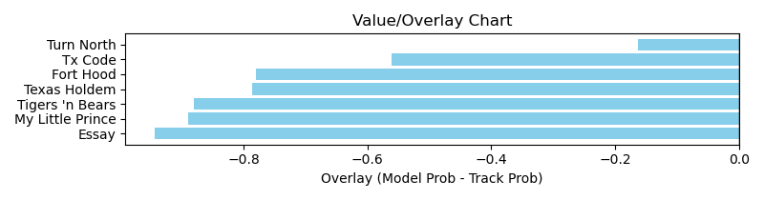

NOTE: GCSF - Global Combined Speed Figure

# Race: TSA | 2025-03-28 | Race #2 | Post: 13:32 | Track: SANTA ANITA PARK

Track: SANTA ANITA PARK

|  |  |  |  |  |  |
| --- | --- | --- | --- | --- | --- |
| Program # | Horse Name | Morn Odds | GCSF | Model Score | Win Prob (%) |
| 1 | Icy Mischief | 12-1 | 98.4 | 1.53 | 38.00 |
| 2 | Woodbine Way | 6-1 | 94.3 | 1.19 | 10.54 |
| 3 | Discrepancy | 9-5 | 99.6 | 1.34 | 19.45 |
| 4 | Chollima | 8-1 | 98.3 | 1.25 | 13.74 |
| 5 | Tiger Queen | 2-1 | 85.0 | 1.14 | 8.59 |
| 6 | Just Is | 10-1 | 87.3 | 1.05 | 5.49 |
| 7 | Queen of the Track | 12-1 | 91.0 | 1.00 | 4.20 |

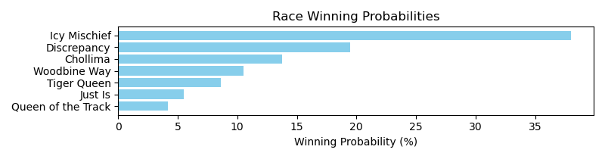

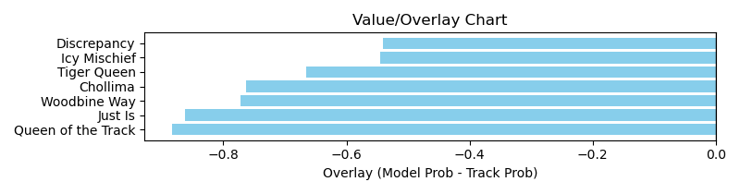

NOTE: GCSF - Global Combined Speed Figure

# Race: TSA | 2025-03-28 | Race #7 | Post: 16:08 | Track: SANTA ANITA PARK

Track: SANTA ANITA PARK

|  |  |  |  |  |  |
| --- | --- | --- | --- | --- | --- |
| Program # | Horse Name | Morn Odds | GCSF | Model Score | Win Prob (%) |
| 1 | El Rey Rey | 9-2 | 97.8 | 1.98 | 22.11 |
| 2 | Nitti (IRE) | 8-1 | 98.0 | 1.19 | 1.61 |
| 3 | dh-Escape Artist | 20-1 | 97.9 | 1.29 | 2.48 |
| 4 | Blamethegoodtimes | 6-1 | 105.4 | 1.33 | 2.92 |
| 5 | Maltese Falcon (IRE) | 9-2 | 111.8 | 1.48 | 4.97 |
| 6 | Coalinga Road | 5-1 | 97.0 | 1.46 | 4.57 |
| 7 | Invigorated | 20-1 | 106.3 | 1.23 | 1.93 |
| 8 | Zalamo (FR) | 5-1 | 110.3 | 2.38 | 57.14 |
| 9 | None Above the Law | 7-2 | 97.3 | 1.27 | 2.27 |

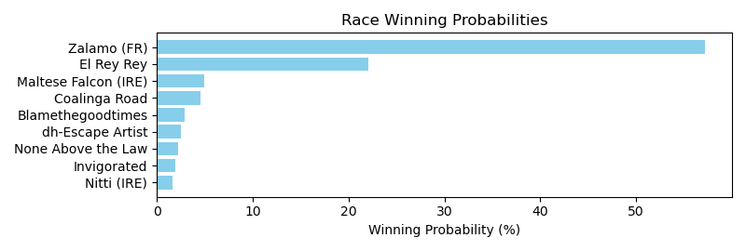

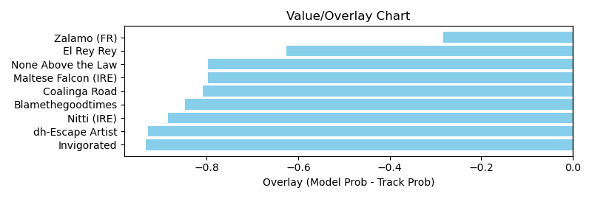

NOTE: GCSF - Global Combined Speed Figure

# Race: TSA | 2025-03-28 | Race #8 | Post: 16:38 | Track: SANTA ANITA PARK

Track: SANTA ANITA PARK

|  |  |  |  |  |  |
| --- | --- | --- | --- | --- | --- |
| Program # | Horse Name | Morn Odds | GCSF | Model Score | Win Prob (%) |
| 1 | See Through It | 9-2 | 128.6 | 1.43 | 10.99 |
| 2 | Bartholdy | 9-5 | 111.6 | 1.30 | 6.78 |
| 3 | Il Bellator | 10-1 | 82.0 | 1.76 | 31.43 |
| 4 | Princess of Time | 20-1 | 106.6 | 1.46 | 12.24 |
| 5 | Cowboy Mike | 2-1 | 103.9 | 1.48 | 13.03 |
| 6 | Barely Funtional | 15-1 | 88.6 | 1.45 | 11.85 |
| 7 | American Admiral | 4-1 | 82.3 | 1.50 | 13.67 |

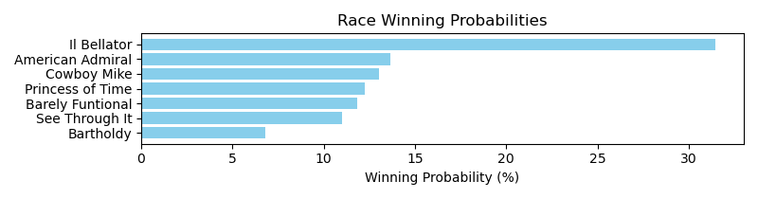

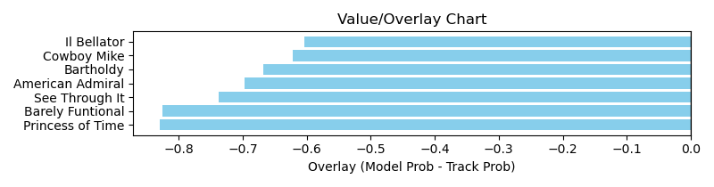

NOTE: GCSF - Global Combined Speed Figure

# Race: TSA | 2025-03-29 | Race #3 | Post: 14:00 | Track: SANTA ANITA PARK

Track: SANTA ANITA PARK

|  |  |  |  |  |  |
| --- | --- | --- | --- | --- | --- |
| Program # | Horse Name | Morn Odds | GCSF | Model Score | Win Prob (%) |
| 1 | Pilot Commander | 5-8 | 95.3 | 1.79 | 32.74 |
| 2 | Fort Bragg | 3-1 | 99.2 | 1.54 | 15.28 |
| 3 | Spirit of Makena | 10-1 | 94.0 | 1.16 | 3.63 |
| 4 | For All Mankind | 7-2 | 99.3 | 1.82 | 36.50 |
| 5 | Vlahos | 12-1 | 101.3 | 1.46 | 11.85 |

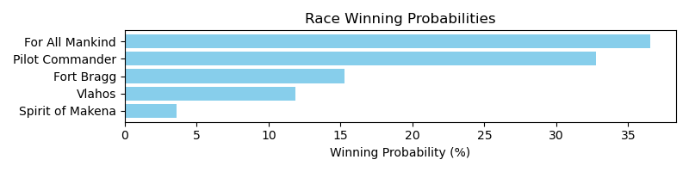

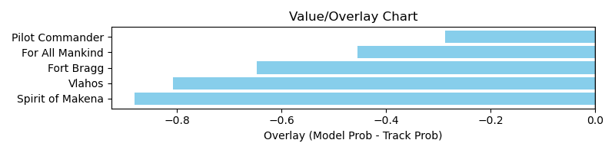

NOTE: GCSF - Global Combined Speed Figure

# Race: TSA | 2025-03-29 | Race #4 | Post: 14:30 | Track: SANTA ANITA PARK

Track: SANTA ANITA PARK

|  |  |  |  |  |  |
| --- | --- | --- | --- | --- | --- |
| Program # | Horse Name | Morn Odds | GCSF | Model Score | Win Prob (%) |
| 1 | Canani | 7-2 | 108.2 | 1.38 | 19.14 |
| 2 | Annan | 5-2 | 99.9 | 1.66 | 49.32 |
| 3 | Fight Back | 9-2 | 88.4 | 0.96 | 2.88 |
| 5 | Just a Graze | 4-1 | 102.6 | 1.09 | 5.72 |
| 6 | Fincairn | 30-1 | 90.3 | 0.75 | 0.81 |
| 7 | Glass of Jameson | 10-1 | 106.6 | 0.78 | 1.00 |
| 8 | Maxville | 30-1 | 105.5 | 1.03 | 4.15 |
| 9 | Going Nowhere | 6-1 | 93.4 | 1.31 | 14.53 |
| 10 | Sir Tom | 20-1 | 106.6 | 0.93 | 2.43 |

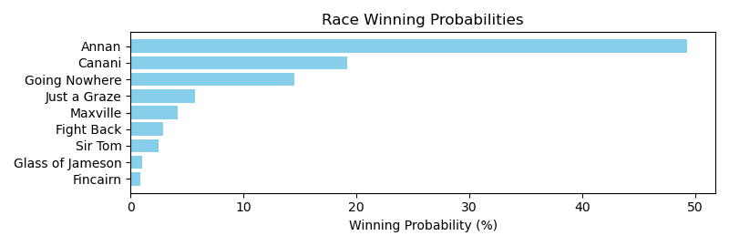

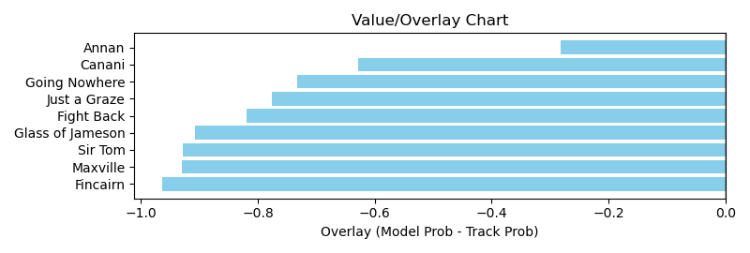

NOTE: GCSF - Global Combined Speed Figure

# Race: TSA | 2025-03-29 | Race #5 | Post: 15:08 | Track: SANTA ANITA PARK

Track: SANTA ANITA PARK

|  |  |  |  |  |  |
| --- | --- | --- | --- | --- | --- |
| Program # | Horse Name | Morn Odds | GCSF | Model Score | Win Prob (%) |
| 1 | Brother o' Brien | 7-2 | 102.0 | 1.20 | 11.75 |
| 2 | Mischief's Thirsty | 20-1 | 102.7 | 0.76 | 1.13 |
| 3 | Union Wave | 5-1 | 94.7 | 1.44 | 29.05 |
| 4 | Happy Does | 9-5 | 96.9 | 1.46 | 31.84 |
| 5 | Chief Jackson | 30-1 | 93.5 | 0.92 | 2.96 |
| 6 | Supermazel | 6-1 | 89.6 | 1.09 | 7.01 |
| 7 | Lord Wimborne (IRE) | 15-1 | 85.6 | 0.89 | 2.46 |
| 8 | Divine Rascal | 10-1 | 121.2 | 0.92 | 2.98 |
| 9 | Wild Wager | 30-1 | 95.1 | 0.84 | 1.84 |
| 10 | Right Hand Ryder | 8-1 | 115.3 | 1.08 | 6.80 |
| 11 | Oh Great (IRE) | 20-1 | 112.4 | 0.87 | 2.18 |

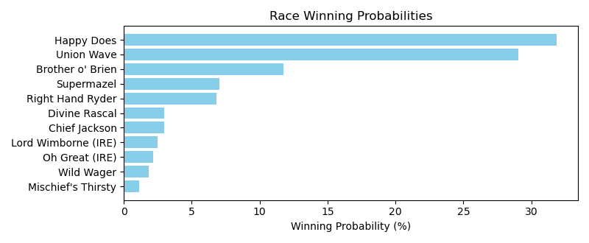

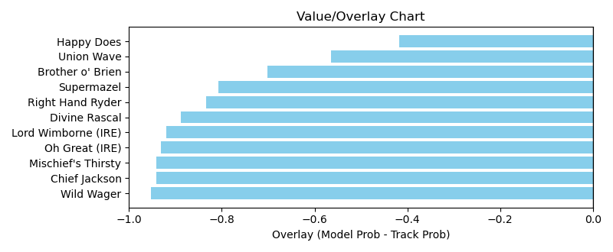

NOTE: GCSF - Global Combined Speed Figure

# Race: TSA | 2025-03-29 | Race #6 | Post: 15:38 | Track: SANTA ANITA PARK

Track: SANTA ANITA PARK

|  |  |  |  |  |  |
| --- | --- | --- | --- | --- | --- |
| Program # | Horse Name | Morn Odds | GCSF | Model Score | Win Prob (%) |
| 1 | Corporal Violette (IRE) | 30-1 | 95.2 | 1.05 | 3.79 |
| 2 | Happy | 5-1 | 93.5 | 1.14 | 5.72 |
| 3 | Lady Gregory | 3-1 | 90.7 | 1.46 | 21.00 |
| 4 | Over Attracted | 8-1 | 94.3 | 1.39 | 15.91 |
| 5 | Tiergarten | 12-1 | 97.6 | 1.24 | 8.99 |
| 6 | Dr. Ray D. | 30-1 | 97.2 | 1.17 | 6.55 |
| 7 | Unwritten Code | 6-1 | 92.6 | 1.41 | 16.96 |
| 8 | Champagne Camie | 10-1 | 104.9 | 1.21 | 7.90 |
| 9 | Lamporghini | 12-1 | 99.3 | 1.28 | 10.48 |
| 10 | Ivory Moon | 5-2 | 108.5 | 0.98 | 2.71 |

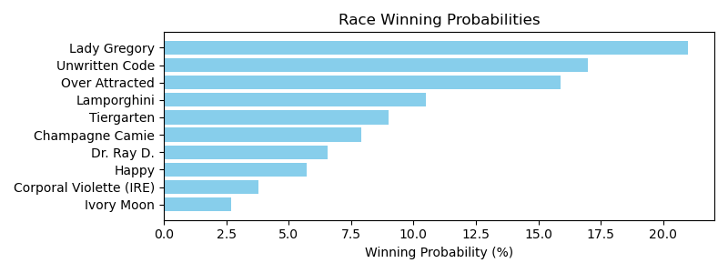

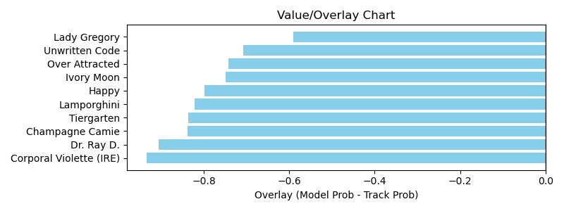

NOTE: GCSF - Global Combined Speed Figure

# Race: TSA | 2025-03-29 | Race #7 | Post: 16:10 | Track: SANTA ANITA PARK

Track: SANTA ANITA PARK

|  |  |  |  |  |  |
| --- | --- | --- | --- | --- | --- |
| Program # | Horse Name | Morn Odds | GCSF | Model Score | Win Prob (%) |
| 1 | Supermax | 6-1 | 95.7 | 1.10 | 7.50 |
| 2 | Big Bet | 10-1 | 89.3 | 0.96 | 3.69 |
| 3 | Petesoldfashioned | 8-1 | 89.2 | 1.41 | 26.95 |
| 4 | Tiger Strength | 30-1 | 112.9 | 0.67 | 0.59 |
| 5 | Cupid's Crusader | 7-2 | 91.9 | 1.18 | 10.76 |
| 6 | Sir Maximus | 5-1 | 108.0 | 1.19 | 11.03 |
| 7 | Swift Stephan | 20-1 | 106.6 | 0.82 | 1.66 |
| 8 | Battle Cruiser | 5-1 | 94.3 | 1.11 | 7.84 |
| 9 | Bowtie Boys | 5-2 | 89.6 | 1.44 | 29.99 |

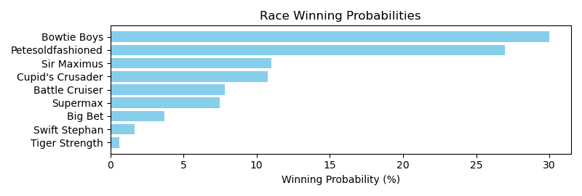

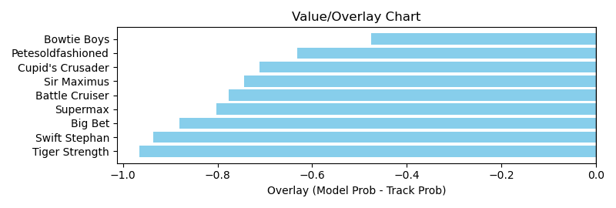

NOTE: GCSF - Global Combined Speed Figure

# Race: TSA | 2025-03-29 | Race #8 | Post: 16:43 | Track: SANTA ANITA PARK

Track: SANTA ANITA PARK

|  |  |  |  |  |  |
| --- | --- | --- | --- | --- | --- |
| Program # | Horse Name | Morn Odds | GCSF | Model Score | Win Prob (%) |
| 1 | Tirupati | 7-5 | 99.3 | 1.89 | 43.87 |
| 2 | Tahini | 15-1 | 97.0 | 1.07 | 2.40 |
| 3 | Alpha Bella | 2-1 | 96.1 | 1.54 | 15.17 |
| 4 | Desert Rhapsody | 20-1 | 98.2 | 1.30 | 6.34 |
| 5 | Uncorked (AUS) | 5-2 | 105.9 | 1.39 | 9.04 |
| 6 | Sophisticate | 12-1 | 102.0 | 1.59 | 17.93 |
| 7 | Big Hug | 30-1 | 97.4 | 1.25 | 5.26 |

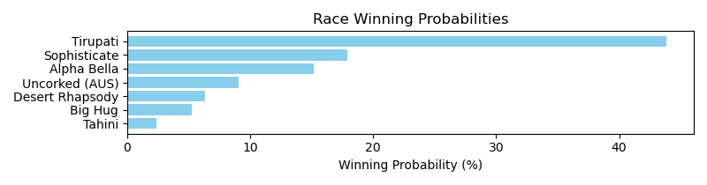

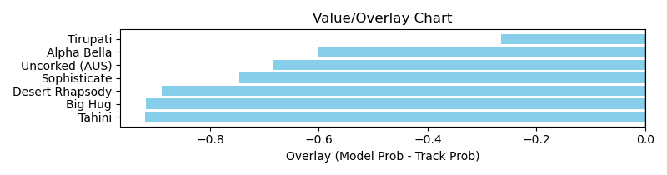

NOTE: GCSF - Global Combined Speed Figure

# Race: TSA | 2025-03-29 | Race #9 | Post: 17:12 | Track: SANTA ANITA PARK

Track: SANTA ANITA PARK

|  |  |  |  |  |  |
| --- | --- | --- | --- | --- | --- |
| Program # | Horse Name | Morn Odds | GCSF | Model Score | Win Prob (%) |
| 1 | Momad | 5-1 | 93.4 | 1.69 | 15.07 |
| 2 | Positivity | 4-1 | 104.2 | 1.85 | 24.22 |
| 3 | Kangaroo Court | 20-1 | 93.0 | 0.94 | 0.74 |
| 4 | Grubauer | 5-2 | 109.2 | 1.97 | 33.28 |
| 5 | Touchdown Brown | 8-1 | 87.1 | 1.62 | 12.22 |
| 6 | Tessuto | 6-1 | 101.9 | 1.31 | 4.03 |
| 7 | Shortman | 30-1 | 90.7 | 0.93 | 0.71 |
| 8 | Mbagnick (CHI) | 8-1 | 104.5 | 1.43 | 6.28 |
| 9 | Devil Among Us | 5-1 | 115.3 | 1.27 | 3.45 |

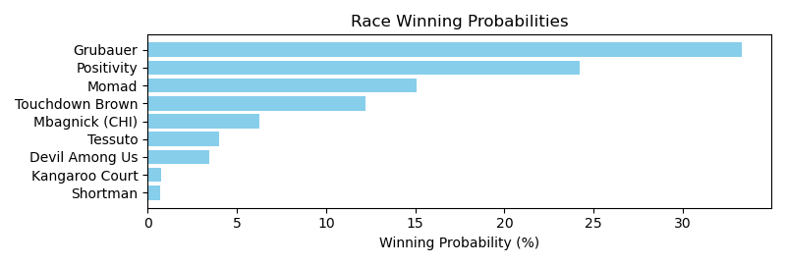

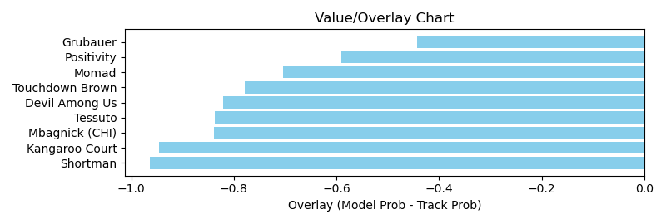

NOTE: GCSF - Global Combined Speed Figure

# Race: SUN | 2025-03-28 | Race #1 | Post: 12:25 | Track: SUNLAND PARK

Track: SUNLAND PARK

|  |  |  |  |  |  |
| --- | --- | --- | --- | --- | --- |
| Program # | Horse Name | Morn Odds | GCSF | Model Score | Win Prob (%) |
| 1 | Threecardmonte | 5-2 | 108.1 | 1.08 | 23.29 |
| 2 | Diablo Rosso | 5-1 | 102.0 | 0.91 | 9.70 |
| 4 | Scorpion Shot | 13-8 | 108.4 | 1.32 | 67.01 |

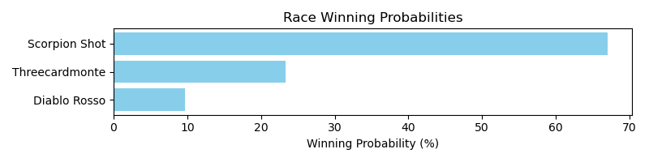

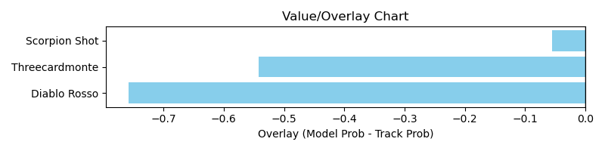

NOTE: GCSF - Global Combined Speed Figure

# Race: SUN | 2025-03-28 | Race #2 | Post: 12:50 | Track: SUNLAND PARK

Track: SUNLAND PARK

|  |  |  |  |  |  |
| --- | --- | --- | --- | --- | --- |
| Program # | Horse Name | Morn Odds | GCSF | Model Score | Win Prob (%) |
| 1 | Bye Bye Liam | 3-2 | 93.0 | 1.14 | 100.00 |

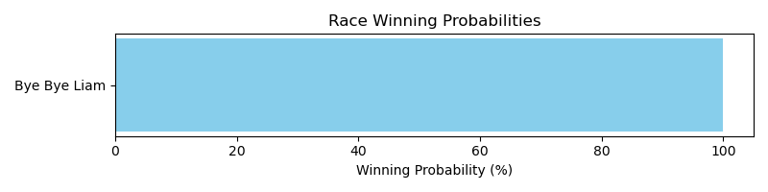

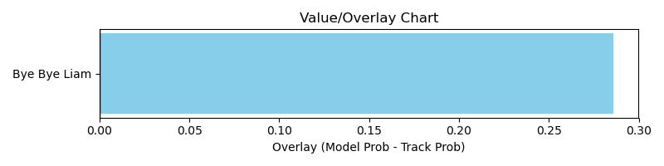

NOTE: GCSF - Global Combined Speed Figure

# Race: SUN | 2025-03-28 | Race #3 | Post: 13:15 | Track: SUNLAND PARK

Track: SUNLAND PARK

|  |  |  |  |  |  |
| --- | --- | --- | --- | --- | --- |
| Program # | Horse Name | Morn Odds | GCSF | Model Score | Win Prob (%) |
| 3 | And Change | 10-1 | 101.9 | 0.98 | 100.00 |

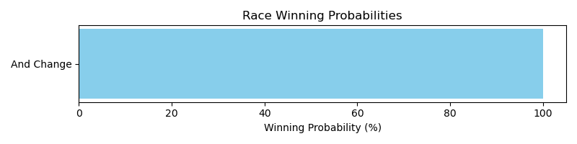

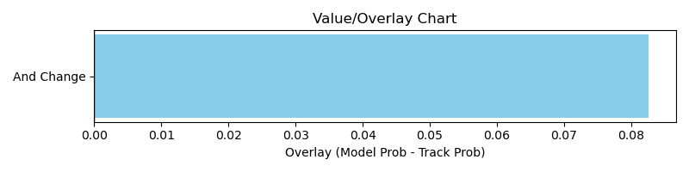

NOTE: GCSF - Global Combined Speed Figure

# Race: SUN | 2025-03-28 | Race #6 | Post: 14:31 | Track: SUNLAND PARK

Track: SUNLAND PARK

|  |  |  |  |  |  |
| --- | --- | --- | --- | --- | --- |
| Program # | Horse Name | Morn Odds | GCSF | Model Score | Win Prob (%) |
| 2 | Win Worthy | 15-1 | 103.4 | 1.12 | 100.00 |

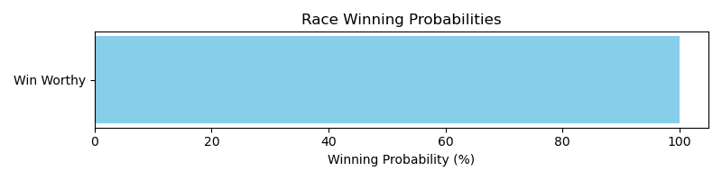

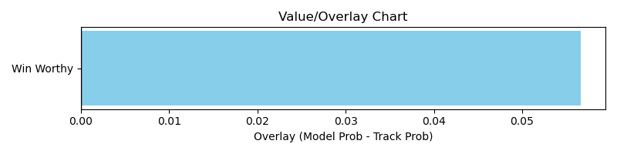

NOTE: GCSF - Global Combined Speed Figure

# Race: SUN | 2025-03-28 | Race #10 | Post: 16:15 | Track: SUNLAND PARK

Track: SUNLAND PARK

|  |  |  |  |  |  |
| --- | --- | --- | --- | --- | --- |
| Program # | Horse Name | Morn Odds | GCSF | Model Score | Win Prob (%) |
| 5 | Souped Up Wildcat | 12-1 | 100.0 | 1.08 | 43.67 |
| 6 | Sirrah | 8-1 | 100.0 | 1.14 | 56.33 |

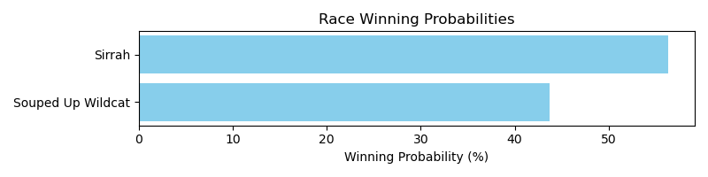

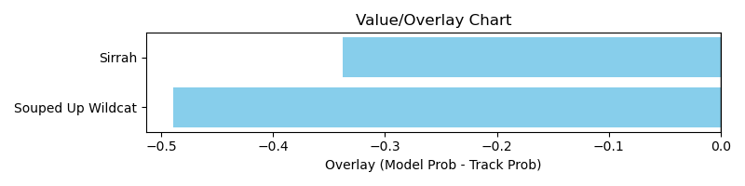

NOTE: GCSF - Global Combined Speed Figure

# Race: TAM | 2025-03-28 | Race #1 | Post: 12:30 | Track: TAMPA BAY DOWNS

Track: TAMPA BAY DOWNS

|  |  |  |  |  |  |
| --- | --- | --- | --- | --- | --- |
| Program # | Horse Name | Morn Odds | GCSF | Model Score | Win Prob (%) |
| 1 | Vino Veloce | 6-1 | 109.7 | 0.99 | 6.79 |
| 2 | Laughintothebank | 9-2 | 89.0 | 0.98 | 6.48 |
| 3 | Pola of Trouble | 4-1 | 103.7 | 1.00 | 7.07 |
| 4 | One Violent Affair | 9-5 | 93.1 | 1.51 | 59.50 |
| 5 | Thank the Academy | 5-2 | 108.1 | 1.13 | 13.37 |
| 6 | Heartburn | 10-1 | 99.6 | 0.99 | 6.80 |

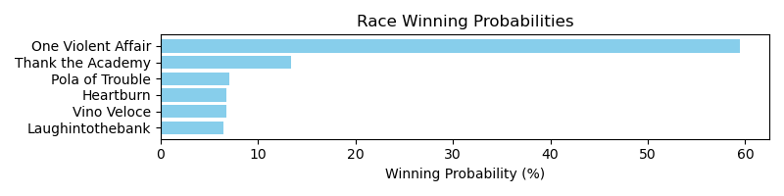

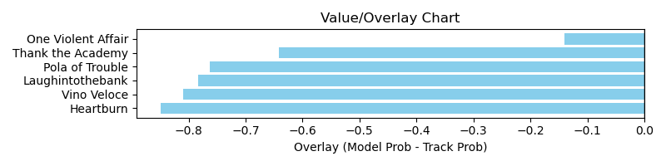

NOTE: GCSF - Global Combined Speed Figure

# Race: TAM | 2025-03-28 | Race #2 | Post: 13:00 | Track: TAMPA BAY DOWNS

Track: TAMPA BAY DOWNS

|  |  |  |  |  |  |
| --- | --- | --- | --- | --- | --- |
| Program # | Horse Name | Morn Odds | GCSF | Model Score | Win Prob (%) |
| 1 | Utopia Rose | 9-5 | 93.3 | 1.23 | 32.07 |
| 2 | Wonderfulvenezuela | 5-1 | 96.3 | 1.01 | 11.33 |
| 3 | Repaynt | 5-2 | 98.3 | 1.18 | 25.55 |
| 4 | Mya C | 15-1 | 108.1 | 0.93 | 7.50 |
| 5 | Shamu | 9-2 | 96.5 | 1.06 | 14.74 |
| 6 | Mia's Angel | 12-1 | 92.4 | 0.81 | 3.82 |
| 7 | Pesadilla Chanel | 8-1 | 114.6 | 0.86 | 4.99 |

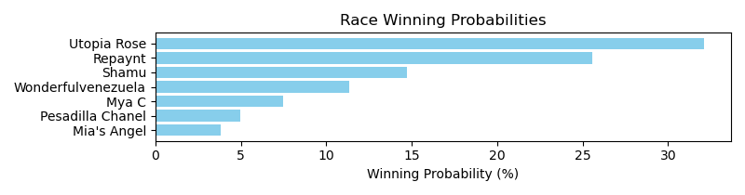

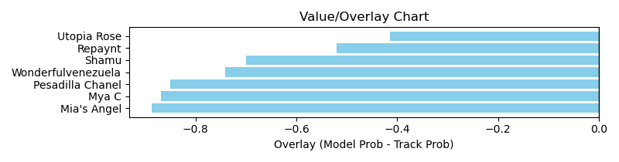

NOTE: GCSF - Global Combined Speed Figure

# Race: TAM | 2025-03-28 | Race #3 | Post: 13:30 | Track: TAMPA BAY DOWNS

Track: TAMPA BAY DOWNS

|  |  |  |  |  |  |
| --- | --- | --- | --- | --- | --- |
| Program # | Horse Name | Morn Odds | GCSF | Model Score | Win Prob (%) |
| 1 | God With Us | 3-1 | 88.3 | 1.28 | 27.41 |
| 2 | Dunedin Causeway | 20-1 | 108.2 | 1.06 | 10.13 |
| 3 | Sincerito | 10-1 | 99.5 | 1.18 | 17.80 |
| 4 | Guaio | 9-5 | 108.7 | 1.31 | 30.09 |
| 5 | Sharp Play Boy | 9-2 | 92.5 | 0.75 | 1.73 |
| 6 | Snowname | 4-1 | 109.1 | 1.09 | 11.77 |
| 7 | Running Bayou | 6-1 | 93.4 | 0.68 | 1.08 |

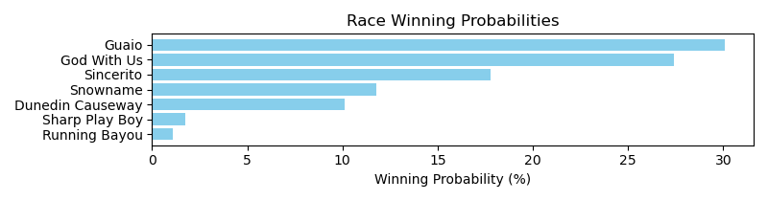

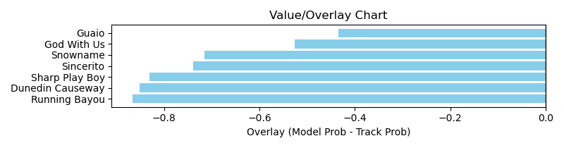

NOTE: GCSF - Global Combined Speed Figure

# Race: TAM | 2025-03-28 | Race #5 | Post: 14:35 | Track: TAMPA BAY DOWNS

Track: TAMPA BAY DOWNS

|  |  |  |  |  |  |
| --- | --- | --- | --- | --- | --- |
| Program # | Horse Name | Morn Odds | GCSF | Model Score | Win Prob (%) |
| 1 | My Jannet | 20-1 | 84.1 | 0.82 | 1.46 |
| 2 | Miss Taptress | 4-1 | 101.5 | 1.09 | 6.24 |
| 3 | Whispering Sea | 12-1 | 109.6 | 0.95 | 3.03 |
| 4 | Special Affair | 8-1 | 95.6 | 1.05 | 5.23 |
| 5 | Permed | 10-1 | 93.2 | 1.19 | 9.85 |
| 6 | Spring Spinning | 30-1 | 96.0 | 0.72 | 0.72 |
| 7 | Lucky Girl Coco | 20-1 | 99.2 | 0.94 | 2.88 |
| 8 | Aztec Princess | 10-1 | 106.6 | 1.16 | 8.55 |
| 9 | Chilling Factor | 20-1 | 99.1 | 0.81 | 1.38 |
| 10 | Allons | 7-2 | 99.6 | 1.34 | 18.15 |
| 11 | Real Mikey | 12-1 | 98.9 | 1.13 | 7.45 |
| 12 | Girly the Butcher | 5-2 | 108.4 | 1.45 | 27.10 |
| 13 | Sadie Baby | 20-1 | 109.6 | 1.06 | 5.46 |
| 14 | Armonia | 20-1 | 96.8 | 0.91 | 2.50 |

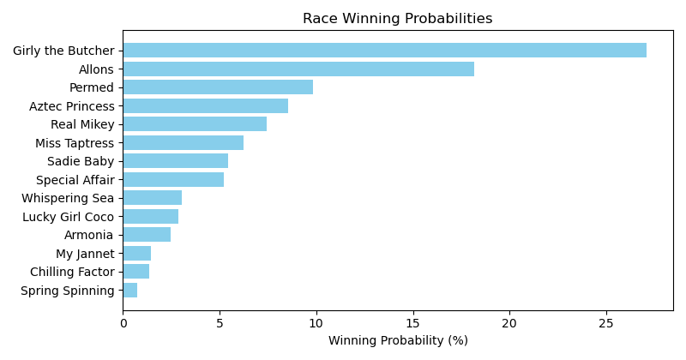

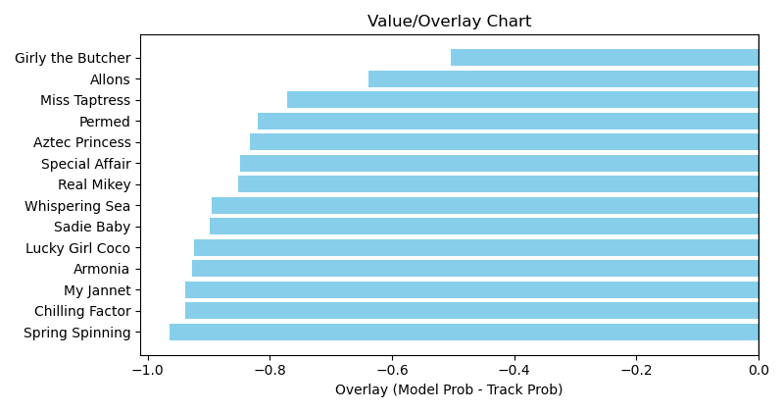

NOTE: GCSF - Global Combined Speed Figure

# Race: TAM | 2025-03-28 | Race #7 | Post: 15:35 | Track: TAMPA BAY DOWNS

Track: TAMPA BAY DOWNS

|  |  |  |  |  |  |
| --- | --- | --- | --- | --- | --- |
| Program # | Horse Name | Morn Odds | GCSF | Model Score | Win Prob (%) |
| 1 | Benvolio | 6-1 | 93.2 | 1.23 | 7.55 |
| 2 | Talkscheap | 30-1 | 109.7 | 0.76 | 0.64 |
| 3 | Sam Stormy | 7-2 | 94.3 | 1.35 | 12.23 |
| 4 | Toro Forward | 12-1 | 91.5 | 1.18 | 6.14 |
| 5 | Magic Heart | 9-2 | 87.8 | 1.40 | 14.84 |
| 6 | Tapintoyourbeer | 30-1 | 93.3 | 0.83 | 1.00 |
| 7 | Oskar Martinez (IRE) | 5-2 | 94.0 | 1.69 | 38.51 |
| 8 | Peace Not War | 3-1 | 96.0 | 1.43 | 16.26 |
| 9 | Mintenon | 20-1 | 126.3 | 0.98 | 2.33 |
| 10 | Overhaul | 30-1 | 107.0 | 0.73 | 0.51 |

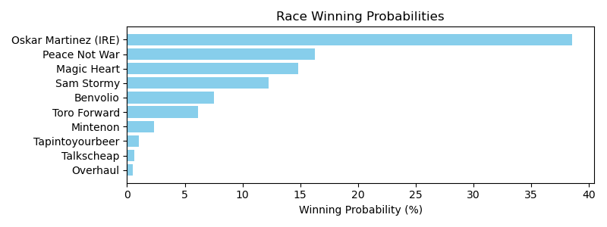

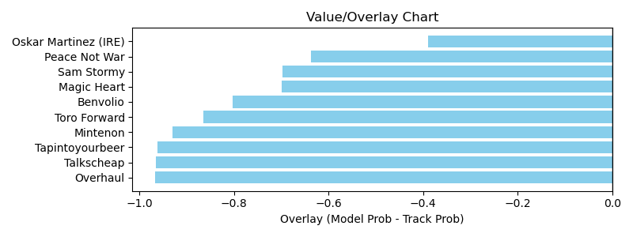

NOTE: GCSF - Global Combined Speed Figure

# Race: TAM | 2025-03-28 | Race #9 | Post: 16:35 | Track: TAMPA BAY DOWNS

Track: TAMPA BAY DOWNS

|  |  |  |  |  |  |
| --- | --- | --- | --- | --- | --- |
| Program # | Horse Name | Morn Odds | GCSF | Model Score | Win Prob (%) |
| 1 | Max's Map | 15-1 | 116.3 | 1.32 | 11.23 |
| 2 | Paxton | 30-1 | 94.6 | 0.85 | 1.18 |
| 3 | Vesting (IRE) | 9-5 | 92.3 | 1.71 | 42.89 |
| 4 | Lonely Ride | 10-1 | 105.0 | 1.11 | 4.71 |
| 5 | Night Ride | 20-1 | 112.3 | 1.12 | 4.95 |
| 6 | Why Not Me | 9-2 | 88.3 | 1.31 | 10.90 |
| 7 | Gold Templar | 30-1 | 97.7 | 0.91 | 1.68 |
| 8 | Sesame Seed Bagel | 12-1 | 108.3 | 0.65 | 0.31 |
| 9 | Prince of Ayrshire | 20-1 | 110.5 | 0.94 | 1.96 |
| 10 | Sonic Speed | 8-1 | 93.9 | 1.10 | 4.49 |
| 11 | Quatrocento | 9-2 | 96.1 | 1.37 | 13.72 |
| 12 | Drunk On Sake | 6-1 | 84.3 | 0.94 | 1.99 |

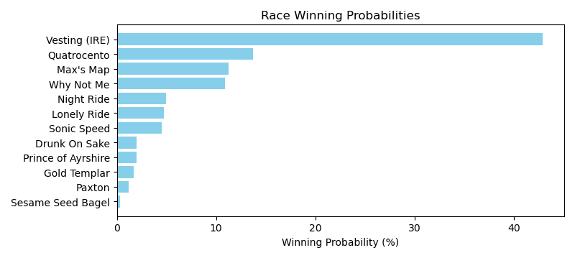

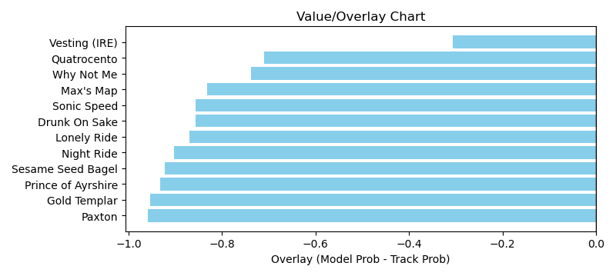

NOTE: GCSF - Global Combined Speed Figure

# Race: TAM | 2025-03-29 | Race #1 | Post: 12:15 | Track: TAMPA BAY DOWNS

Track: TAMPA BAY DOWNS

|  |  |  |  |  |  |
| --- | --- | --- | --- | --- | --- |
| Program # | Horse Name | Morn Odds | GCSF | Model Score | Win Prob (%) |
| 1 | Big Toby | 20-1 | 104.8 | 0.92 | 5.68 |
| 2 | Piccata Prince | 10-1 | 103.7 | 0.85 | 3.72 |
| 3 | Shipwreck | 30-1 | 127.2 | 0.88 | 4.70 |
| 4 | Midnight Onyx | 2-1 | 101.9 | 1.12 | 15.53 |
| 5 | Starship Tango | 4-1 | 109.8 | 0.89 | 4.91 |
| 6 | Colors | 20-1 | 86.4 | 0.71 | 1.56 |
| 7 | Eternal Glory | 7-2 | 105.4 | 1.43 | 55.77 |
| 8 | Kohaku | 30-1 | 106.9 | 0.73 | 1.71 |
| 9 | Mama Banned Me | 5-2 | 116.0 | 0.94 | 6.41 |

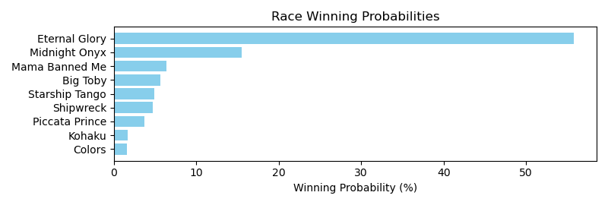

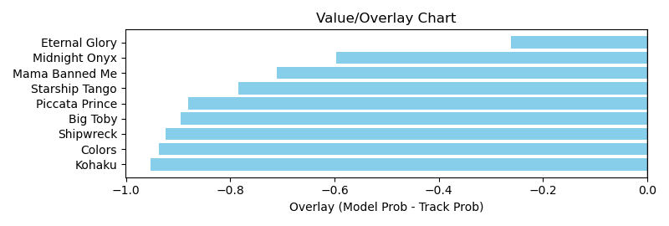

NOTE: GCSF - Global Combined Speed Figure

# Race: TAM | 2025-03-29 | Race #2 | Post: 12:45 | Track: TAMPA BAY DOWNS

Track: TAMPA BAY DOWNS

|  |  |  |  |  |  |
| --- | --- | --- | --- | --- | --- |
| Program # | Horse Name | Morn Odds | GCSF | Model Score | Win Prob (%) |
| 1 | Test Pilot | 12-1 | 92.4 | 1.00 | 6.12 |
| 2 | Lieutenant Stan | 6-1 | 108.0 | 1.13 | 11.58 |
| 3 | King Miano | 4-1 | 110.3 | 1.18 | 14.28 |
| 4 | Call Me Ice Man | 10-1 | 101.3 | 1.20 | 15.73 |
| 5 | Paynted Warrior | 8-1 | 99.2 | 0.85 | 2.59 |
| 6 | All the Rage | 12-1 | 94.7 | 0.87 | 3.01 |
| 7 | Baltasar | 13-8 | 105.2 | 1.40 | 35.08 |
| 8 | Arak | 4-1 | 90.5 | 1.13 | 11.60 |

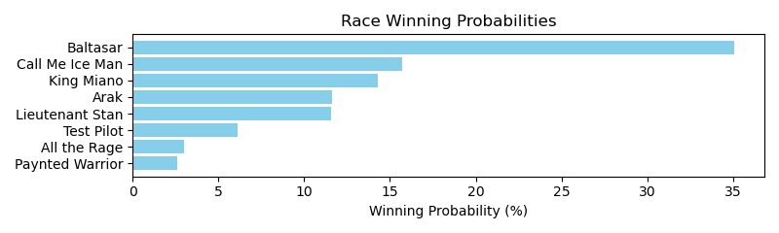

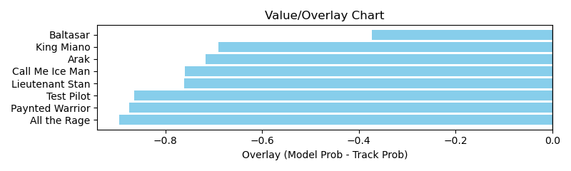

NOTE: GCSF - Global Combined Speed Figure

# Race: TAM | 2025-03-29 | Race #3 | Post: 13:16 | Track: TAMPA BAY DOWNS

Track: TAMPA BAY DOWNS

|  |  |  |  |  |  |
| --- | --- | --- | --- | --- | --- |
| Program # | Horse Name | Morn Odds | GCSF | Model Score | Win Prob (%) |
| 1 | Bingo Baby | 20-1 | 93.4 | 1.14 | 10.18 |
| 2 | Whirlwind | 4-1 | 103.3 | 1.31 | 20.84 |
| 3 | Classicals Finale | 12-1 | 96.3 | 0.93 | 3.61 |
| 4 | Kanjeng | 12-1 | 106.6 | 1.12 | 9.68 |
| 5 | O K to Dance | 30-1 | 109.0 | 0.97 | 4.45 |
| 6 | Alien Princess | 15-1 | 106.6 | 0.73 | 1.07 |
| 7 | Sparkling Ruby | 4-1 | 100.2 | 0.68 | 0.74 |
| 8 | Unbounded Movement | 7-2 | 96.7 | 1.42 | 32.13 |
| 9 | Step Lightly | 30-1 | 106.6 | 1.20 | 13.38 |
| 10 | Mia Vita | 5-2 | 91.3 | 0.71 | 0.89 |
| 11 | Aranciata | 15-1 | 96.4 | 0.90 | 3.02 |

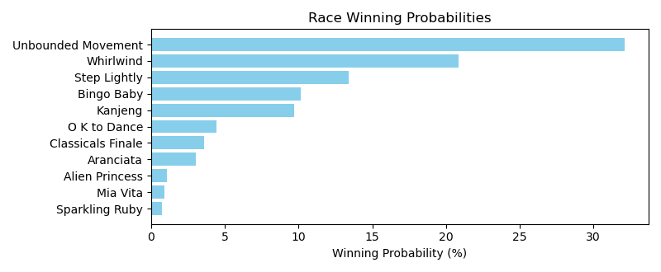

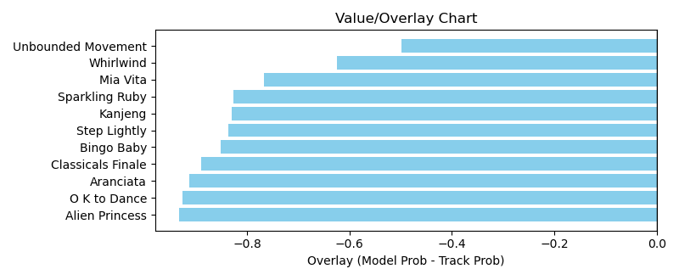

NOTE: GCSF - Global Combined Speed Figure

# Race: TAM | 2025-03-29 | Race #8 | Post: 15:56 | Track: TAMPA BAY DOWNS

Track: TAMPA BAY DOWNS

|  |  |  |  |  |  |
| --- | --- | --- | --- | --- | --- |
| Program # | Horse Name | Morn Odds | GCSF | Model Score | Win Prob (%) |
| 1 | Catatumbo | 6-1 | 96.7 | 1.40 | 7.67 |
| 2 | Lead Off | 30-1 | 94.0 | 0.99 | 1.28 |
| 3 | In Honor of Artie | 20-1 | 103.0 | 0.92 | 0.88 |
| 4 | The Doorman | 4-1 | 97.3 | 1.98 | 45.14 |
| 5 | Makizan | 20-1 | 115.2 | 0.96 | 1.06 |
| 6 | Golden Juan | 5-8 | 95.0 | 1.87 | 33.21 |
| 7 | Post Facto | 10-1 | 102.0 | 1.32 | 5.50 |
| 8 | Ghost Stalker | 30-1 | 87.8 | 0.95 | 1.01 |
| 9 | Hakkimi (CHI) | 30-1 | 123.8 | 0.72 | 0.25 |
| 10 | Le Griffon | 15-1 | 94.9 | 1.24 | 4.01 |

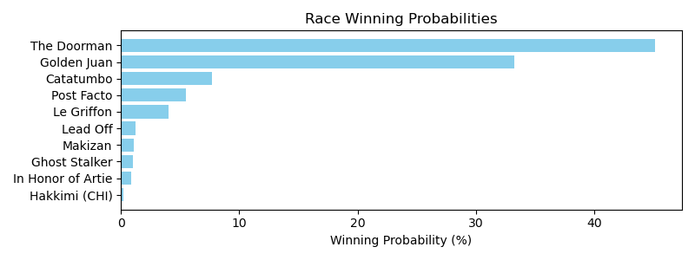

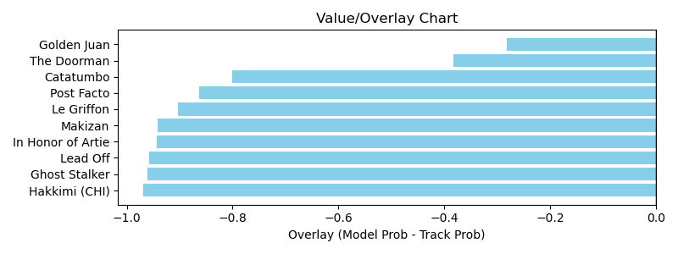

NOTE: GCSF - Global Combined Speed Figure

# Race: TAM | 2025-03-29 | Race #9 | Post: 16:35 | Track: TAMPA BAY DOWNS

Track: TAMPA BAY DOWNS

|  |  |  |  |  |  |
| --- | --- | --- | --- | --- | --- |
| Program # | Horse Name | Morn Odds | GCSF | Model Score | Win Prob (%) |
| 1 | Denying | 10-1 | 92.7 | 1.09 | 3.63 |
| 2 | Mongolian Apple | 9-2 | 82.3 | 1.23 | 6.53 |
| 3 | Indy Lyon | 12-1 | 110.8 | 1.01 | 2.44 |
| 4 | It's a Fact | 10-1 | 95.4 | 1.28 | 8.25 |
| 5 | Lookin to Excel | 30-1 | 126.4 | 1.02 | 2.53 |
| 6 | Leo Monte | 20-1 | 98.6 | 0.94 | 1.69 |
| 7 | The Best Distance | 30-1 | 94.7 | 0.98 | 2.05 |
| 8 | Burnin Turf | 5-2 | 91.3 | 1.62 | 27.18 |
| 9 | Skipperini | 10-1 | 112.4 | 0.97 | 1.93 |
| 10 | Dear Santa | 10-1 | 86.2 | 1.42 | 13.97 |
| 11 | More Than Work | 7-2 | 99.4 | 1.39 | 12.59 |
| 12 | Eddie the Great | 12-1 | 92.4 | 1.02 | 2.56 |
| 13 | English Painter | 8-1 | 84.1 | 1.39 | 12.39 |
| 14 | Opposites Attract | 8-1 | 93.1 | 1.00 | 2.25 |

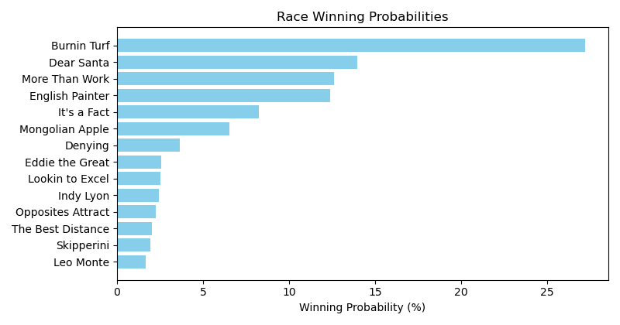

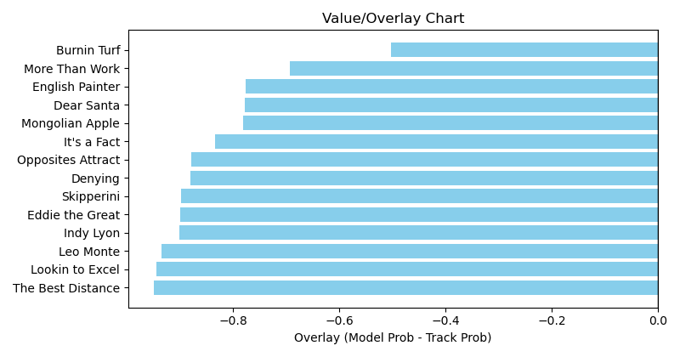

NOTE: GCSF - Global Combined Speed Figure

# Race: TUP | 2025-03-31 | Race #3 | Post: 13:51 | Track: TURF PARADISE

Track: TURF PARADISE

|  |  |  |  |  |  |
| --- | --- | --- | --- | --- | --- |
| Program # | Horse Name | Morn Odds | GCSF | Model Score | Win Prob (%) |
| 8 | Empire Warrior | 10-1 | 91.5 | 1.00 | 100.00 |

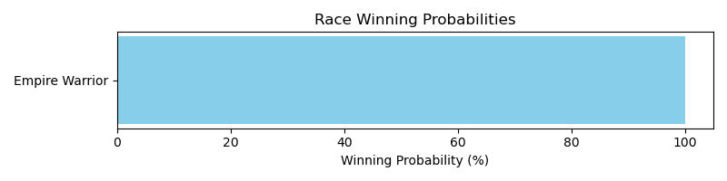

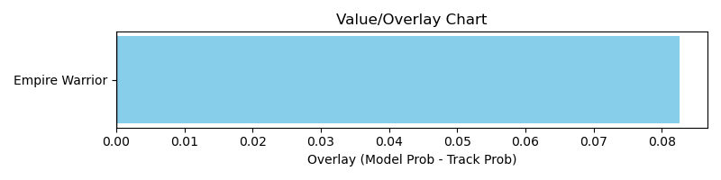

NOTE: GCSF - Global Combined Speed Figure

# Race: TUP | 2025-03-31 | Race #4 | Post: 14:20 | Track: TURF PARADISE

Track: TURF PARADISE

|  |  |  |  |  |  |
| --- | --- | --- | --- | --- | --- |
| Program # | Horse Name | Morn Odds | GCSF | Model Score | Win Prob (%) |
| 2 | Exxel | 5-1 | 94.0 | 1.33 | 17.78 |
| 3 | Itsallgoodman | 5-1 | 89.1 | 1.18 | 9.69 |
| 5 | Joe Don Looney | 2-1 | 115.8 | 1.42 | 24.86 |
| 7 | Ultimate | 7-2 | 104.6 | 1.61 | 47.67 |

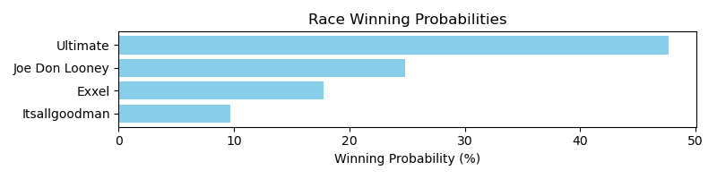

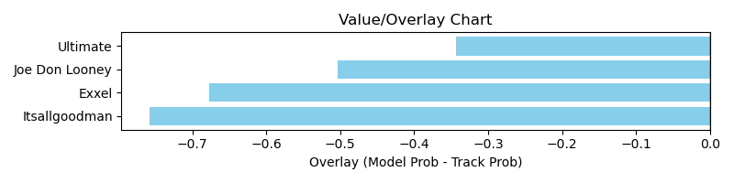

NOTE: GCSF - Global Combined Speed Figure

# Race: TUP | 2025-03-31 | Race #5 | Post: 14:49 | Track: TURF PARADISE

Track: TURF PARADISE

|  |  |  |  |  |  |
| --- | --- | --- | --- | --- | --- |
| Program # | Horse Name | Morn Odds | GCSF | Model Score | Win Prob (%) |
| 5 | Smoocherro | 6-1 | 100.0 | 0.91 | 100.00 |

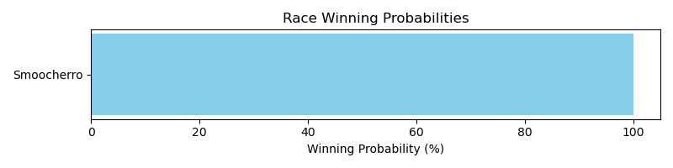

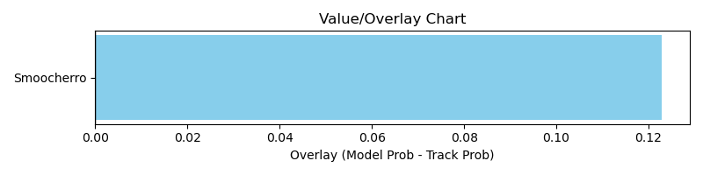

NOTE: GCSF - Global Combined Speed Figure

# Race: TUP | 2025-03-31 | Race #6 | Post: 15:18 | Track: TURF PARADISE

Track: TURF PARADISE

|  |  |  |  |  |  |
| --- | --- | --- | --- | --- | --- |
| Program # | Horse Name | Morn Odds | GCSF | Model Score | Win Prob (%) |
| 7 | Rocket Ribbon | 8-1 | 96.4 | 1.23 | 100.00 |

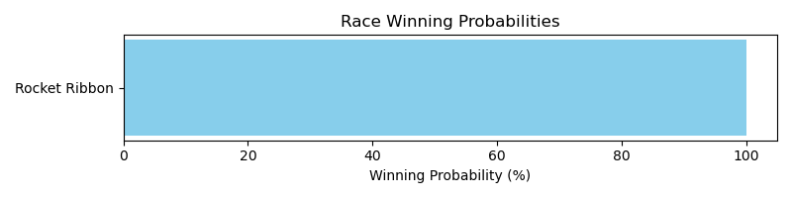

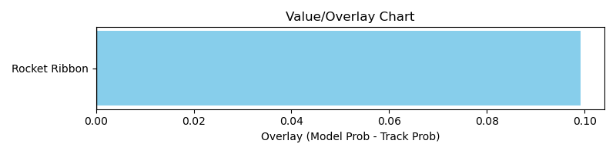

NOTE: GCSF - Global Combined Speed Figure

# Race: TUP | 2025-03-31 | Race #7 | Post: 15:47 | Track: TURF PARADISE

Track: TURF PARADISE

|  |  |  |  |  |  |
| --- | --- | --- | --- | --- | --- |
| Program # | Horse Name | Morn Odds | GCSF | Model Score | Win Prob (%) |
| 1 | Aspirational | 20-1 | 98.3 | 1.12 | 51.89 |
| 2 | Stanford Holiday | 4-1 | 89.5 | 0.68 | 4.03 |
| 10 | Solid Tune | 5-1 | 94.5 | 1.09 | 44.07 |

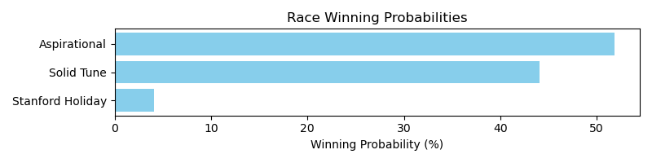

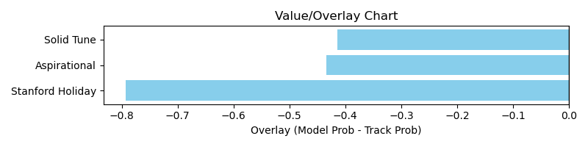

NOTE: GCSF - Global Combined Speed Figure

# Race: TUP | 2025-03-31 | Race #8 | Post: 16:16 | Track: TURF PARADISE

Track: TURF PARADISE

|  |  |  |  |  |  |
| --- | --- | --- | --- | --- | --- |
| Program # | Horse Name | Morn Odds | GCSF | Model Score | Win Prob (%) |
| 1 | Marinas Tina (IRE) | 5-2 | 112.8 | 1.60 | 47.65 |
| 2 | Poker Alice | 5-1 | 107.6 | 1.54 | 39.36 |
| 7 | Sunglasses (GB) | 9-2 | 94.3 | 1.08 | 6.37 |
| 8 | Una Palabra | 5-1 | 96.0 | 1.09 | 6.62 |

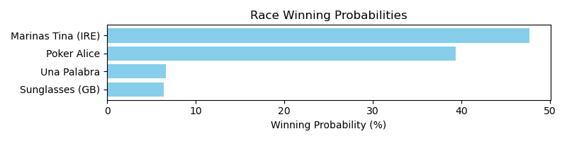

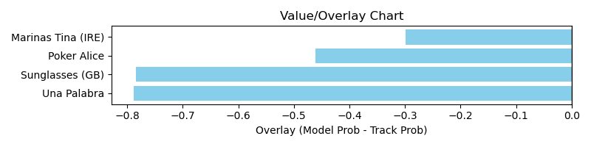

NOTE: GCSF - Global Combined Speed Figure

# Race: TUP | 2025-03-31 | Race #9 | Post: 16:45 | Track: TURF PARADISE

Track: TURF PARADISE

|  |  |  |  |  |  |
| --- | --- | --- | --- | --- | --- |
| Program # | Horse Name | Morn Odds | GCSF | Model Score | Win Prob (%) |
| 1 | Handsome Harry | 10-1 | 85.4 | 0.95 | 8.94 |
| 4 | Duplication | 4-1 | 101.6 | 1.14 | 22.14 |
| 11 | Horse Doctor | 3-1 | 117.6 | 1.42 | 68.92 |

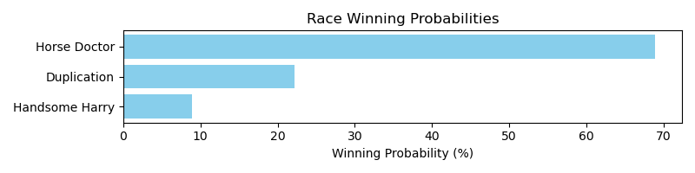

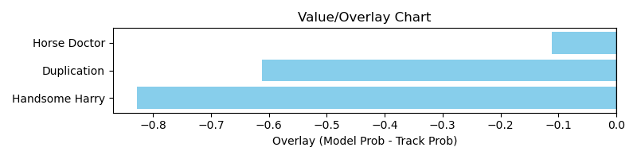

NOTE: GCSF - Global Combined Speed Figure

# Race: TUP | 2025-04-01 | Race #3 | Post: 13:55 | Track: TURF PARADISE

Track: TURF PARADISE

|  |  |  |  |  |  |
| --- | --- | --- | --- | --- | --- |
| Program # | Horse Name | Morn Odds | GCSF | Model Score | Win Prob (%) |
| 2 | Yellow Jacket | 10-1 | 89.2 | 1.03 | 9.40 |
| 3 | Chasin a Dollar | 5-1 | 100.6 | 1.25 | 25.11 |
| 4 | Whats the Buzz | 4-1 | 103.2 | 1.08 | 12.05 |
| 5 | Factory Drive | 3-1 | 96.1 | 1.16 | 17.16 |
| 7 | Cause for Divorce | 2-1 | 103.7 | 1.34 | 36.28 |

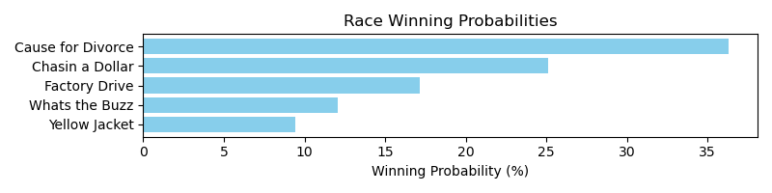

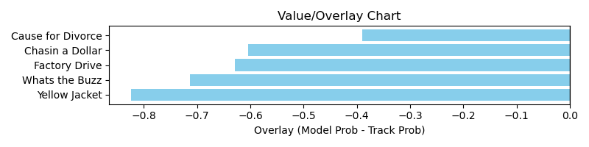

NOTE: GCSF - Global Combined Speed Figure

# Race: TUP | 2025-04-01 | Race #4 | Post: 14:25 | Track: TURF PARADISE

Track: TURF PARADISE

|  |  |  |  |  |  |
| --- | --- | --- | --- | --- | --- |
| Program # | Horse Name | Morn Odds | GCSF | Model Score | Win Prob (%) |
| 2 | Neon Lights (IRE) | 7-2 | 103.5 | 1.53 | 29.46 |
| 3 | Sbagliato | 9-2 | 92.3 | 1.77 | 61.48 |
| 5 | McClusky | 5-1 | 106.6 | 0.82 | 1.17 |
| 7 | Sanger | 2-1 | 97.8 | 1.19 | 7.89 |

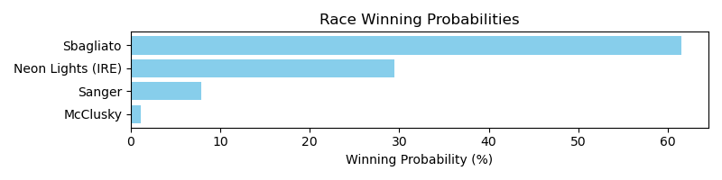

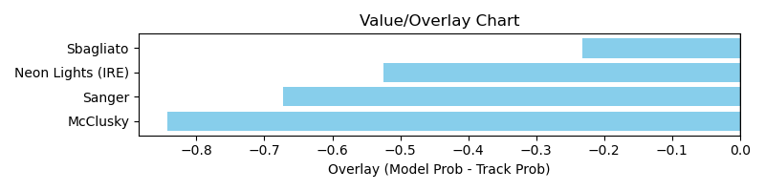

NOTE: GCSF - Global Combined Speed Figure

# Race: TUP | 2025-04-01 | Race #5 | Post: 14:54 | Track: TURF PARADISE

Track: TURF PARADISE

|  |  |  |  |  |  |
| --- | --- | --- | --- | --- | --- |
| Program # | Horse Name | Morn Odds | GCSF | Model Score | Win Prob (%) |
| 1 | Accidental Genius | 5-2 | 106.6 | 0.79 | 0.90 |
| 5 | Brownstone | 7-2 | 101.1 | 1.49 | 22.70 |
| 6 | For A Laugh (IRE) | 3-1 | 100.8 | 1.89 | 76.40 |

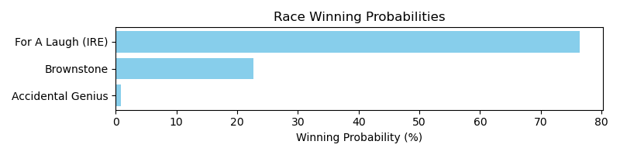

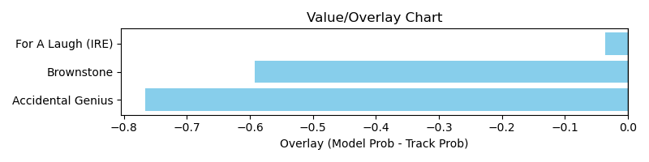

NOTE: GCSF - Global Combined Speed Figure

# Race: TUP | 2025-04-01 | Race #6 | Post: 15:23 | Track: TURF PARADISE

Track: TURF PARADISE

|  |  |  |  |  |  |
| --- | --- | --- | --- | --- | --- |
| Program # | Horse Name | Morn Odds | GCSF | Model Score | Win Prob (%) |
| 2 | The Scent | 3-1 | 89.2 | 1.35 | 100.00 |

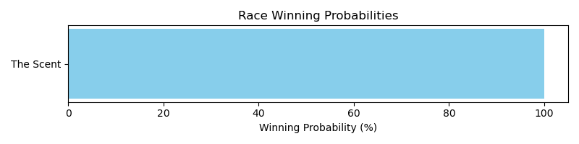

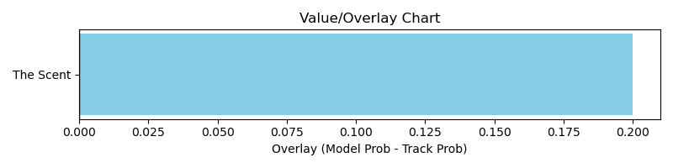

NOTE: GCSF - Global Combined Speed Figure

# Race: TUP | 2025-04-01 | Race #7 | Post: 15:52 | Track: TURF PARADISE

Track: TURF PARADISE

|  |  |  |  |  |  |
| --- | --- | --- | --- | --- | --- |
| Program # | Horse Name | Morn Odds | GCSF | Model Score | Win Prob (%) |
| 3 | Measureofdevotion | 10-1 | 105.8 | 0.79 | 2.22 |
| 4 | Joy in Grace | 6-1 | 94.0 | 1.49 | 57.36 |
| 6 | Loveaboveandbeyond | 13-8 | 102.4 | 1.31 | 30.43 |
| 8 | Zelaia | 5-1 | 90.9 | 1.06 | 10.00 |

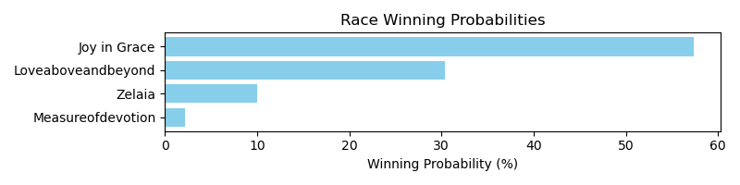

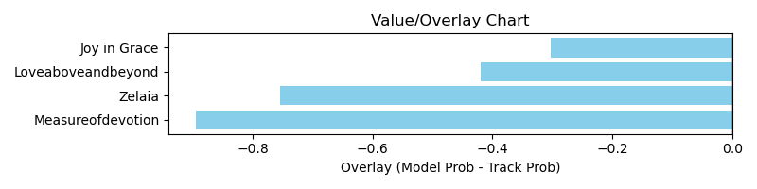

NOTE: GCSF - Global Combined Speed Figure

# Race: TUP | 2025-04-01 | Race #8 | Post: 16:21 | Track: TURF PARADISE

Track: TURF PARADISE

|  |  |  |  |  |  |
| --- | --- | --- | --- | --- | --- |
| Program # | Horse Name | Morn Odds | GCSF | Model Score | Win Prob (%) |
| 1 | Elegant Bella | 20-1 | 106.6 | 0.60 | 1.31 |
| 8 | Expect Love | 4-1 | 112.5 | 1.39 | 98.69 |

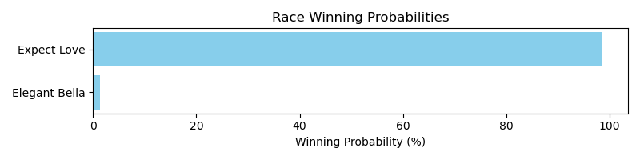

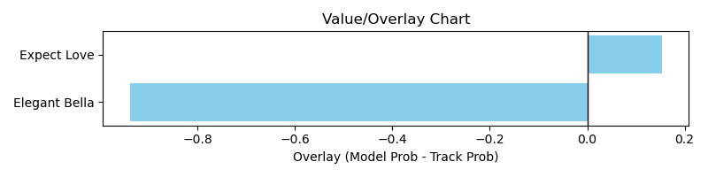

NOTE: GCSF - Global Combined Speed Figure

# Race: TUP | 2025-04-01 | Race #9 | Post: 16:50 | Track: TURF PARADISE

Track: TURF PARADISE

|  |  |  |  |  |  |
| --- | --- | --- | --- | --- | --- |
| Program # | Horse Name | Morn Odds | GCSF | Model Score | Win Prob (%) |
| 2 | Happy Hour Bobby | 6-1 | 93.1 | 1.16 | 100.00 |

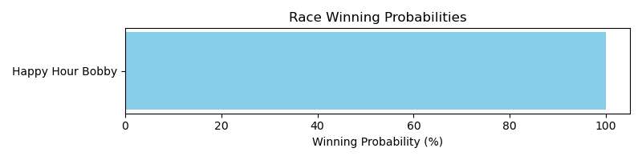

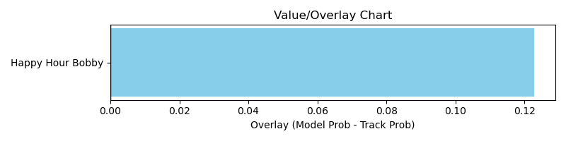

NOTE: GCSF - Global Combined Speed Figure

# Race: TUP | 2025-04-02 | Race #4 | Post: 14:25 | Track: TURF PARADISE

Track: TURF PARADISE

|  |  |  |  |  |  |
| --- | --- | --- | --- | --- | --- |
| Program # | Horse Name | Morn Odds | GCSF | Model Score | Win Prob (%) |
| 3 | Spaghetti Tree | 6-1 | 84.3 | 0.94 | 88.39 |
| 4 | Forgot the Roses | 8-1 | 107.5 | 0.63 | 11.61 |

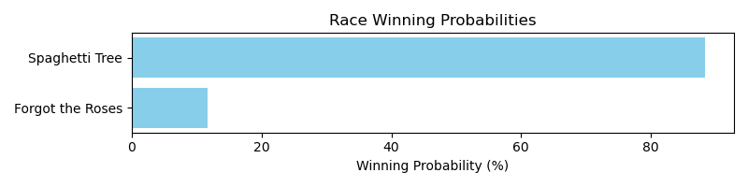

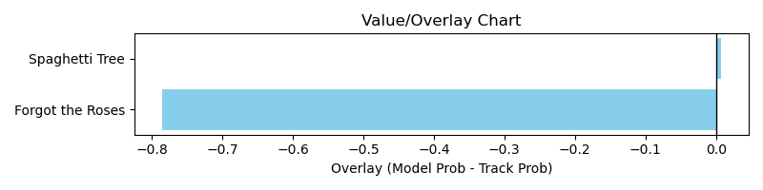

NOTE: GCSF - Global Combined Speed Figure

# Race: TUP | 2025-04-02 | Race #5 | Post: 14:54 | Track: TURF PARADISE

Track: TURF PARADISE

|  |  |  |  |  |  |
| --- | --- | --- | --- | --- | --- |
| Program # | Horse Name | Morn Odds | GCSF | Model Score | Win Prob (%) |
| 1 | Sent by Angels | 5-1 | 90.9 | 1.22 | 61.67 |
| 5 | Clay's Ruby Love | 12-1 | 102.2 | 0.97 | 19.53 |
| 7 | Lula Bella | 10-1 | 90.3 | 0.97 | 18.80 |

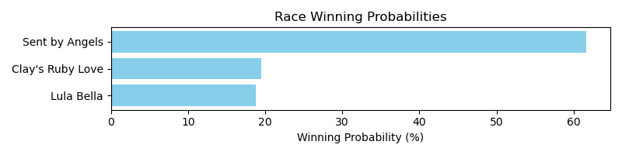

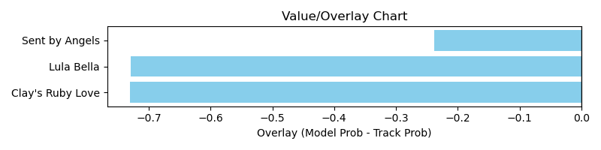

NOTE: GCSF - Global Combined Speed Figure

# Race: TUP | 2025-04-02 | Race #6 | Post: 15:23 | Track: TURF PARADISE

Track: TURF PARADISE

|  |  |  |  |  |  |
| --- | --- | --- | --- | --- | --- |
| Program # | Horse Name | Morn Odds | GCSF | Model Score | Win Prob (%) |
| 1 | Fearless Soldier | 3-1 | 95.8 | 1.57 | 37.79 |
| 4 | Stamp My Passport | 5-2 | 83.4 | 1.70 | 56.78 |
| 6 | Tenth Street Don | 8-1 | 113.7 | 1.08 | 5.42 |

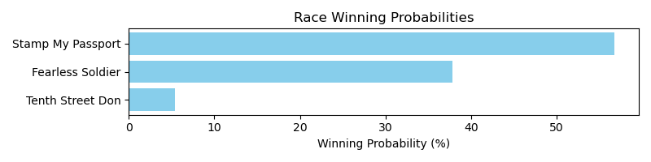

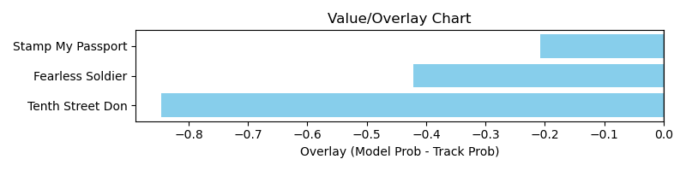

NOTE: GCSF - Global Combined Speed Figure

# Race: TUP | 2025-04-02 | Race #7 | Post: 15:52 | Track: TURF PARADISE

Track: TURF PARADISE

|  |  |  |  |  |  |
| --- | --- | --- | --- | --- | --- |
| Program # | Horse Name | Morn Odds | GCSF | Model Score | Win Prob (%) |
| 2 | Immelmann | 3-1 | 100.5 | 1.28 | 13.29 |
| 4 | He's Init to Winit | 12-1 | 90.6 | 1.09 | 5.85 |
| 6 | Stan From Malibu | 4-1 | 94.6 | 1.04 | 4.59 |
| 8 | Getemdusty | 8-1 | 92.9 | 1.80 | 76.27 |

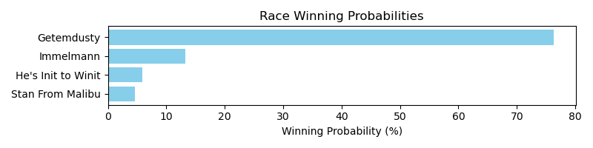

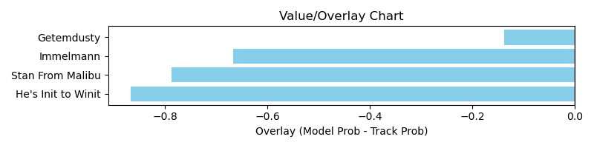

NOTE: GCSF - Global Combined Speed Figure

# Race: TUP | 2025-04-02 | Race #8 | Post: 16:21 | Track: TURF PARADISE

Track: TURF PARADISE

|  |  |  |  |  |  |
| --- | --- | --- | --- | --- | --- |
| Program # | Horse Name | Morn Odds | GCSF | Model Score | Win Prob (%) |
| 3 | Last Martini | 9-2 | 104.8 | 1.14 | 100.00 |

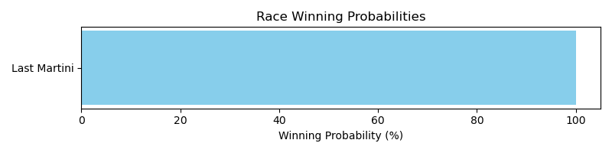

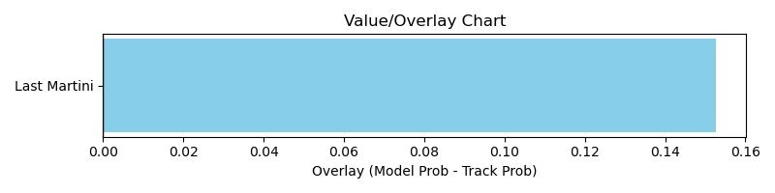

NOTE: GCSF - Global Combined Speed Figure

# Race: TUP | 2025-04-02 | Race #9 | Post: 16:50 | Track: TURF PARADISE

Track: TURF PARADISE

|  |  |  |  |  |  |
| --- | --- | --- | --- | --- | --- |
| Program # | Horse Name | Morn Odds | GCSF | Model Score | Win Prob (%) |
| 1 | Devilnthebluegras | 6-1 | 96.1 | 1.03 | 15.69 |
| 2 | Precedent Luke | 8-1 | 93.3 | 0.94 | 9.98 |
| 3 | Picking It Up | 3-1 | 103.0 | 1.32 | 56.51 |
| 4 | Shankadopolous | 8-1 | 89.4 | 0.90 | 8.07 |
| 5 | Cassano | 15-1 | 96.9 | 0.94 | 9.75 |

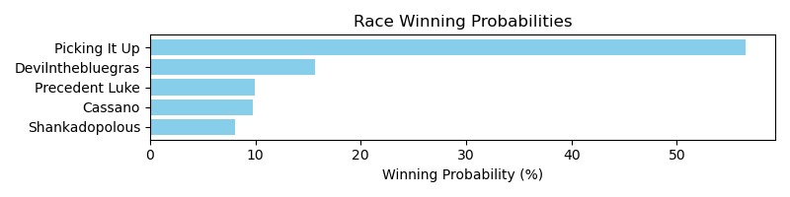

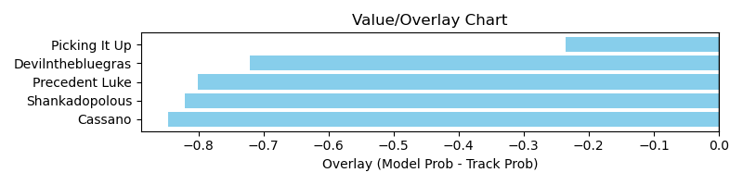

NOTE: GCSF - Global Combined Speed Figure

# Race: TTP | 2025-03-28 | Race #4 | Post: 19:25 | Track: TURFWAY PARK

Track: TURFWAY PARK

|  |  |  |  |  |  |
| --- | --- | --- | --- | --- | --- |
| Program # | Horse Name | Morn Odds | GCSF | Model Score | Win Prob (%) |
| 1 | Vast Horizons | 12-1 | 110.2 | 0.90 | 1.84 |
| 2 | Tiverton | 30-1 | 97.9 | 0.87 | 1.52 |
| 3 | Bayou Magic | 15-1 | 89.8 | 1.05 | 3.95 |
| 4 | Coach Campbell | 12-1 | 94.6 | 1.08 | 4.61 |
| 5 | Patrolman | 4-1 | 103.4 | 1.20 | 8.06 |
| 6 | Longshadow | 10-1 | 96.5 | 1.13 | 5.90 |
| 7 | Fear and Loathing | 12-1 | 104.1 | 0.96 | 2.59 |
| 8 | God of Wine | 9-2 | 92.6 | 1.72 | 50.38 |
| 9 | Evening News | 3-1 | 109.5 | 1.28 | 11.10 |
| 10 | Class Photo | 5-1 | 103.1 | 0.92 | 1.98 |
| 11 | Son of Thunder | 20-1 | 101.2 | 0.97 | 2.64 |
| 12 | Runwithheart | 12-1 | 95.0 | 1.11 | 5.43 |

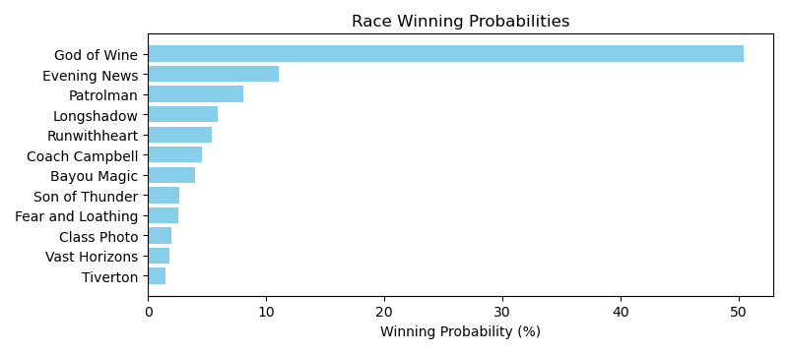

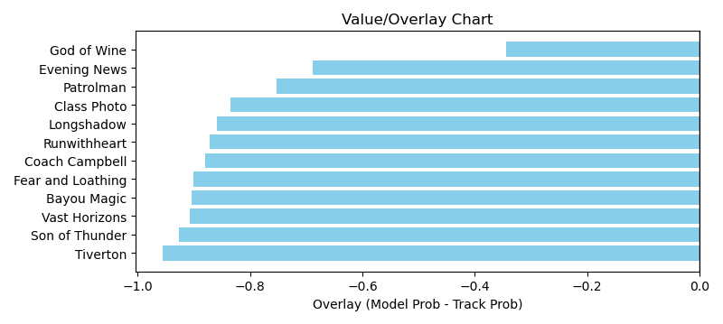

NOTE: GCSF - Global Combined Speed Figure

# Race: TTP | 2025-03-29 | Race #1 | Post: 17:55 | Track: TURFWAY PARK

Track: TURFWAY PARK

|  |  |  |  |  |  |
| --- | --- | --- | --- | --- | --- |
| Program # | Horse Name | Morn Odds | GCSF | Model Score | Win Prob (%) |
| 1 | Sophisticated Cat | 5-2 | 114.8 | 1.49 | 46.56 |
| 2 | Bali Baby | 20-1 | 85.2 | 0.83 | 2.29 |
| 3 | Itsablingthing | 20-1 | 89.0 | 1.01 | 6.33 |
| 4 | Orozimba | 8-1 | 109.4 | 1.06 | 7.85 |
| 5 | Ms. the Law | 10-1 | 98.0 | 1.01 | 6.19 |
| 6 | Sense of Pearl | 5-1 | 96.5 | 0.93 | 3.99 |
| 7 | Gatita Suave | 12-1 | 95.7 | 1.00 | 5.98 |
| 8 | Thirsty Accountant | 6-1 | 92.6 | 0.85 | 2.50 |
| 9 | Lock It Up | 9-5 | 91.7 | 1.25 | 18.31 |

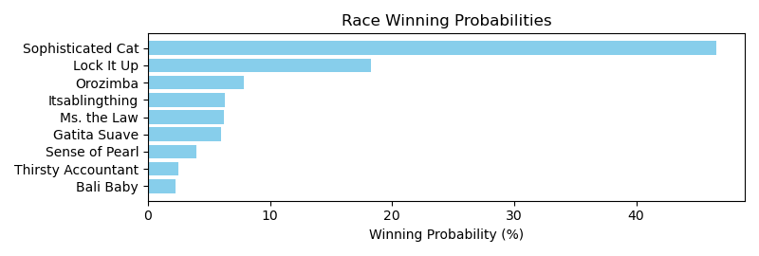

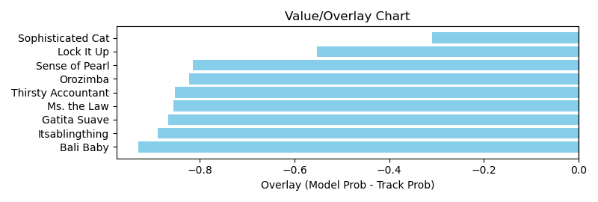

NOTE: GCSF - Global Combined Speed Figure

# Race: TTP | 2025-03-29 | Race #2 | Post: 18:25 | Track: TURFWAY PARK

Track: TURFWAY PARK

|  |  |  |  |  |  |
| --- | --- | --- | --- | --- | --- |
| Program # | Horse Name | Morn Odds | GCSF | Model Score | Win Prob (%) |
| 1 | Kendal Grace | 20-1 | 106.9 | 1.04 | 3.93 |
| 2 | Filly Crystal | 3-1 | 116.2 | 1.28 | 11.14 |
| 3 | No Tappin Out | 9-2 | 104.7 | 1.30 | 12.09 |
| 4 | Jackie's Love | 30-1 | 88.4 | 0.88 | 1.61 |
| 5 | Four the Girls | 15-1 | 89.5 | 0.88 | 1.63 |
| 6 | Yuma's Shadow | 15-1 | 104.8 | 1.54 | 28.85 |
| 7 | Best Kiss Yet | 12-1 | 103.3 | 1.02 | 3.46 |
| 8 | Mariposa de Pista | 8-1 | 93.8 | 1.30 | 12.13 |
| 9 | Rose Rita | 15-1 | 96.7 | 0.79 | 0.94 |
| 10 | Razzle Red | 15-1 | 94.9 | 0.90 | 1.83 |
| 11 | Creative Quality | 5-1 | 90.2 | 1.25 | 9.82 |
| 12 | Purr Factor | 4-1 | 120.3 | 1.06 | 4.19 |
| 13 | Three Coins | 20-1 | 97.2 | 1.06 | 4.20 |
| 14 | Miss Peabody | 20-1 | 98.7 | 1.06 | 4.19 |

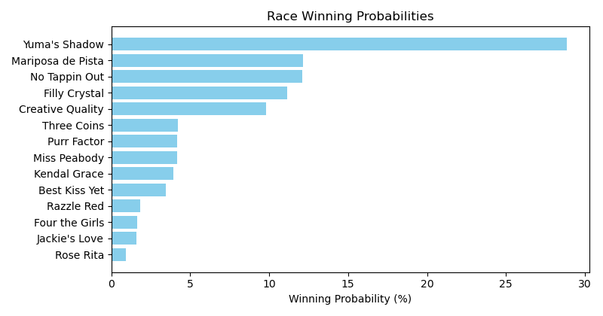

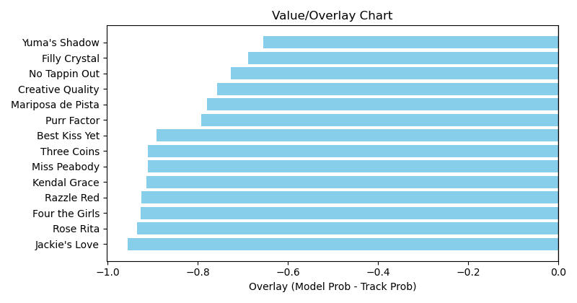

NOTE: GCSF - Global Combined Speed Figure

# Race: TTP | 2025-03-29 | Race #3 | Post: 18:55 | Track: TURFWAY PARK

Track: TURFWAY PARK

|  |  |  |  |  |  |
| --- | --- | --- | --- | --- | --- |
| Program # | Horse Name | Morn Odds | GCSF | Model Score | Win Prob (%) |
| 1 | Vincenzino | 20-1 | 104.2 | 0.91 | 0.97 |
| 2 | I Am the Game | 15-1 | 103.3 | 1.09 | 2.53 |
| 3 | Reapply | 12-1 | 99.0 | 1.01 | 1.68 |
| 4 | Hurry On Out | 8-1 | 99.0 | 1.22 | 4.41 |
| 5 | Sant' Antimo | 15-1 | 109.1 | 1.02 | 1.79 |
| 6 | P H Factor | 7-2 | 98.1 | 1.13 | 2.96 |
| 7 | Cool Rags | 8-1 | 101.3 | 1.17 | 3.57 |
| 8 | Vanzzy | 6-1 | 108.1 | 0.97 | 1.41 |
| 9 | Noahs Ark | 8-1 | 99.6 | 1.39 | 8.64 |
| 10 | Atta Boy Anthony | 12-1 | 101.4 | 1.37 | 8.06 |
| 11 | Devils Gotta Go | 20-1 | 97.3 | 0.85 | 0.70 |
| 12 | P K Wood | 3-1 | 104.2 | 2.04 | 61.98 |
| 13 | Kentucky Ghost | 5-1 | 100.0 | 0.96 | 1.31 |

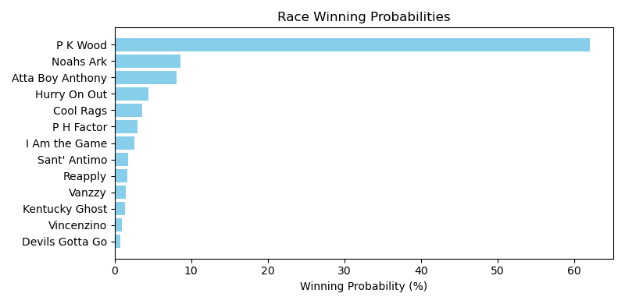

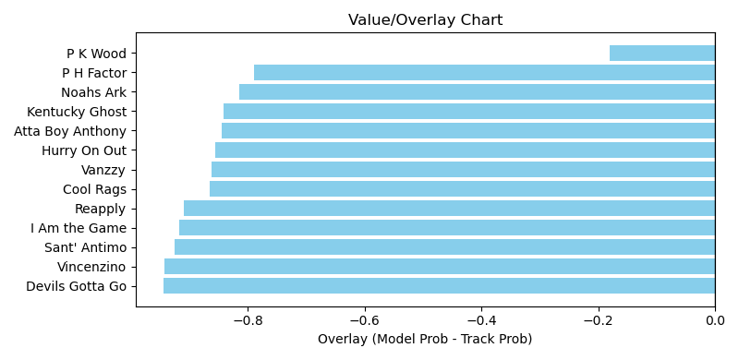

NOTE: GCSF - Global Combined Speed Figure

# Race: TTP | 2025-03-29 | Race #4 | Post: 19:25 | Track: TURFWAY PARK

Track: TURFWAY PARK

|  |  |  |  |  |  |
| --- | --- | --- | --- | --- | --- |
| Program # | Horse Name | Morn Odds | GCSF | Model Score | Win Prob (%) |
| 1 | Docs Seven | 10-1 | 99.5 | 1.06 | 5.00 |
| 2 | Bel Aria | 30-1 | 90.8 | 1.03 | 4.30 |
| 3 | Talkin in Cursive | 5-1 | 96.2 | 1.42 | 22.01 |
| 4 | Crickenberger | 5-1 | 89.6 | 1.20 | 9.24 |
| 5 | Harmonica | 7-2 | 103.0 | 1.08 | 5.45 |
| 6 | Ms Temptation | 12-1 | 98.6 | 0.95 | 2.83 |
| 7 | Urban Cowgirl | 4-1 | 96.2 | 1.33 | 15.63 |
| 8 | Sandrinha Love | 10-1 | 100.7 | 0.94 | 2.59 |
| 9 | Wildcatjustice | 8-1 | 101.3 | 1.30 | 13.85 |
| 10 | Very Wealthy | 20-1 | 107.4 | 0.79 | 1.08 |
| 11 | Posh Playday | 10-1 | 90.2 | 1.14 | 7.19 |
| 12 | Protomagic | 20-1 | 88.4 | 0.93 | 2.53 |
| 13 | Frango Electrico | 8-1 | 100.1 | 1.12 | 6.57 |
| 14 | Wild Irish | 10-1 | 115.8 | 0.86 | 1.72 |

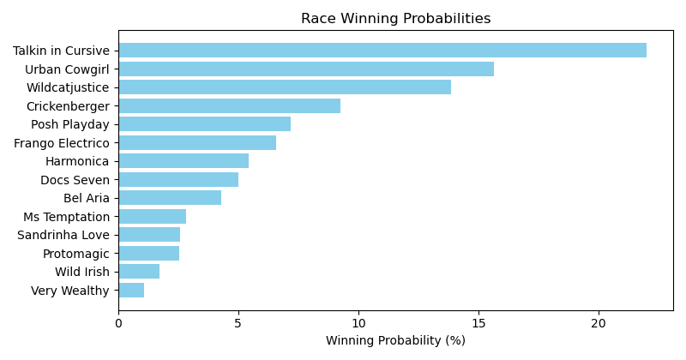

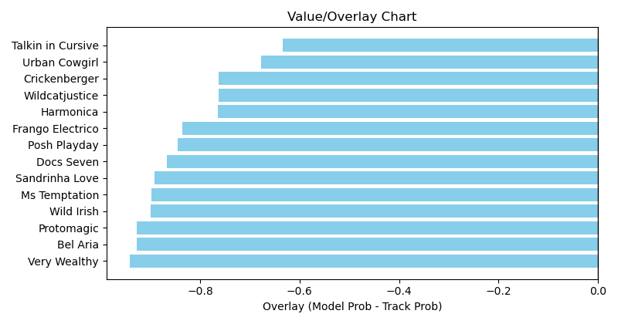

NOTE: GCSF - Global Combined Speed Figure

# Race: TTP | 2025-03-29 | Race #7 | Post: 20:55 | Track: TURFWAY PARK

Track: TURFWAY PARK

|  |  |  |  |  |  |
| --- | --- | --- | --- | --- | --- |
| Program # | Horse Name | Morn Odds | GCSF | Model Score | Win Prob (%) |
| 1 | One for My Brother | 15-1 | 124.9 | 0.95 | 2.37 |
| 2 | Panthor | 15-1 | 112.6 | 0.74 | 0.68 |
| 3 | Cowboy Justice (GB) | 3-1 | 96.8 | 1.46 | 21.35 |
| 4 | Go Bali Go | 12-1 | 111.6 | 1.05 | 3.89 |
| 5 | Mucho Mojo | 15-1 | 89.9 | 1.28 | 10.78 |
| 6 | Manabi | 12-1 | 89.4 | 1.00 | 3.03 |
| 7 | Schifty's Haloid | 8-1 | 93.0 | 1.44 | 20.10 |
| 8 | Candy Nun | 8-1 | 93.4 | 1.08 | 4.63 |
| 9 | Two Beers by Ten | 4-1 | 101.7 | 1.22 | 8.70 |
| 10 | Forge in Fire | 15-1 | 97.4 | 0.97 | 2.70 |
| 11 | Double Neat | 15-1 | 99.3 | 1.02 | 3.46 |
| 12 | Memphis Pharoah | 9-2 | 90.9 | 1.18 | 7.11 |
| 13 | Runwithheart | 15-1 | 94.3 | 1.04 | 3.73 |
| 14 | Azoi | 6-1 | 88.6 | 1.19 | 7.46 |

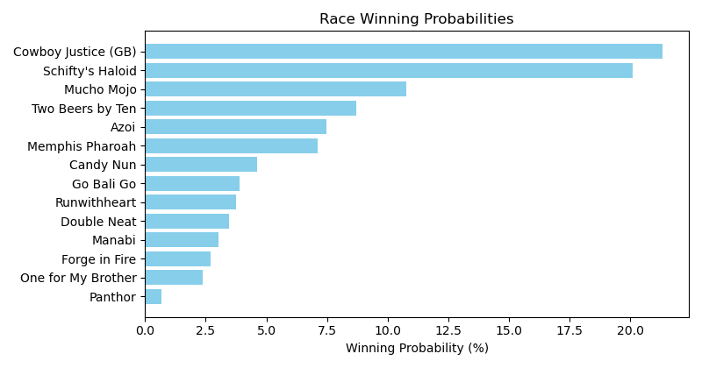

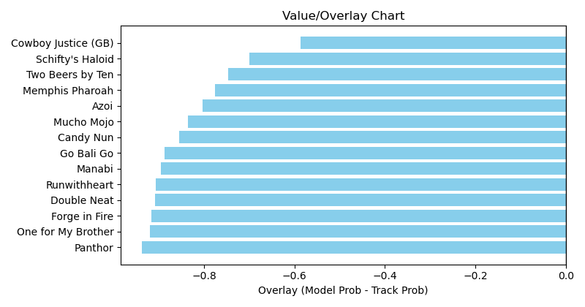

NOTE: GCSF - Global Combined Speed Figure

# Race: TTP | 2025-03-29 | Race #8 | Post: 21:25 | Track: TURFWAY PARK

Track: TURFWAY PARK

|  |  |  |  |  |  |
| --- | --- | --- | --- | --- | --- |
| Program # | Horse Name | Morn Odds | GCSF | Model Score | Win Prob (%) |
| 1 | Unusual Activity | 20-1 | 107.5 | 0.78 | 1.55 |
| 2 | Fire Wire | 15-1 | 109.4 | 1.08 | 8.42 |
| 3 | Golden Text | 30-1 | 88.5 | 0.71 | 0.96 |
| 4 | Drunken Sailor | 6-1 | 92.2 | 1.15 | 11.59 |
| 5 | Caballo Feliz | 15-1 | 96.7 | 0.99 | 5.46 |
| 6 | Bettering | 8-1 | 110.7 | 1.09 | 8.96 |
| 7 | Inflation Nation (IRE) | 2-1 | 95.2 | 1.31 | 22.27 |
| 8 | Ms Ks Dynasty | 20-1 | 90.0 | 0.91 | 3.44 |
| 9 | Centrifugal Force | 30-1 | 85.6 | 0.67 | 0.71 |
| 10 | Huntertown | 5-2 | 104.3 | 1.28 | 20.24 |
| 11 | Royal Icing | 12-1 | 106.0 | 0.92 | 3.67 |
| 12 | Manchester | 10-1 | 113.2 | 0.96 | 4.64 |
| 13 | Shosha | 20-1 | 87.4 | 0.99 | 5.39 |
| 14 | Sonho de Verao | 15-1 | 90.7 | 0.87 | 2.69 |

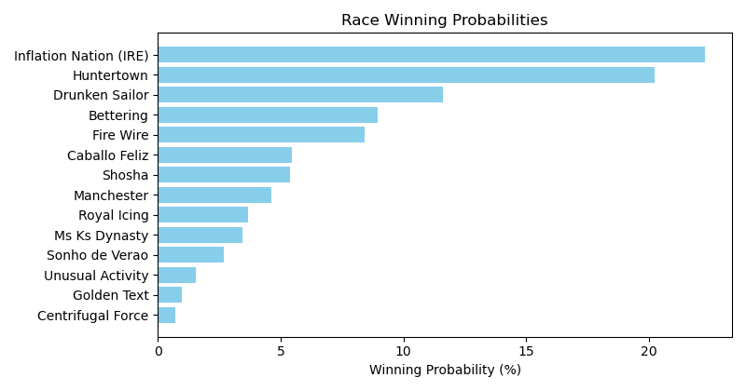

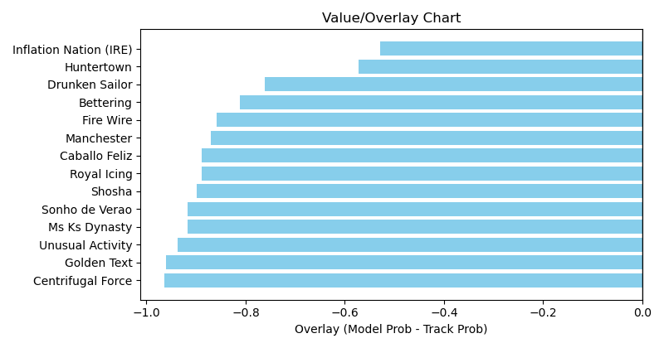

NOTE: GCSF - Global Combined Speed Figure